
TABSAN EDUSPHERE
User Manual
Campus Portal for Universities, Colleges and Schools
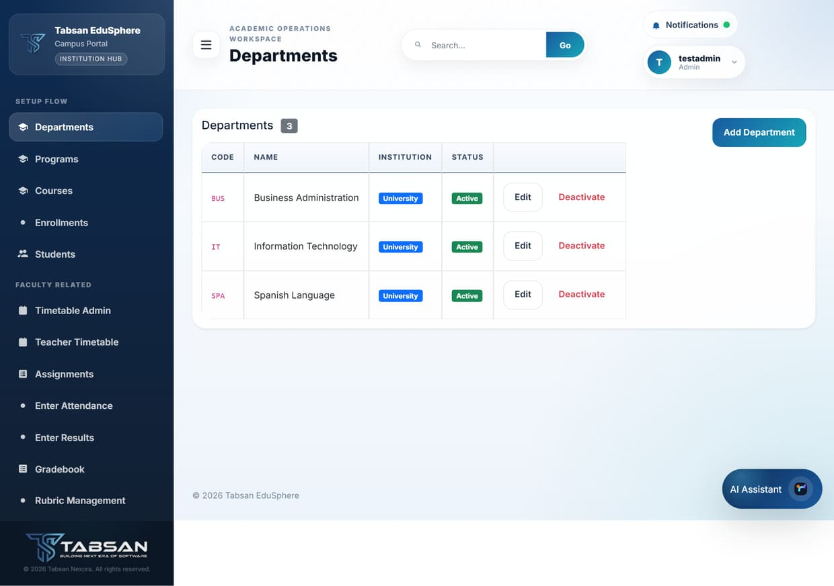
Version 1.2 · 10 October 2026
Tabsan Nexora — Building the Next Era of Software

About This Manual
This manual describes Tabsan EduSphere as installed from the main branch on 10 October 2026. Screenshots were captured from the live application using the demonstration data set.
Item | Detail
Product | Tabsan EduSphere Campus Portal
Document | User Manual
Version | 1.2
Date | 10 October 2026
Audience | SuperAdmin, Admin, Faculty, Student and Finance users
Publisher | Tabsan Nexora

NOTE Screens may differ slightly from these screenshots depending on your role, your institution type, the theme you choose and which modules your administrator has enabled.

Contents
About This Manual 1
Contents 2
1 Introduction 5
1.1 Who should read this manual 5
1.2 How this manual is organised 5
1.3 User roles at a glance 6
1.4 Accounts used in this manual 6
1.5 Conventions used in this manual 7
2 Key Concepts 8
2.1 How the academic structure fits together 8
2.2 Institution types 8
2.3 Statuses you will see 9
2.4 Security and your session 9
3 Getting Started 10
3.1 Opening the portal and signing in 10
3.2 The portal layout 12
3.3 Using filters and lists 13
3.4 Profile menu and signing out 13
3.5 Access messages and read-only mode 14
4 Quick Start by Role 15
4.1 Admin: setting up a new term 15
4.2 Faculty: a typical week 15
4.3 Student: finding your information 15
4.4 Finance: managing fees 16
5 Academic Setup 17
5.1 Departments 17
5.2 Programs 19
5.3 Courses and offerings 20
5.4 Enrollments 22
5.5 Students 24
6 Timetables and Facilities 25
6.1 Buildings and rooms 25
6.2 Timetable Admin 27
6.3 Teacher Timetable 28
6.4 Student Timetable 29
7 Teaching and Learning 31
7.1 Assignments 31
7.2 Entering attendance 33
7.3 Viewing attendance 36
7.4 Entering results 37
7.5 Gradebook 39
7.6 Rubric Management 40
7.7 Quizzes 41
7.8 LMS Manage 43
7.9 Course Material 44
7.10 Discussion 46
7.11 Announcements 46
8 Results, Progression and Final Year Projects 48
8.1 Results 48
8.2 Result Calculation 49
8.3 Grading Config 50
8.4 Prerequisites 51
8.5 Student Lifecycle 52
8.6 Study Plan 54
8.7 Final Year Projects (FYP) 55
9 Graduation and Certificates 57
9.1 Degree Rules 57
9.2 Degree Audit 58
9.3 Graduation Eligibility 59
9.4 Applying for graduation (Students) 60
9.5 Graduation Applications 61
9.6 Generate Certificates 62
10 Reports and Analytics 64
10.1 Report Center 64
10.2 Analytics 66
11 Finance 68
11.1 Fee receipts (Payments) 68
12 Users, Communication and Personal Settings 71
12.1 User Import and creating users 71
12.2 User Settings 73
12.3 Two-Factor Authentication 75
12.4 Notifications 76
12.5 Helpdesk 77
12.6 Theme Settings 79
13 SuperAdmin Administration 81
13.1 Dashboard 81
13.2 Tenant and Campus Management 81
13.3 Admin Users 83
13.4 Module Composition 84
13.5 Sidebar Settings 85
13.6 Report Settings 86
13.7 Dashboard Settings (Branding) 87
13.8 Institution Policy 88
13.9 License Update 89
13.10 Library Config 90
13.11 Accreditation 91
13.12 Advanced Audit 92
14 Troubleshooting and FAQ 94
14.1 Signing in and accounts 94
14.2 Pages and data 94
14.3 Getting more help 95
Appendix A Menu Access by Role 96
Appendix B Glossary 98
Index 99

1 Introduction
Tabsan EduSphere is a web-based campus management portal for universities, colleges and schools. It brings the everyday work of an institution into one secure place: departments, programs, courses, enrolments, timetables, attendance, assessments, results, graduation, certificates, fee receipts, reports and support tickets.
Everyone uses the same portal. What each person sees depends on their role: an administrator sees setup and management pages, a teacher sees their classes, a student sees their own records, and the finance office sees fee receipts.
This manual explains every screen in the portal step by step, with screenshots taken from a running installation. You do not need to read it from start to finish. Use the Contents page or the Index at the back to jump to the task you need.

1.1 Who should read this manual
The manual is written for everyone who signs in to the portal. Each section begins with an "Available to" line, so you can quickly see whether it applies to you.
- SuperAdmin – the platform owner. Manages the product license, tenants and campuses, which modules are switched on, which menus each role sees, portal branding, the institution policy and the Admin accounts.
- Admin – institution administrators. Set up departments, programs, courses, students and timetables, and manage results, graduation, certificates, user accounts, fee receipts and reports for their departments.
- Faculty – teachers. Work with their own classes: timetable, assignments, attendance, marks, gradebook, rubrics, quizzes, online course content, final year project supervision and announcements.
- Student – learners. View their timetable, assignments, quizzes, course material, attendance and results, check their degree progress and apply for graduation.
- Finance – finance office staff. Issue and confirm fee receipts and run the payment report.

1.2 How this manual is organised
Chapters follow the order in which an institution normally works: first the concepts and sign-in, then academic setup, then teaching and assessment, then progression and graduation, and finally reports, finance, accounts and SuperAdmin administration.
- Chapter 2 explains the terms used throughout the portal. Read it once if you are new.
- Chapter 3 covers signing in, finding your way around and signing out.
- Chapter 4 is a quick start for each role: the handful of pages you will use most.
- Chapters 5 to 13 describe each screen in detail: what it is for, what you need before you start, the steps, the fields, what happens afterwards and useful tips.
- Chapter 14 answers common questions. Appendix A shows which menus each role can see, and Appendix B is a glossary.

1.3 User roles at a glance
Each user account has exactly one role. The role decides which menus appear in the sidebar and which actions the portal allows. If you need something your role cannot do, ask an Admin or SuperAdmin; they can either do it for you or, where appropriate, change your access.
Role | Scope | Typical work
SuperAdmin | Whole installation, all tenants | License, tenants and campuses, module composition, sidebar visibility, branding, institution policy, Admin accounts, audit logs
Admin | One tenant; only the departments assigned to them | Departments, programs, courses, enrolments, students, timetables, attendance, results, graduation, certificates, user import, payments, reports
Faculty | The departments and classes they teach | Teacher timetable, assignments, attendance, results, gradebook, rubrics, quizzes, LMS, course material, FYP, announcements
Student | Their own records | Timetable, assignments, quizzes, course material, attendance, results, degree audit, graduation application
Finance | Fee receipts | Payments, payment summary report, analytics

1.4 Accounts used in this manual
The screenshots were captured with the demonstration accounts below. All demo accounts use the password EduSphere147. These accounts exist only in the demonstration data; change or remove them before the portal is used with real students.
Username | Role | Notes
superadmin | SuperAdmin | Full platform access, including license and tenant management.
testadmin | Admin | Testing account with every right except SuperAdmin. Works in the University tenant and is assigned to all of its departments. Created by Scripts/08-Create-Test-Admin-User.sql.
faculty.it1 | Faculty | A teacher in the Information Technology department.
bscs8s1 | Student | A Computer Science student in semester 8.
finance1 | Finance | A finance officer.

NOTE Every account other than SuperAdmin belongs to one tenant (for example University, College or School). Only SuperAdmin can see data across tenants.

1.5 Conventions used in this manual
- Menu names, buttons and field labels are shown in bold, for example Departments > Add Department.
- Numbered lists are procedures: follow the steps in order.
- "Fields and options" tables explain each box or list on a form.
- "What happens next" explains the result of an action, and "Good to know" lists tips and limits.
- NOTE boxes add context, TIP boxes suggest a faster way, and IMPORTANT boxes warn about actions that change data or access.
- Fields marked with a red asterisk (*) in the portal are required; the portal will not save the form until they are filled in.

2 Key Concepts
The portal uses a few terms consistently on every page. Understanding them makes the filters and forms much easier to follow.

2.1 How the academic structure fits together
Information in the portal is organised from the broadest level to the most specific. Most pages ask you to choose these levels in order, from left to right, before they show any data. Each choice narrows the next list.
Level | What it means | Example
Tenant | A separate institution in the installation, with its own users and data. | University, College, School
Campus | A physical site of a tenant. | UNI-1 (main campus)
Department | An academic unit. Belongs to one institution type. | Information Technology
Program | A degree or course of study offered by a department. | BS Computer Science
Semester / Class | A level within a program: semesters for University, classes for School and College. | Semester 4, Class 11
Course (subject) | A subject with a code, title and credit hours. | CS101 Introduction to Programming
Offering | A course taught in a particular semester or class, usually by one teacher. Students enrol in offerings. | CS101, BSCS Semester 1

Good to know
- If a list looks empty, check the filters at the top of the page first. Most pages show nothing until a department and an offering are chosen.
- Admins only see the departments assigned to them. Faculty only see the departments and classes they teach.

2.2 Institution types
Each department belongs to one institution type, and the type changes how progression and results work.
Type | Levels | Results
University | Semesters 1 to 8 (depending on the program); final year project in the last semester | Grades and GPA / CGPA
College | Class 11 and Class 12 | Percentage based
School | Class 1 to Class 10 | Percentage based

NOTE Degree audit, degree rules, graduation applications, FYP and the GPA & CGPA report apply to University departments only.

2.3 Statuses you will see
Many lists show a coloured status badge. The most common ones are:
- Active / Inactive – inactive records are kept for history but no longer used. Most lists hide them unless you tick a "Show inactive" option.
- Published – results and assignments become visible to students only once published.
- Pending / Approved / Rejected – used for requests that need someone else to act, such as graduation applications, study plans and result changes.

2.4 Security and your session
- Your session ends automatically after a period of inactivity set by your administrator. Sign in again to continue; unsaved changes on the open page are lost.
- Passwords must be at least 8 characters and different from your previous password. Passwords expire after 90 days by default, and the portal asks you to choose a new one.
- New accounts start with a temporary password (the username) and must choose a new password at first sign-in.
- Two-factor authentication adds a 6-digit code from an authenticator app to sign-in (see Two-Factor Authentication).
- Every sign-in and every important change is recorded in the audit log.

3 Getting Started
This chapter covers signing in, finding your way around the portal, and signing out.

3.1 Opening the portal and signing in
Open the portal address supplied by your administrator in a current browser such as Microsoft Edge, Google Chrome, Mozilla Firefox or Safari. The portal works on desktop computers, tablets and phones.

Before you start
- You need a username and password from your administrator. Students and staff usually receive them by email.
- If two-factor authentication is switched on for your account, have your authenticator app ready.

Procedure
- Open the portal address. The Sign in to your account page appears.
- Enter your Username and Password. Click the eye icon to show or hide the password while you type.
- Click Sign In.
- If two-factor authentication is enabled on your account, enter the 6-digit code from your authenticator app when prompted.
- If this is your first sign-in, or your password has expired, the portal asks you to choose a new password before continuing.
- The portal opens. SuperAdmin users land on the Dashboard; all other users land on the Helpdesk ticket queue, and the sidebar shows their menus.

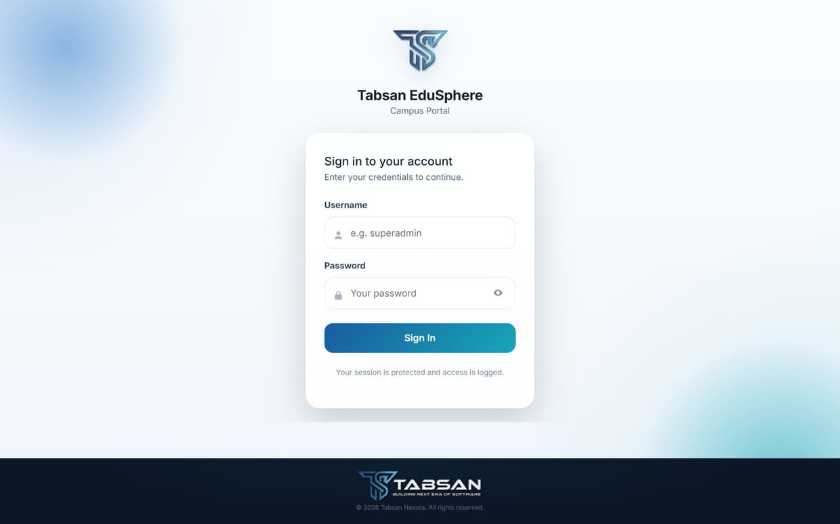
Figure 3.1 The sign-in page
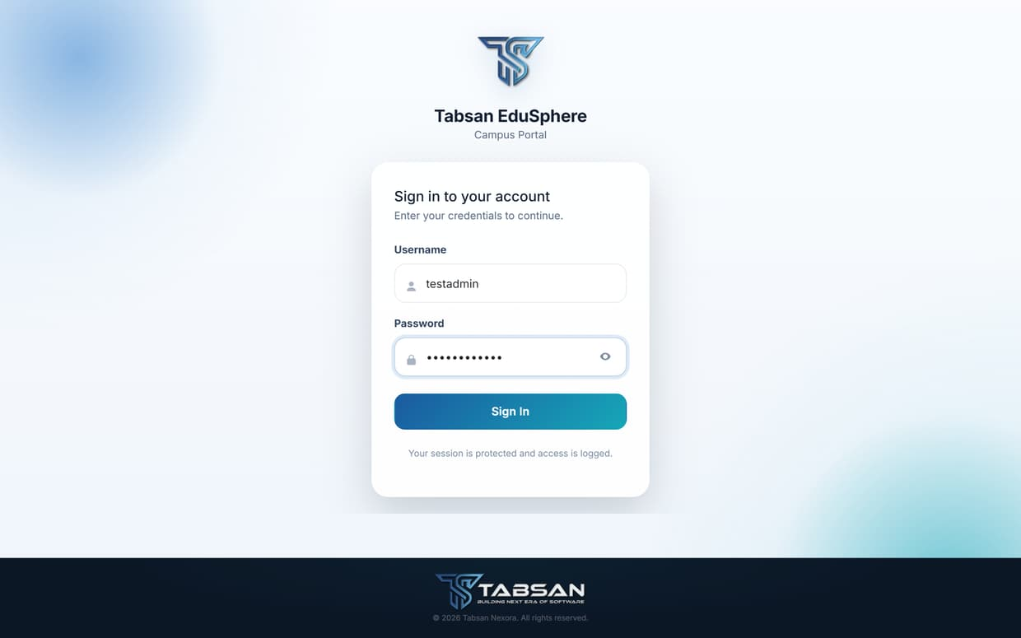
Figure 3.2 Sign-in page with credentials entered
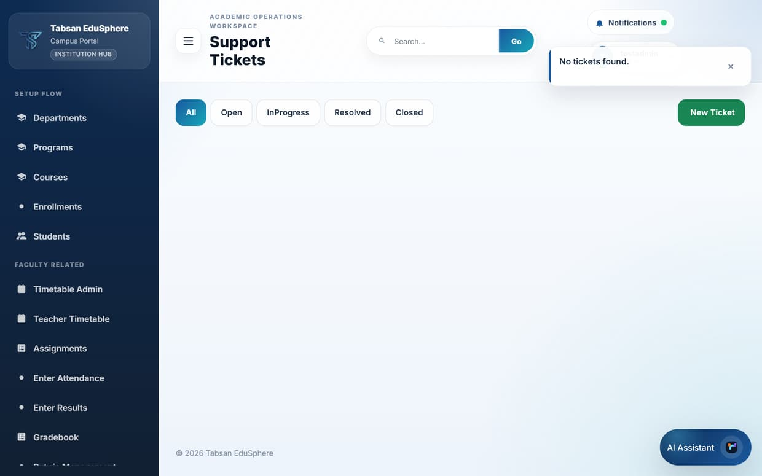
Figure 3.3 Landing page after signing in (Admin)

Good to know
- After several failed attempts the account may be blocked for security reasons. Ask your administrator to check the account rather than trying repeatedly.
- Do not let your browser save your password on a shared or public computer.

3.2 The portal layout
Every page shares the same layout, so once you know one page you know them all.
- Sidebar (left) – the menus your role can use, grouped into sections: Overview, Setup Flow, Faculty Related, Student Related, Academic Related, Settings Related and Financial Related. The highlighted item is the current page. Click the menu button (three lines) to collapse the sidebar to icons and give the page more room.
- Page header – the page title and the workspace name.
- Search – type part of a page or feature name, such as "attendance", and click Go to jump straight to it.
- Notifications – opens your notification inbox. A green dot means you have unread notifications.
- Profile chip (top right) – shows your username and role; click it to open the profile menu.
- AI Assistant (bottom right) – a chat assistant that answers questions about using the portal, when the AI module is switched on.
- Messages – after you save something, a short message appears at the top right confirming success or explaining a problem. It closes by itself, or click × to close it.
Figure 3.4 Portal layout: sidebar, header, search, notifications and profile

3.3 Using filters and lists
Most pages start with a row of filters, such as Campus, Department, Course and Offering. Choose them from left to right; each choice refreshes the next list and the data below.
Tables can be long. Use the browser's find feature (Ctrl+F, or Cmd+F on a Mac) to locate a name quickly, or narrow the filters.

Good to know
- Your last choices are kept in the address bar, so you can bookmark a filtered page or send the link to a colleague with the same access.
- Buttons that change data, such as Deactivate or Delete, ask you to confirm first.

3.4 Profile menu and signing out

Procedure
- Click your name in the top-right corner.
- Choose View Notifications, User Settings or Two-Factor Authentication to open those pages.
- Click Sign Out to end your session.

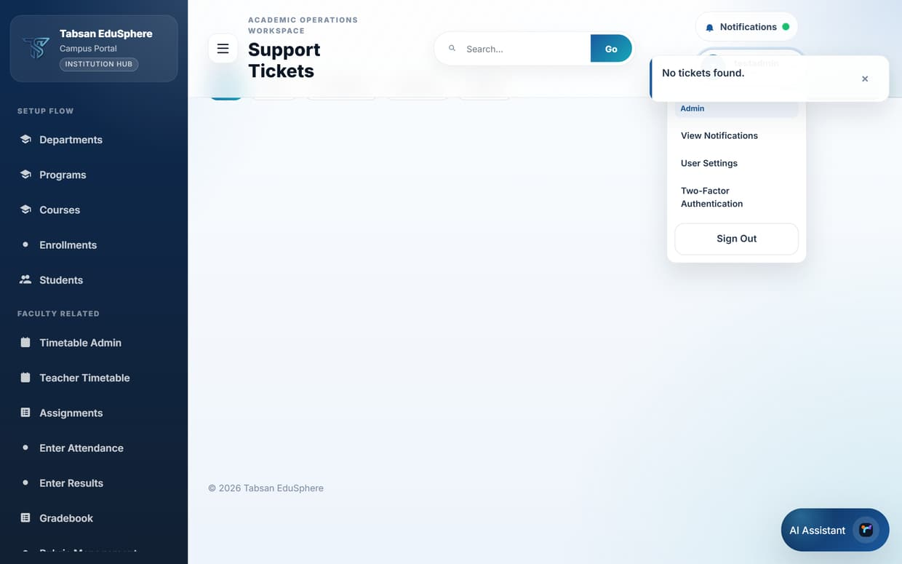
Figure 3.5 The profile menu
IMPORTANT Always sign out on a shared computer. Closing the browser tab alone may leave your session open until it times out.

3.5 Access messages and read-only mode
If you open a page your role cannot use (for example from an old bookmark), the portal returns you to your landing page with a short message explaining why. Nothing is changed. Ask your administrator if you believe you need access.
IMPORTANT If the product license is missing, expired or invalid, the portal switches to read-only mode: you can still view information, but saving, creating and deleting are blocked until a SuperAdmin uploads a valid license (see License Update).

4 Quick Start by Role
This chapter lists the pages each role uses most, in the order they are usually needed. Each item points to the chapter that explains it in detail.

4.1 Admin: setting up a new term
Available to: Admin, SuperAdmin
Follow this order when preparing a new semester or school year. Each step depends on the one before it.

Procedure
- Check that your Departments and Programs exist (Chapter 5).
- Add any new Courses, then create an offering for each course you will teach this term and choose the teacher (Chapter 5).
- Create Buildings and Rooms if they are new, then build the class timetables in Timetable Admin (Chapter 6).
- Create accounts for new students and staff in User Import (Chapter 12).
- Enrol students in their offerings in Enrollments (Chapter 5).
- Check Result Calculation and Grading Config so marks become grades correctly (Chapter 8).
- At the end of the term, publish results, then promote students in Student Lifecycle (Chapter 8).

4.2 Faculty: a typical week
Available to: Faculty
- Check your classes in Teacher Timetable (Chapter 6).
- Take attendance after each class in Enter Attendance (Chapter 7).
- Post notices in Announcements and upload notes in Course Material or LMS Manage (Chapter 7).
- Create and grade Assignments and Quizzes (Chapter 7).
- Enter marks in Enter Results and review them in the Gradebook (Chapter 7).
- Answer questions in Discussion and, for final-year students, supervise projects in FYP (Chapters 7 and 8).

4.3 Student: finding your information
Available to: Student
- Student Timetable – when and where your classes are (Chapter 6).
- Assignments and View Quizzes – what is due and how to submit (Chapter 7).
- Course Material and Announcements – notes, files and notices from your teachers (Chapter 7).
- Attendance – your attendance percentage for each course (Chapter 7).
- Results – your published marks and grades; request a re-check if needed (Chapter 8).
- Degree Audit and Graduation Apply – your progress towards your degree (Chapter 9).
- Helpdesk – ask for help from the institution (Chapter 12).

4.4 Finance: managing fees
Available to: Finance
- Create a fee receipt for each student in Payments, or import many at once from a CSV file (Chapter 11).
- Confirm receipts when payment arrives, and cancel any issued in error (Chapter 11).
- Run Report Center > Payment Summary for totals by status (Chapter 10).

5 Academic Setup
Academic setup follows the order shown in the Setup Flow menu: departments first, then programs, then courses and their offerings, and finally enrolments. Each level depends on the one before it: a program needs a department, an offering needs a course, and an enrolment needs an offering.
Students are created in User Import (Chapter 12) and then appear in the Students list.

5.1 Departments
Available to: SuperAdmin, Admin
Departments are the top level of the academic structure, such as Information Technology or Business Administration. Every program, course, teacher and student belongs to a department, and Admins manage only the departments assigned to them.
The list shows each department's code, name, institution type and status.

Procedure
- Open Departments from the Setup Flow menu.
- Click Add Department. A form opens on top of the page.
- Enter the Department Code and Department Name, and choose the Institution Type.
- Click Create. A confirmation message appears and the department is added to the list.
- To rename a department later, click Edit, change the name and save.
- To stop using a department without losing its history, click Deactivate and confirm. Click Activate to bring it back.

Fields and options
Field | What to enter or choose
Department Code | A short, unique code, for example CS or BUS. It appears in lists and reports and cannot be reused within the same campus.
Department Name | The full name, for example Computer Science.
Institution Type | University, College or School. It decides how levels and results work for everything in the department and cannot be changed later.

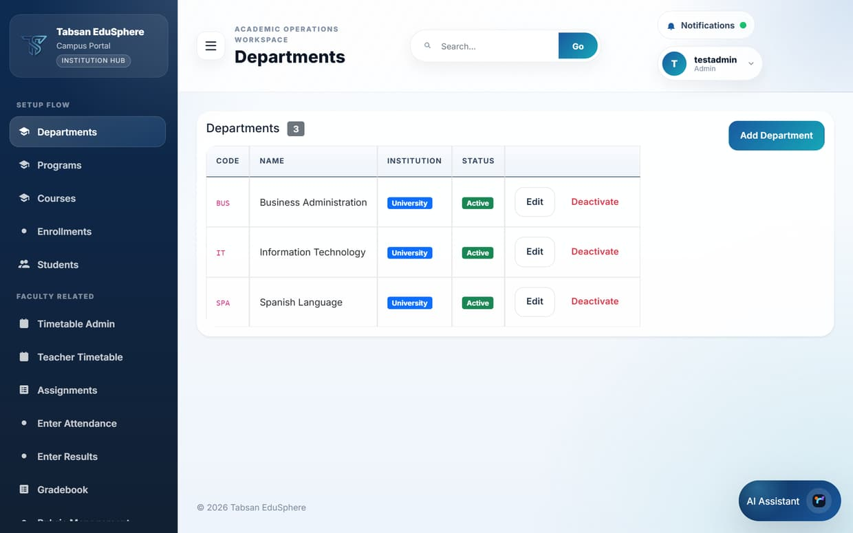
Figure 5.1 Departments list
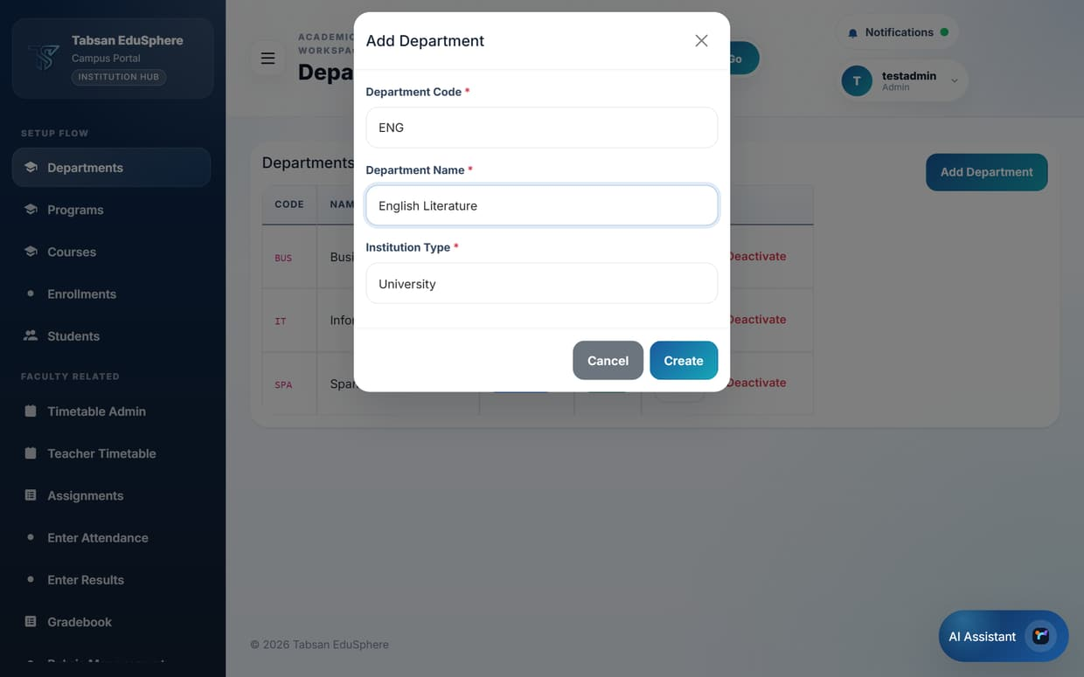
Figure 5.2 Add Department form completed

What happens next
The new department is immediately available in the Department filters across the portal. If you are an Admin, it is assigned to you automatically so you can manage it straight away.
NOTE SuperAdmin also sees tenant and campus filters and the Admin Department Assignments panel, which controls which Admin users manage each department.

5.2 Programs
Available to: SuperAdmin, Admin, Faculty (view)
A program is a degree or course of study offered by a department, for example Bachelor of Science in Computer Science. Students are admitted to a program, and the program decides how many levels (semesters or classes) they study.

Before you start
- The department the program belongs to must already exist.

Procedure
- Open Programs.
- In Create Program, enter the Code and Name, choose the Department, and set Total Levels.
- Click Create. The program appears in the Program List.
- Use Filter by Department to narrow the list. Use Rename to correct a name and Deactivate to retire a program.

Fields and options
Field | What to enter or choose
Code | A short code, for example BSCS.
Name | The full program name as it should appear on certificates and transcripts.
Department | The department that runs the program.
Total Levels | The number of semesters (University) or classes (School and College). Students graduate after completing the last level.

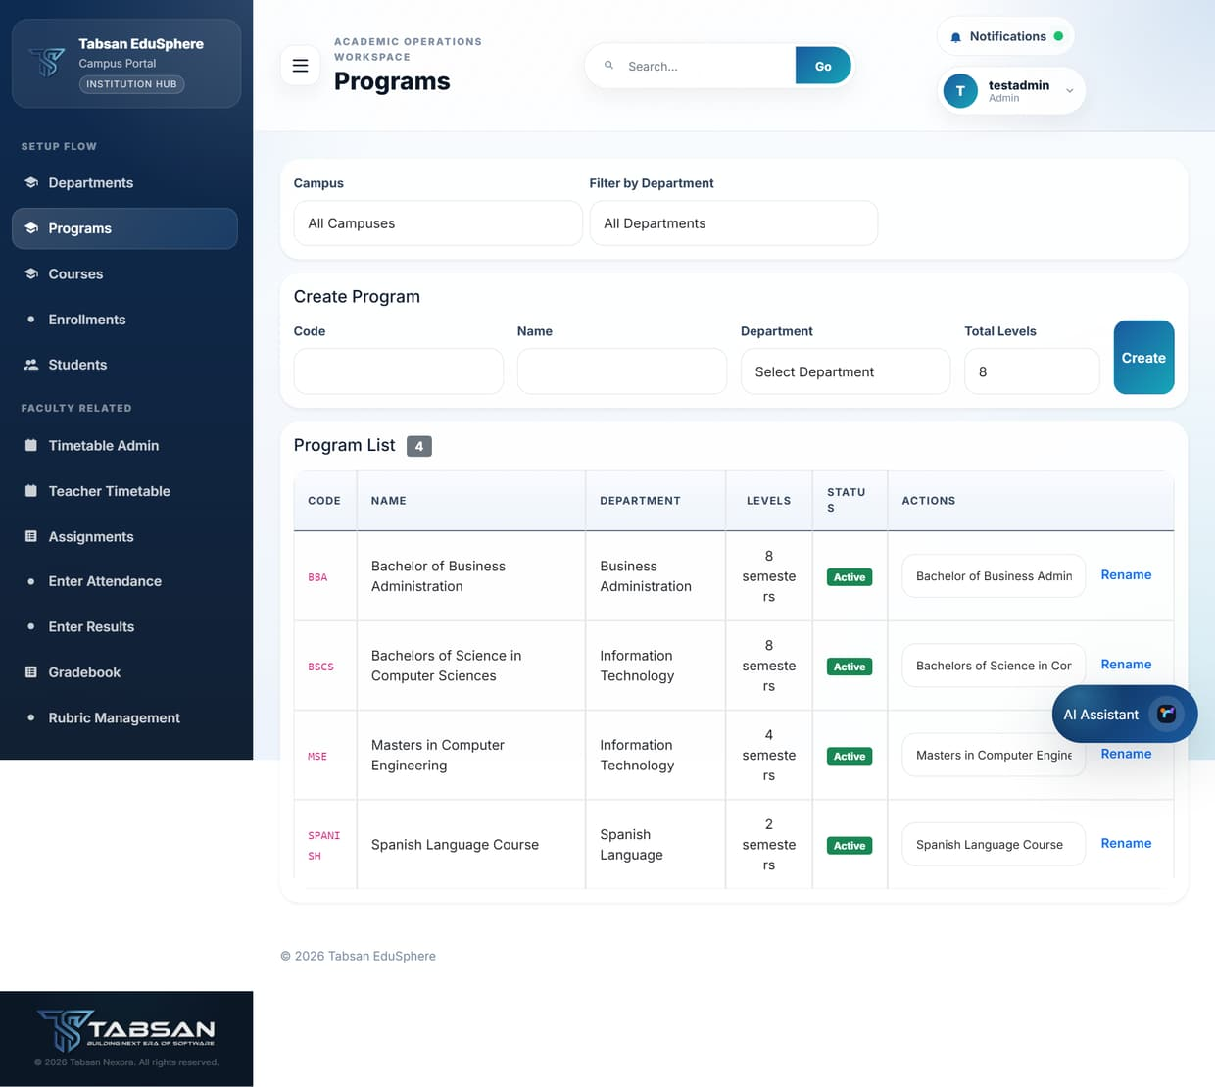
Figure 5.3 Programs page

Good to know
- A University program usually needs a degree rule before students can be audited for graduation (see Degree Rules).

5.3 Courses and offerings
Available to: SuperAdmin, Admin, Faculty (view)
A course is a subject, such as CS101 Introduction to Programming, with its credit hours and grading type. An offering is that course being taught in a particular semester or class, usually by one teacher. Students enrol in offerings, attendance is taken per offering, and marks are entered per offering.
The page has two parts: the course catalogue on the left and the active offerings on the right.

Before you start
- The department exists, and for offerings the teacher has a Faculty account.

Procedure
- Open Courses, choose the Department in the scope filter and click Apply Scope.
- To add a course, click Add Course, complete the form and save.
- To teach a course this term, create an offering: choose the Course, optionally the Faculty member and the Max Enrollment, and save.
- When teaching finishes, switch the offering Off so it no longer accepts enrolments.

Fields and options
Field | What to enter or choose
Course Code / Course Title | The subject code and full title, for example CS101 / Introduction to Programming.
Credit Hours | The credit value used for GPA and degree audits.
Grading Type | How the course is graded (for example by marks and grades).
This course is semester-based | Tick for normal semester courses. Untick for courses that run over several semesters, then set the Number of Semesters or a Duration.
Faculty (offering) | The teacher responsible for the offering. They will see it in their classes. Optional; it can be added later.
Max Enrollment (offering) | The largest number of students who can enrol. Further students are placed on a waiting list.

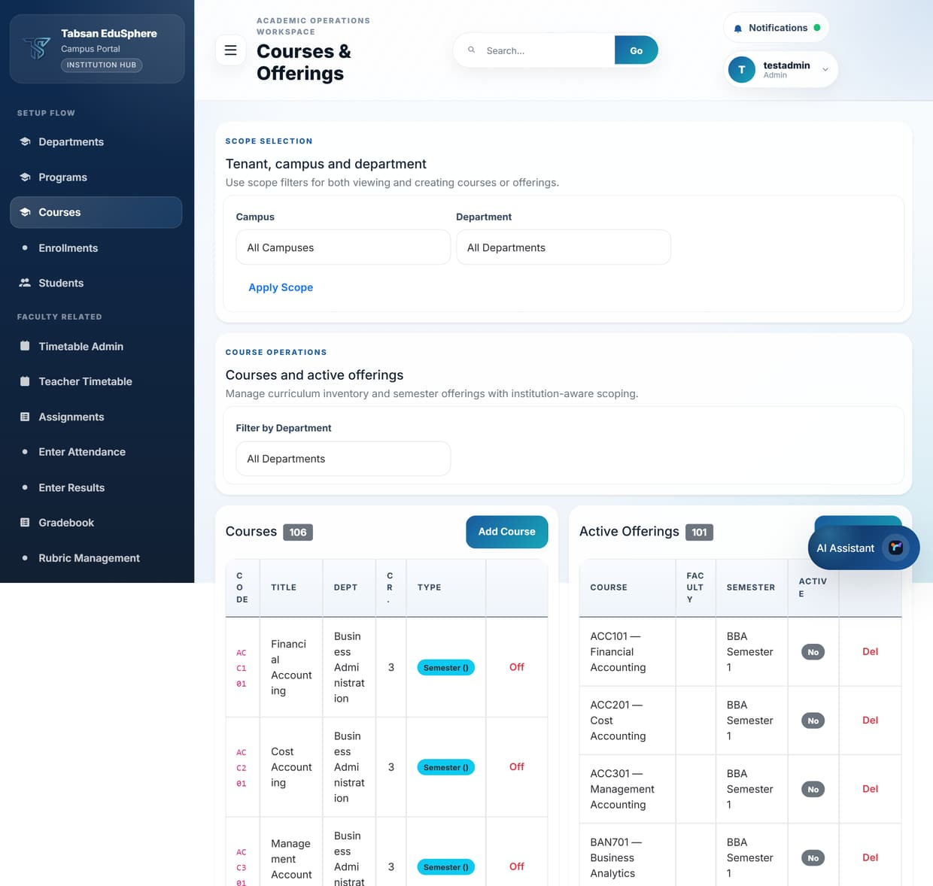
Figure 5.4 Courses and active offerings

Good to know
- Mark a course as core or elective where the option is shown; degree audits count core and elective credits separately.

5.4 Enrollments
Available to: SuperAdmin, Admin, Faculty (view)
Enrollments connect students to the offerings they are taking. A student must be enrolled in an offering to appear in its attendance sheet, mark sheet and gradebook.

Before you start
- The offering exists and the student has a student profile (created in User Import).

Procedure
- Open Enrollments.
- Choose an offering in Select Course Offering. The Enrollment Roster lists the students already enrolled.
- Click Enroll Student, choose the student and click Enroll.
- To remove a student from the offering, click Drop and confirm.
- Admins can open or close enrolment for the whole tenant/campus with Deactivate Enrollment (and re-open it the same way).

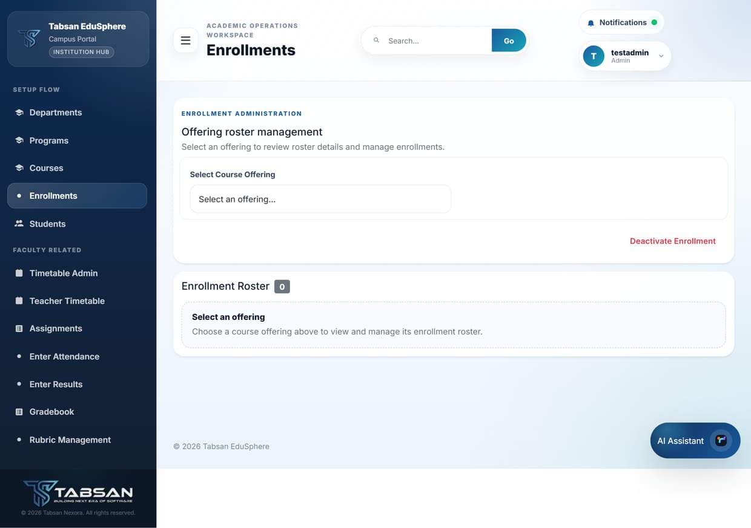
Figure 5.5 Enrollments page

Enrollment statuses
Status | Meaning
Active | The student is taking the offering.
Waitlisted | The offering was full; the student moves in automatically when a place becomes free.
Dropped | The student left the offering. History is kept.
Cancelled | The enrolment was cancelled by the institution.

NOTE Courses with prerequisites can only be enrolled in once the student has passed the prerequisite course (see Prerequisites).

5.5 Students
Available to: SuperAdmin, Admin, Faculty
The Students page is a searchable directory of student profiles. Each row shows the registration number, full name, department, program, current level and status.
Faculty see the students of the departments they teach; Admins see the students of their assigned departments.

Procedure
- Open Students.
- Choose a Department to filter the list.
- Scan or search the list. The number beside Student List shows how many students match.

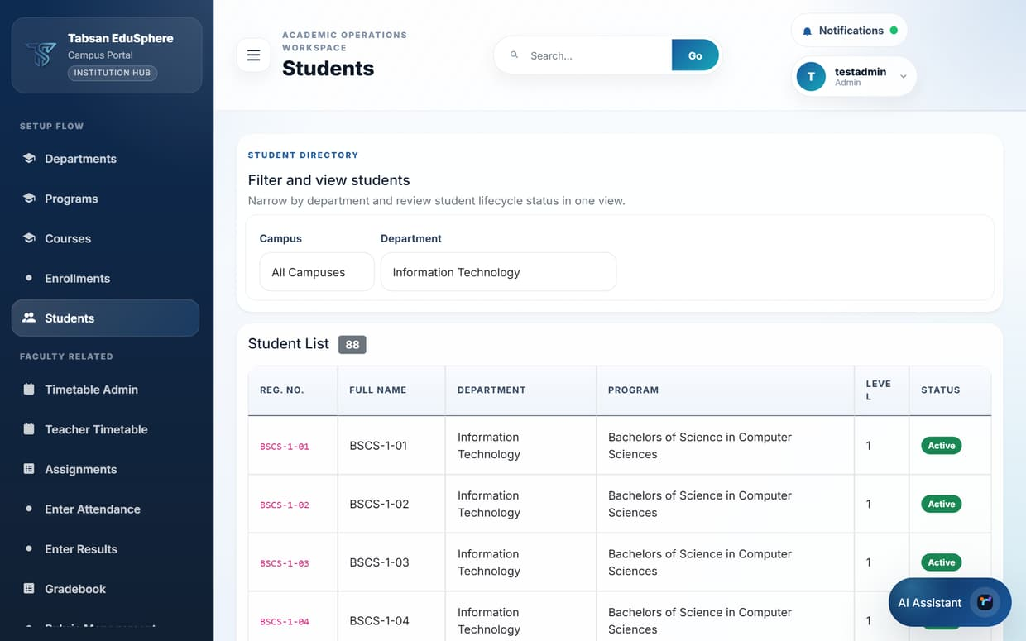
Figure 5.6 Student list filtered by department

Student statuses
Status | Meaning
Active | Currently studying.
Inactive | Studies paused or the account was deactivated.
Graduated | Completed the program. Graduated students keep read access to their records.

TIP New students are added through User Import (single user or CSV). Promotion between semesters is handled in Student Lifecycle.

6 Timetables and Facilities
Timetables tell teachers and students when and where each class happens. Buildings and rooms are set up first so they can be chosen when timetable entries are added.

6.1 Buildings and rooms
Available to: SuperAdmin, Admin
Buildings and rooms describe where classes take place. They are used when adding timetable entries, so rooms show correctly on teacher and student timetables.

Procedure
- Open Buildings. Under Add Building, enter the Name and Code and click Create.
- To rename a building or switch it off, click its name in the list; an edit panel opens with Save and Deactivate.
- Open Rooms (or click Rooms next to a building). Choose the building, enter the Room Number and optional Capacity, and click Create.

Fields and options
Field | What to enter or choose
Building Name / Code | For example Faculty Block A / FBA. The code is shown on timetables, so keep it short.
Room Number | The room label, for example 101 or Lab 2.
Capacity | Optional. The number of seats, useful when planning large classes.

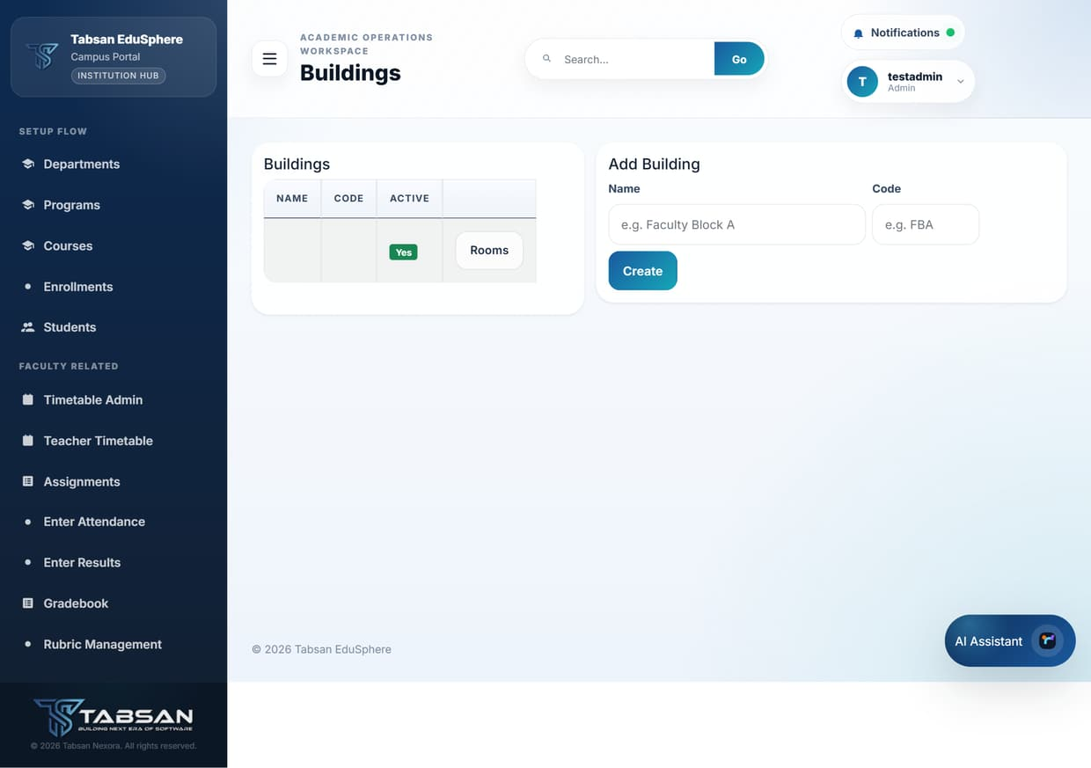
Figure 6.1 Buildings
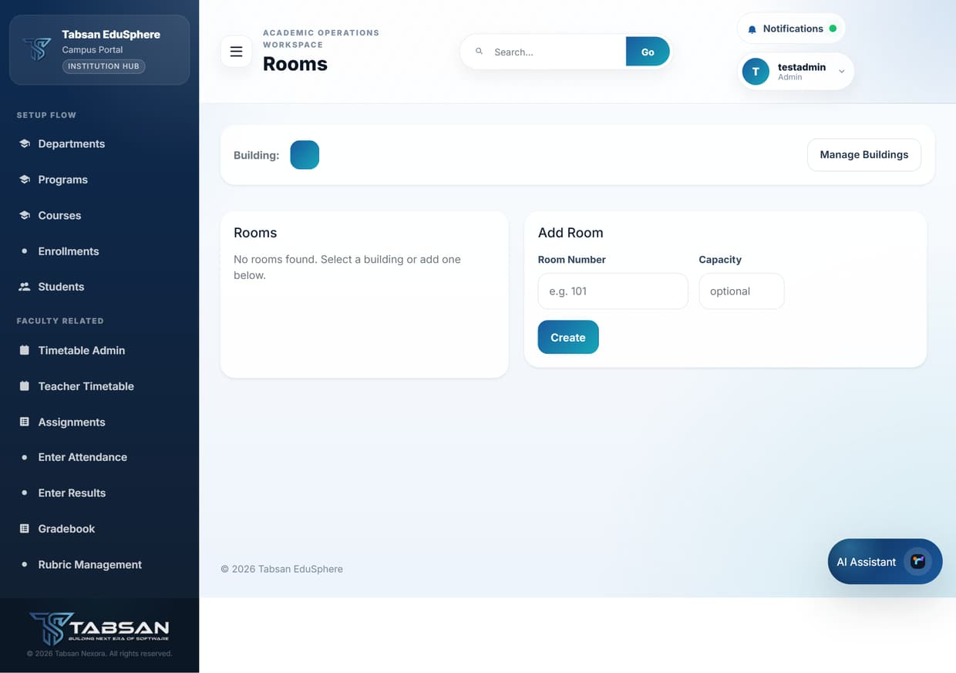
Figure 6.2 Rooms

6.2 Timetable Admin
Available to: SuperAdmin, Admin
Timetable Admin builds the weekly class timetable for each program level, for example "7th Semester of BBA". A timetable has an effective date and a list of entries; each entry is one class on one day.

Before you start
- The program, its courses, the teachers and the rooms already exist.

Procedure
- Open Timetable Admin and set the Scope Selection (campus and department), then click Apply Scope.
- Under Create Timetable, choose the Degree Program, Semester and Semester Number, set the Effective Date, and click Create Timetable.
- Select the new timetable in Available Timetables.
- Under Add Entry, choose the Day, Start and End time, Subject, Teacher, Building and Room, then click Add Entry.
- Repeat for every class in the week. The entries appear in a table ordered by day and time.
- Publish the timetable so that students can see it in Student Timetable.

Fields and options
Field | What to enter or choose
Effective Date | The date from which the timetable applies. Create a new timetable when the schedule changes, rather than editing an old one, to keep history.
Subject (Fallback) / Room (Fallback) | Free-text alternatives for a subject or room that is not in the lists, for example "Sports Ground".

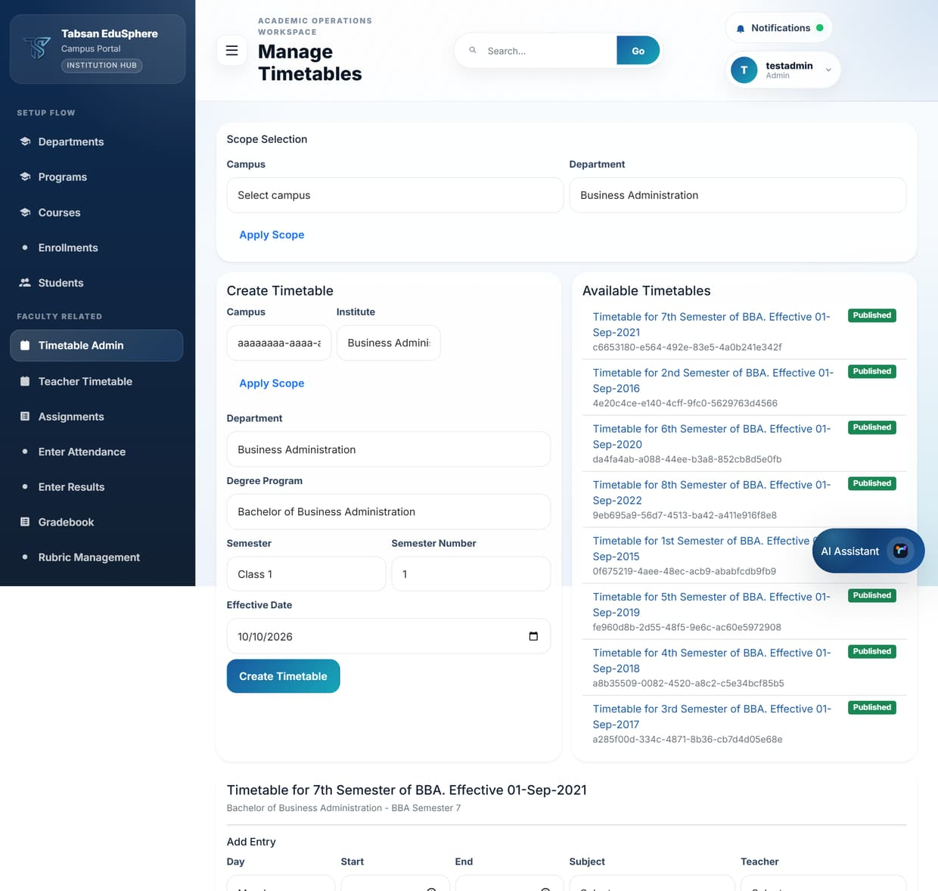
Figure 6.3 Timetable Admin
NOTE SuperAdmin must select both a tenant and a campus before creating or editing entries.

6.3 Teacher Timetable
Available to: SuperAdmin, Admin, Faculty
Teacher Timetable shows every class assigned to one teacher across all published timetables, so a teacher can see their whole week in one place.
Faculty see their own timetable straight away. Admins choose a Faculty member and click Apply. Tick Show deactivated to include timetables that are no longer in use.
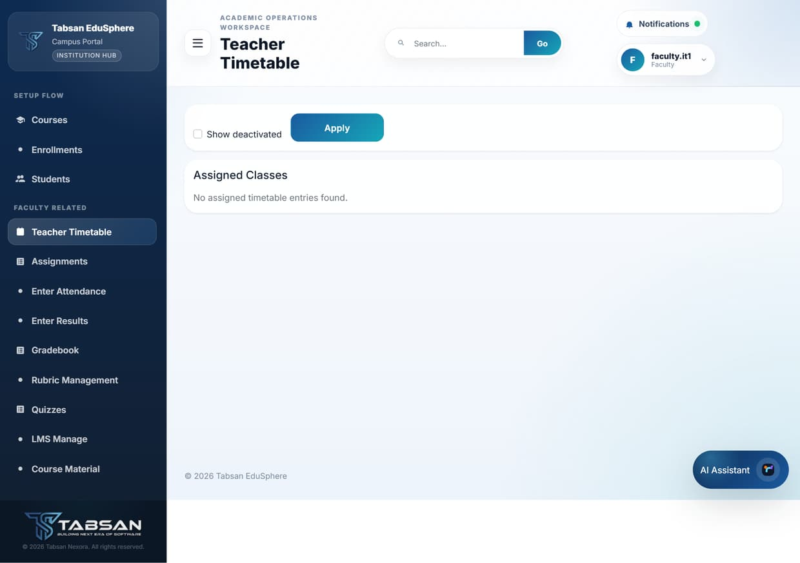
Figure 6.4 Teacher Timetable (Faculty view)

6.4 Student Timetable
Available to: Student
Students see the published timetables for their own department. Choose a Timetable and, if you only want one day, a Day Filter, then click Apply. Each row shows the day, time, subject, teacher, building and room.
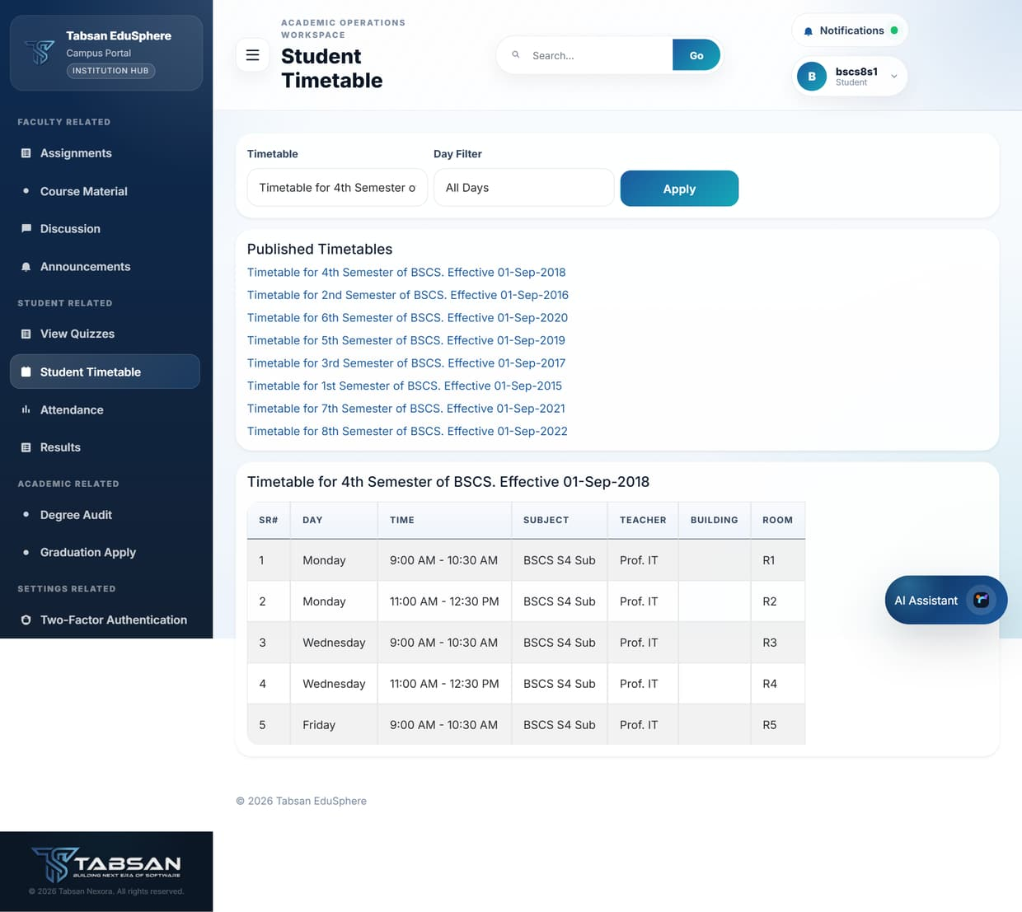
Figure 6.5 Student Timetable

Good to know
- If no timetable appears, it may not be published yet. Check with your department office.

7 Teaching and Learning
This chapter covers the pages teachers use every week and what students see on the other side: assignments, attendance, marks, quizzes, course content, discussions and announcements.

7.1 Assignments
Available to: SuperAdmin, Admin, Faculty, Student
Assignments are pieces of coursework set for an offering. Teachers create and publish them, students submit text and/or a file before the due date, and teachers grade each submission with marks and feedback.

Procedure
- Open Assignments and choose the department and offering.
- Faculty: create an assignment with a Title, Description, Due Date and Max Marks, then publish it so students can see it.
- Students: open the assignment, type notes in Text Submission and/or choose a file in Upload File, and submit before the due date.
- Faculty: open the assignment to review submissions. For each student enter Marks Awarded and Feedback, and save.
- Tick Show inactive assignments to see assignments that have been retired.

Fields and options
Field | What to enter or choose
Title / Description | What the students must do. Include any length, format or referencing requirements in the description.
Due Date | The deadline shown to students.
Max Marks | The highest mark available; used to calculate percentages and grades.

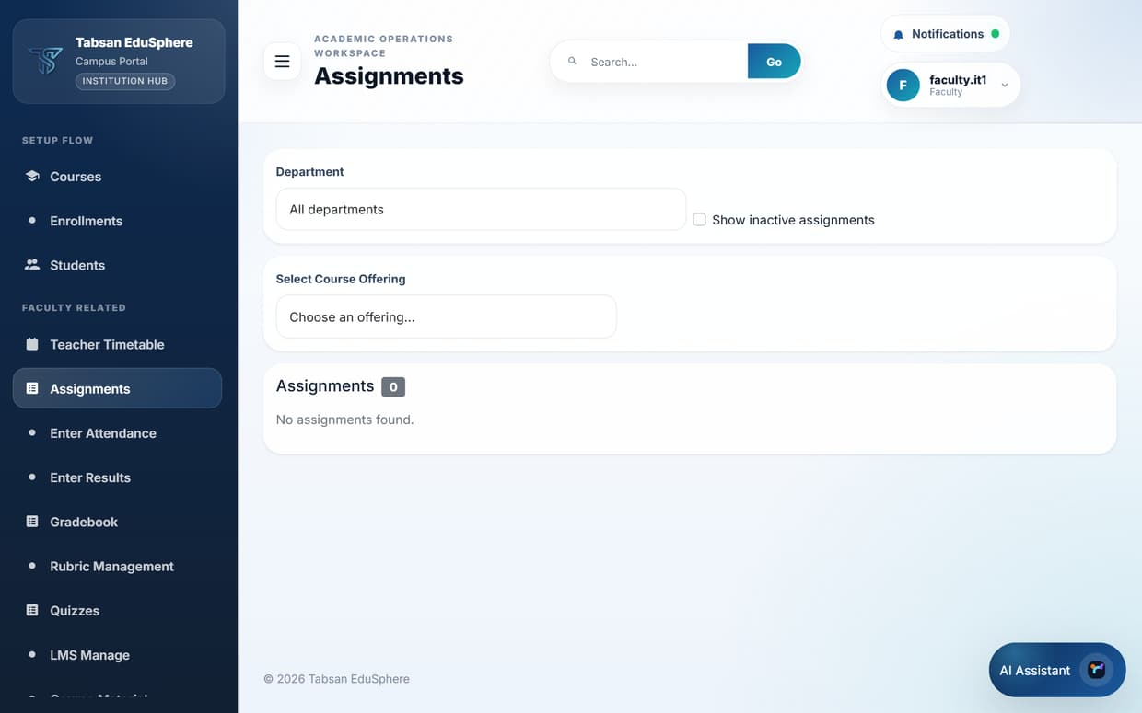
Figure 7.1 Assignments (Faculty)
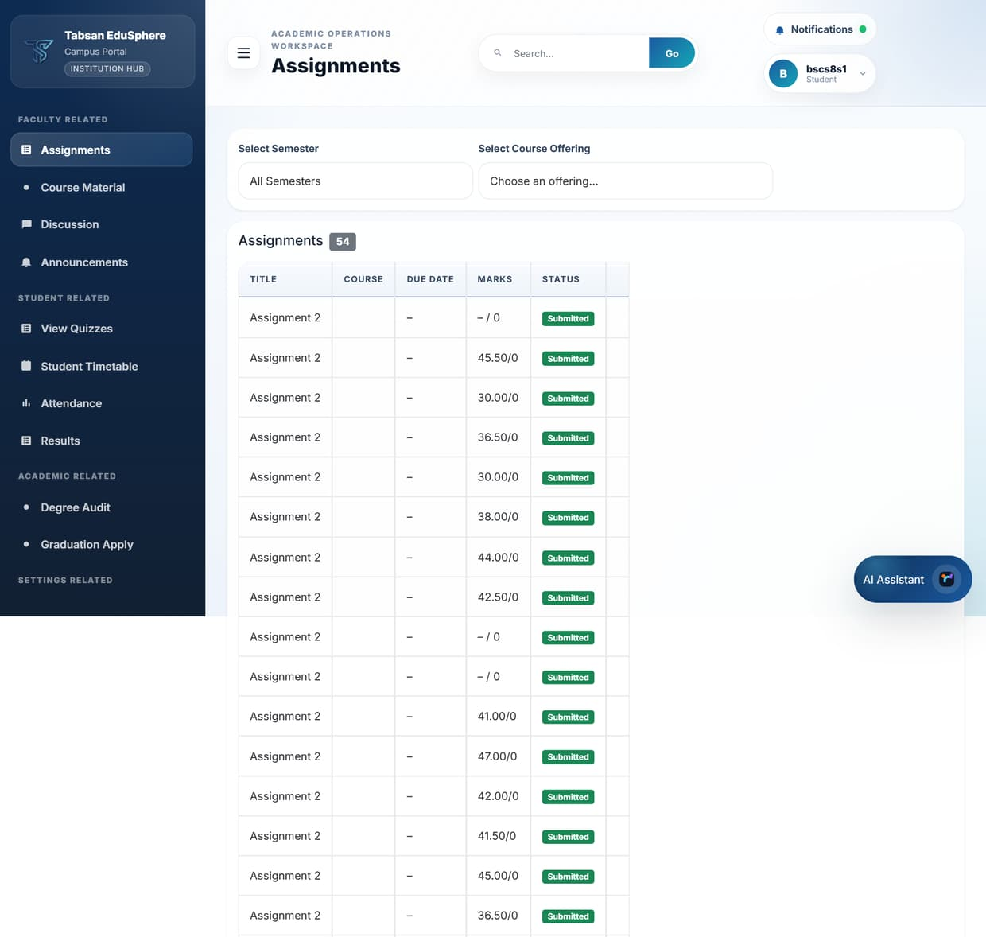
Figure 7.2 Assignments (Student view)

Submission statuses
Status | Meaning
Submitted | The student has handed in work; waiting for grading.
Graded | Marks and feedback are available to the student.
Rejected | The teacher returned the submission; the student should follow the feedback.

7.2 Entering attendance
Available to: SuperAdmin, Admin, Faculty
Attendance is recorded for each offering and each class date. Teachers usually record it at the end of every class. The page also shows a running summary for the offering.

Before you start
- Students must be enrolled in the offering to appear in the attendance table.

Procedure
- Open Enter Attendance.
- Choose the Department.
- Choose the Course (program).
- Choose the offering in Select Course Offering. The Attendance Summary and the Attendance Entry Table load.
- In the entry table, tick Present for each student who attended (untick for absent) and click Save Attendance.
- To load a whole class at once, click Get Template, fill in the CSV in a spreadsheet, and use Import Attendance. Tick Strict mode to reject the whole file if any row is invalid.

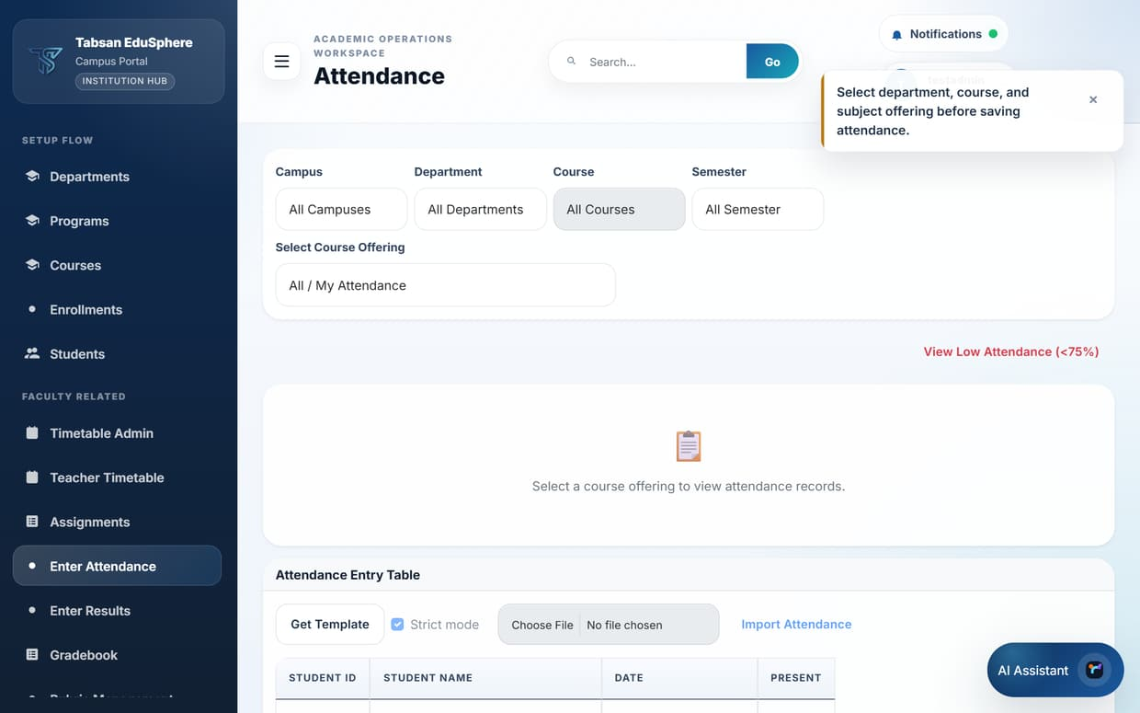
Figure 7.3 Enter Attendance – scope filters
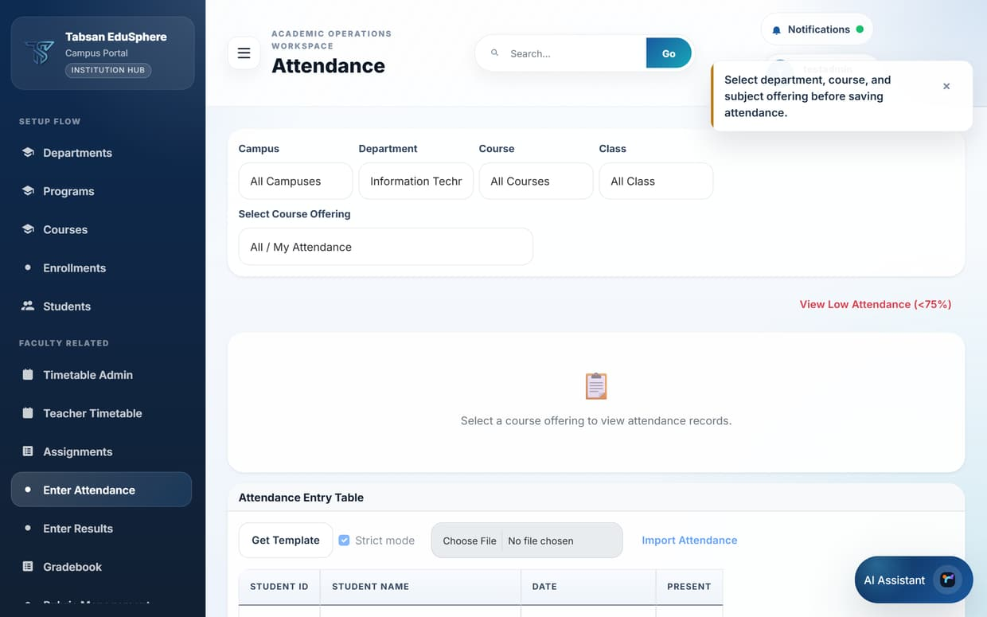
Figure 7.4 Step 1: department selected
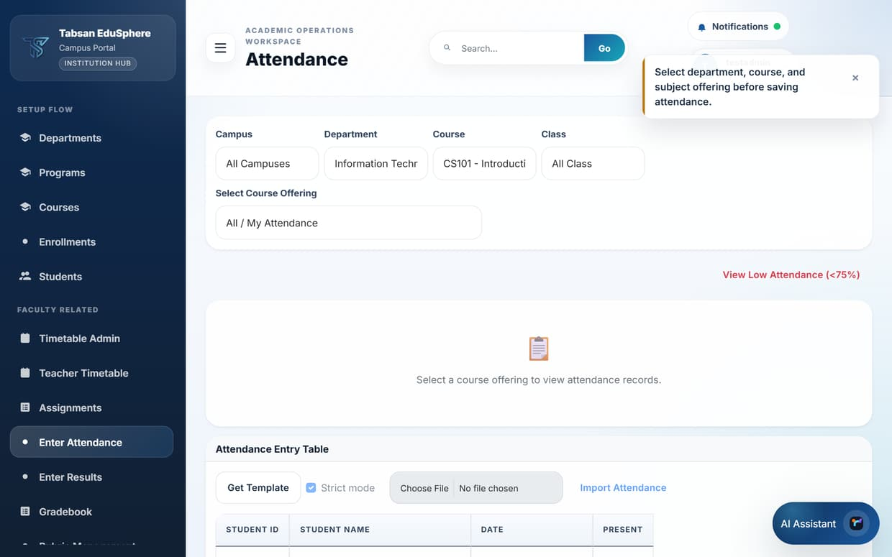
Figure 7.5 Step 2: course selected
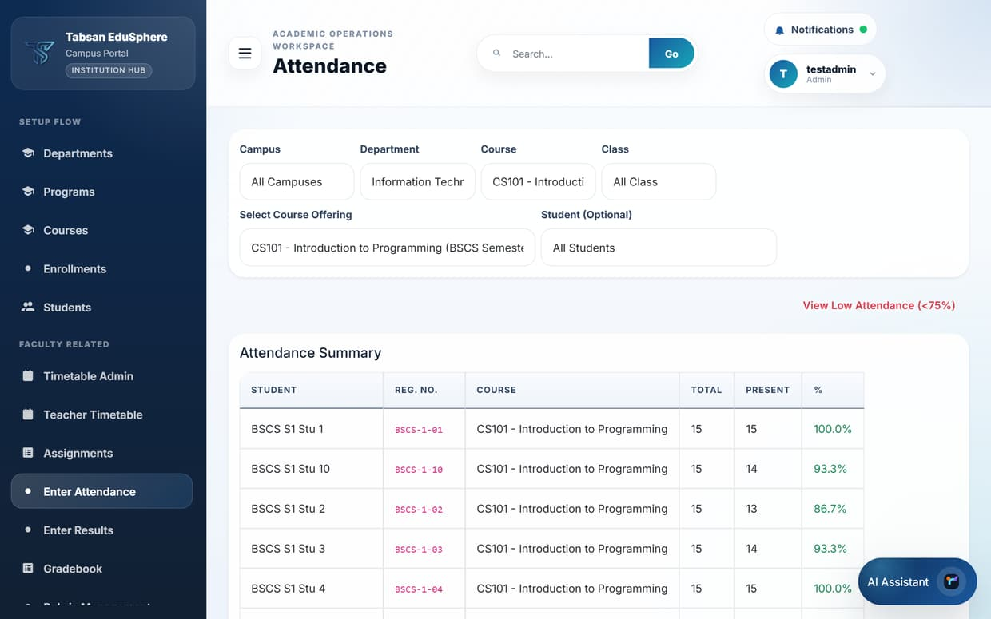
Figure 7.6 Step 3: offering selected – attendance summary per student

Attendance statuses
Status | Meaning
Present | Attended the class.
Late | Attended but arrived late. Counts as present in percentages.
Absent | Did not attend.
Excused | Absent with permission.

Good to know
- Click View Low Attendance (<75%) to list students below the attendance threshold so you can follow up early.
- Mistakes can be corrected later; corrections are recorded in the audit log.

7.3 Viewing attendance
Available to: Faculty, Student
The Attendance page shows totals and percentages. Students see one row per course with the number of classes held, the number attended and the percentage, coloured green (75% or more), amber (50–75%) or red (below 50%).
A separate Low Attendance (<75%) list shows any courses where the student is below the threshold.
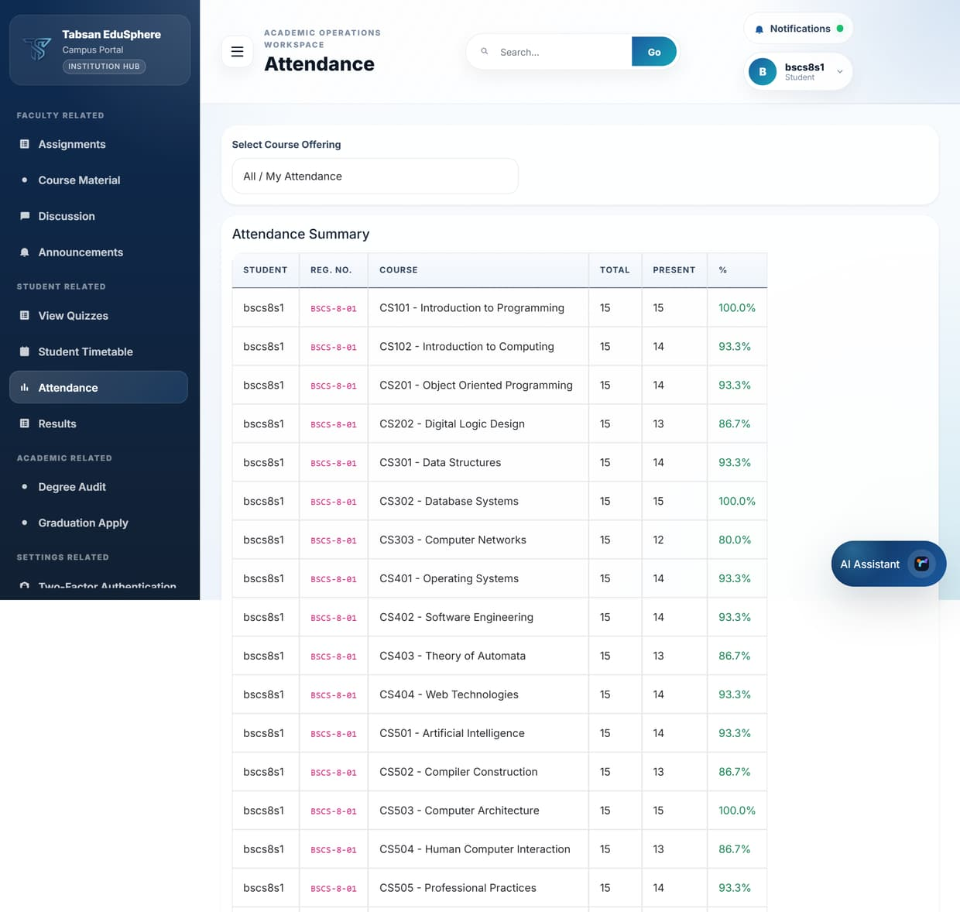
Figure 7.7 Attendance (Student view)
IMPORTANT Many institutions require at least 75% attendance to sit final exams. Students should contact their teacher early if their percentage is low.

7.4 Entering results
Available to: SuperAdmin, Admin, Faculty
Marks are entered per subject and exam type, for example the Midterm of CS101. The page requires the department, program, subject and exam type to be chosen first, so that marks are always stored against the right assessment.
Results stay private until they are published. After publishing, students can see them immediately.

Before you start
- Students are enrolled in the offering, and Result Calculation is set up so marks can be turned into grades.

Procedure
- Open Enter Results and choose the Department.
- Choose the Program/Course.
- Choose the Subject.
- Choose the Exam Type and click Apply.
- Click + Enter Result, choose the Student, enter Marks Obtained and Max Marks, and save. Repeat for each student, or download the CSV with Get Template, fill it in and upload it with Import Results.
- Review the Result Entry Grid. When it is correct, click Publish All to release the results to students.
- Use Export CSV or Export PDF to keep a copy.

Fields and options
Field | What to enter or choose
Exam Type | The assessment: Midterm, Final, Quiz, Assignment, Practical, Theory or Internal.
Marks Obtained / Max Marks | The student's mark and the highest possible mark. The grade is calculated automatically.
strict (import) | When ticked, the whole file is rejected if any row has a problem, so you never get a half-imported mark sheet.

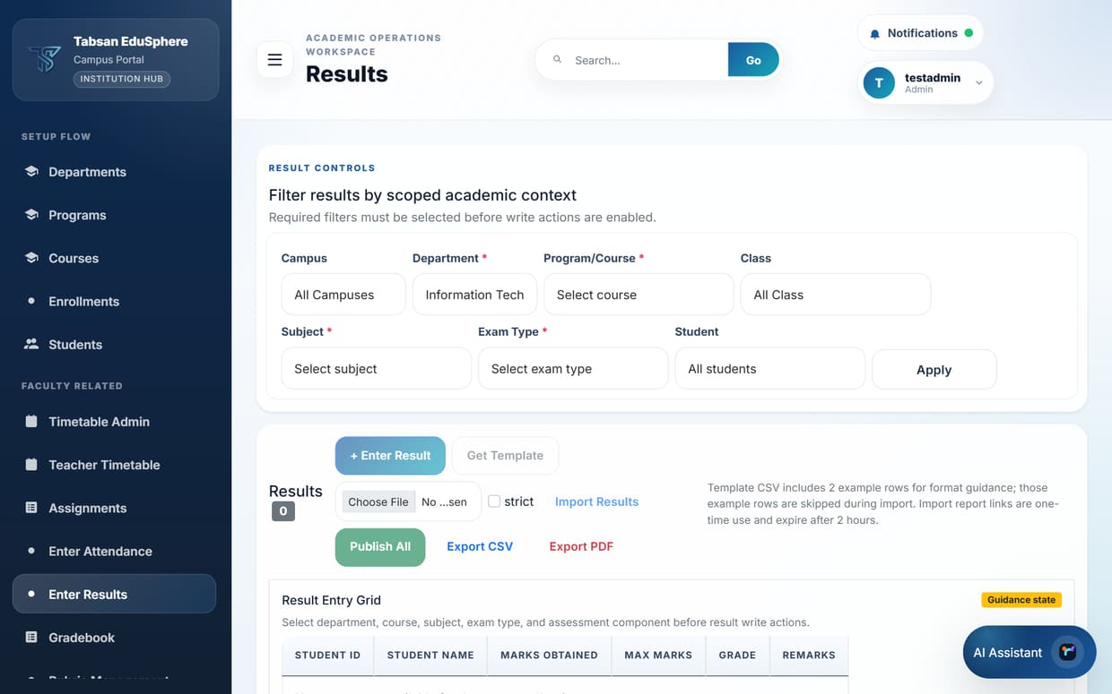
Figure 7.8 Step 1: department
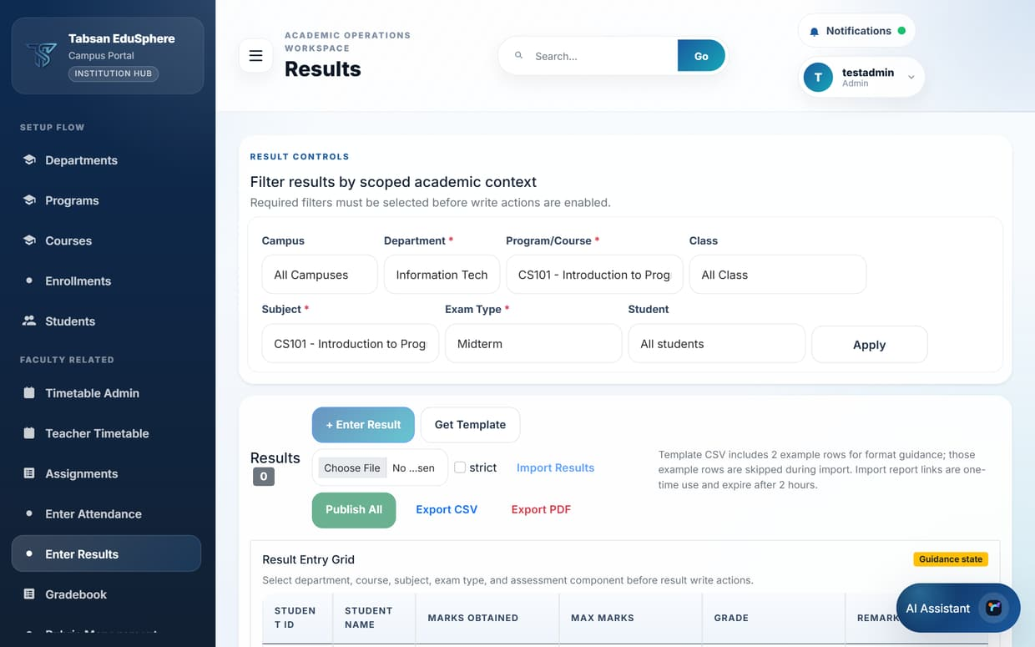
Figure 7.9 Steps 2–4: program, subject and exam type applied; the Result Entry Grid

What happens next
Published marks appear on the student's Results page, in the Gradebook and in result reports. The student's semester GPA and CGPA (University) or percentage (School and College) are recalculated.
To change a published mark, a teacher submits a modification request with the proposed marks and a reason; an Admin approves or rejects it. Every change is recorded in the audit log.
IMPORTANT Check marks carefully before clicking Publish All. Students are notified and can see published results straight away.

7.5 Gradebook
Available to: SuperAdmin, Admin, Faculty
The Gradebook shows every student's marks for every assessment of one offering in a single grid, so a teacher can see the whole class at a glance and spot missing marks.
Choose a Course Offering to load the grid. You can also upload marks in bulk from a CSV file, review the preview, confirm it, and publish all marks for the offering.
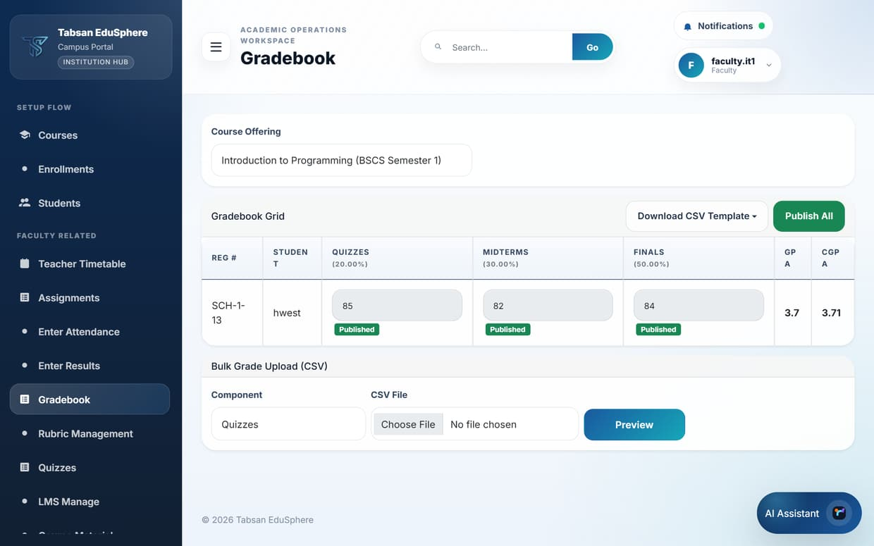
Figure 7.10 Gradebook for a course offering

7.6 Rubric Management
Available to: SuperAdmin, Admin, Faculty
A rubric is a marking guide: a list of criteria (for example Content, Structure, Referencing) and the performance levels for each, with points. Rubrics make grading fair and consistent and help students understand how they will be assessed.
Choose a Course Offering, enter a Rubric Title, then add the criteria and levels with their points. Rubrics are used when grading assignments.
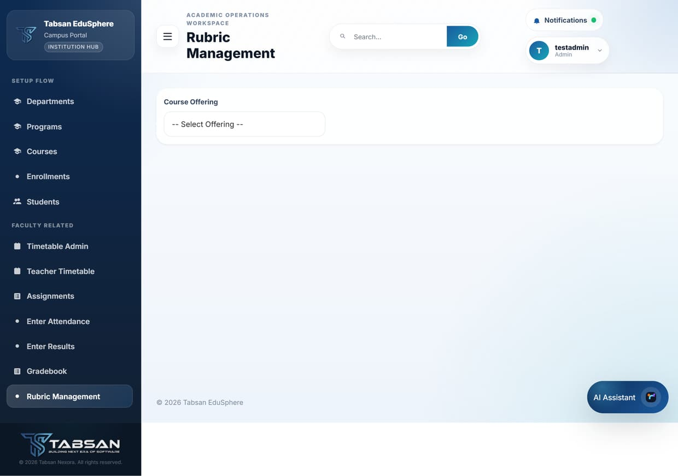
Figure 7.11 Rubric Management

7.7 Quizzes
Available to: SuperAdmin, Faculty; Students take quizzes in View Quizzes
Quizzes are short assessments for an offering. Teachers create them with instructions, an optional time limit and a maximum number of attempts, then publish them. Students see published quizzes in View Quizzes, prepare their answers and upload them as a file before the last date.

Procedure
- Faculty: open Quizzes and choose the offering in Select Course Offering.
- Create a quiz with a Title, Instructions (the questions or what to answer), Time Limit (minutes) and Max Attempts.
- Click Publish when it is ready. Use Deactivate to close it early, or Delete to remove a quiz that was created by mistake.
- Students: open View Quizzes, read the instructions, attach your answer file and click Submit before the last date.

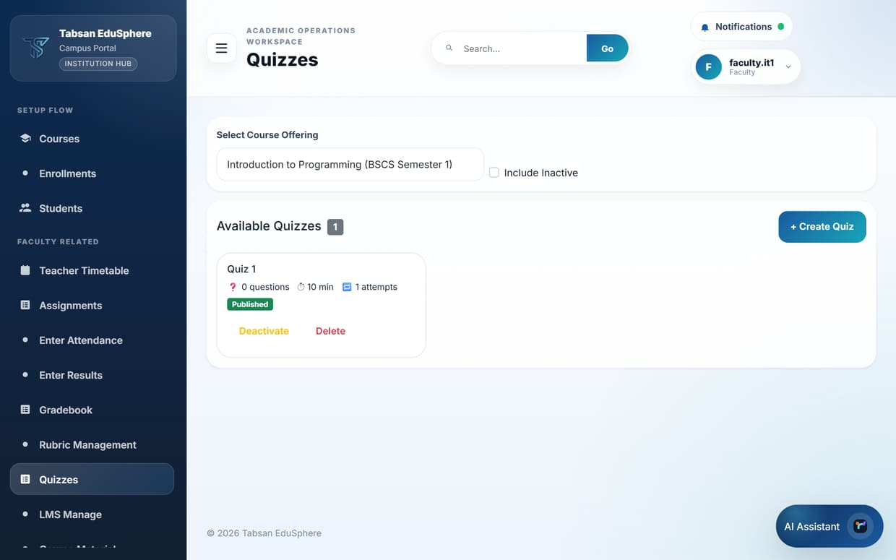
Figure 7.12 Quizzes (Faculty)
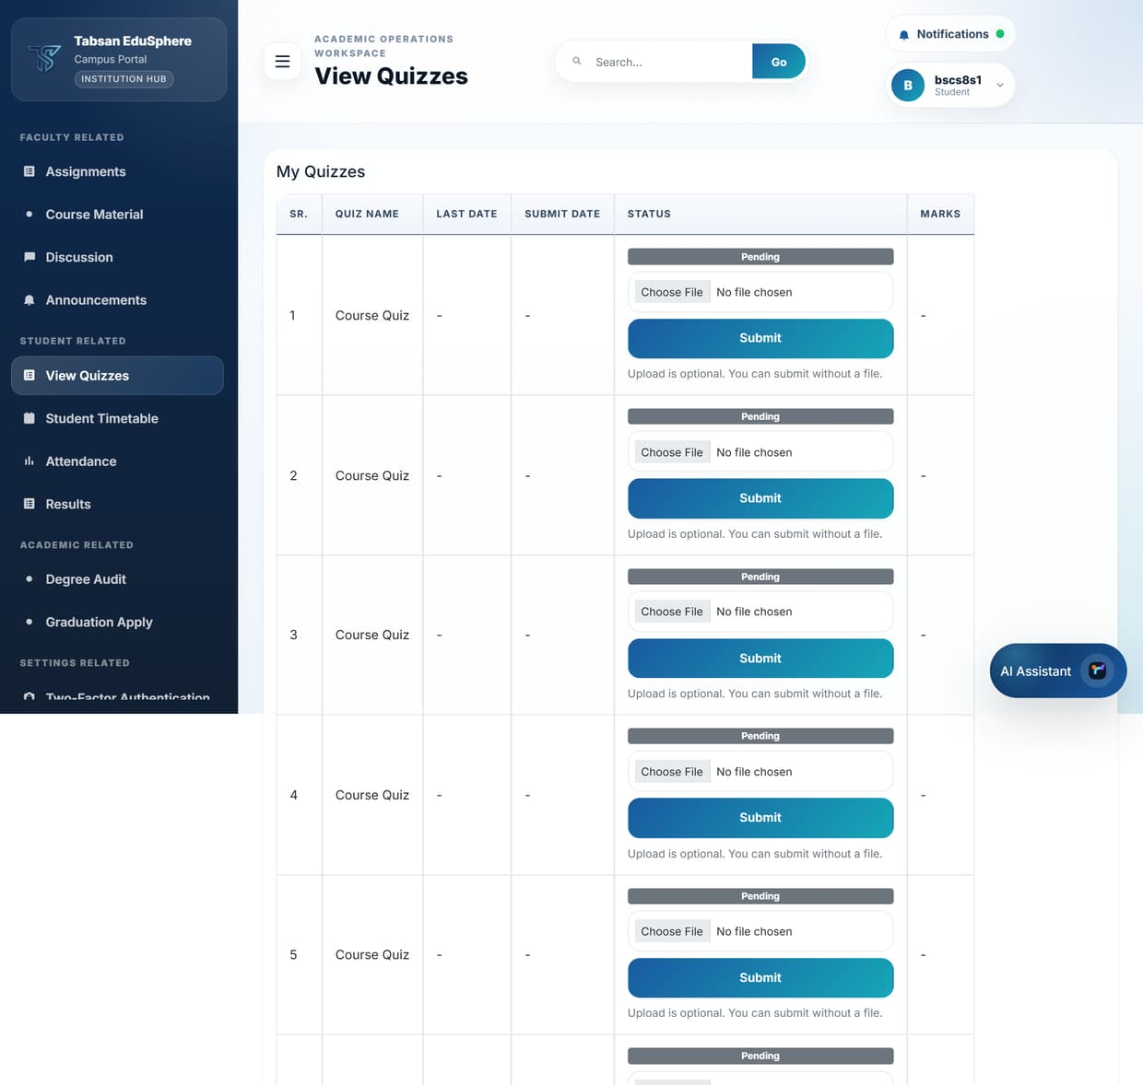
Figure 7.13 My Quizzes (Student)

Good to know
- Tick Include Inactive to see closed quizzes. Students see their marks once the quiz is graded.

7.8 LMS Manage
Available to: SuperAdmin, Admin, Faculty
LMS Manage builds online learning content for an offering, organised by week. Each module has a title, a week number and a body that can contain formatted text, links and embedded videos.

Procedure
- Open LMS Manage and choose the offering.
- Under Add New Module, enter the Title and Week #, and write the Body (HTML is allowed for headings, lists and links).
- Click Add Module. Add videos to a module where needed.
- Click Publish to make a module visible to students, or Unpublish to hide it again while you edit.

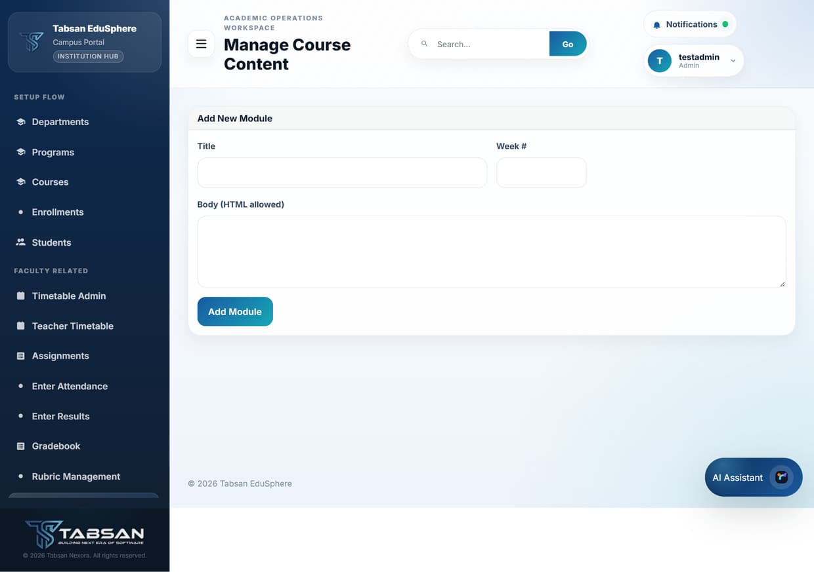
Figure 7.14 LMS Manage

7.9 Course Material
Available to: SuperAdmin, Admin, Faculty, Student
Course Material is a library of files and links for each subject: lecture slides, notes, past papers or useful websites. Teachers add material; students browse and download it.

Procedure
- Open Course Material and set the filters (department, program, semester, subject/course), then click Apply Filters.
- Click Add Material. Choose the Type, enter a Title and Description, and either upload a file or enter an External URL.
- Save. The material appears in the list for that subject.
- Untick Active only to see material that has been withdrawn, and use the row actions to edit or withdraw an item.

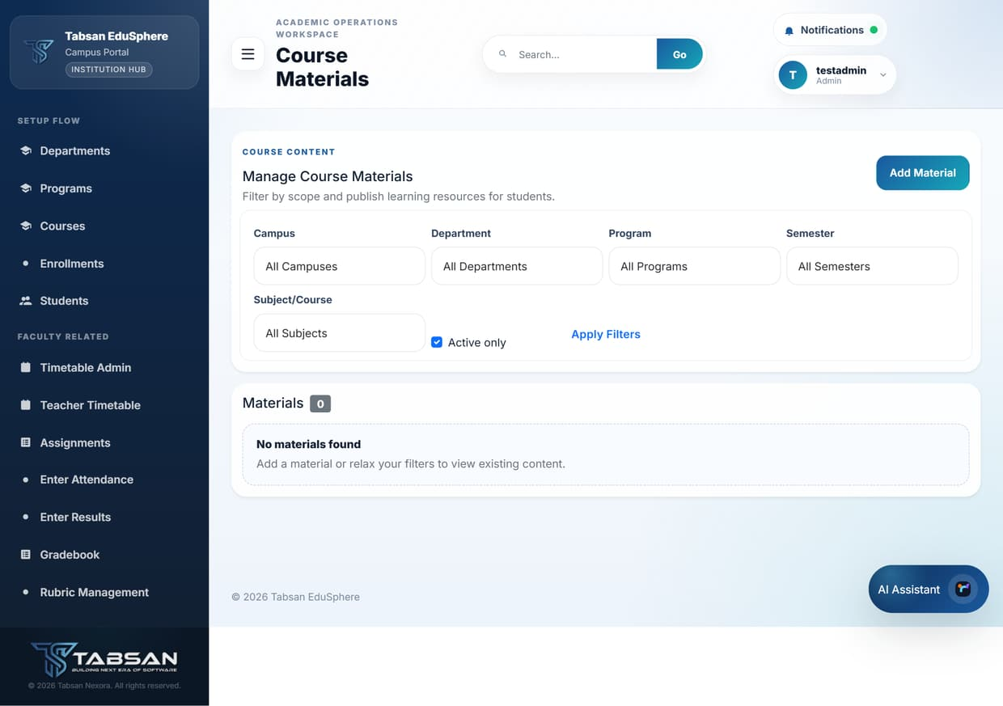
Figure 7.15 Manage Course Materials
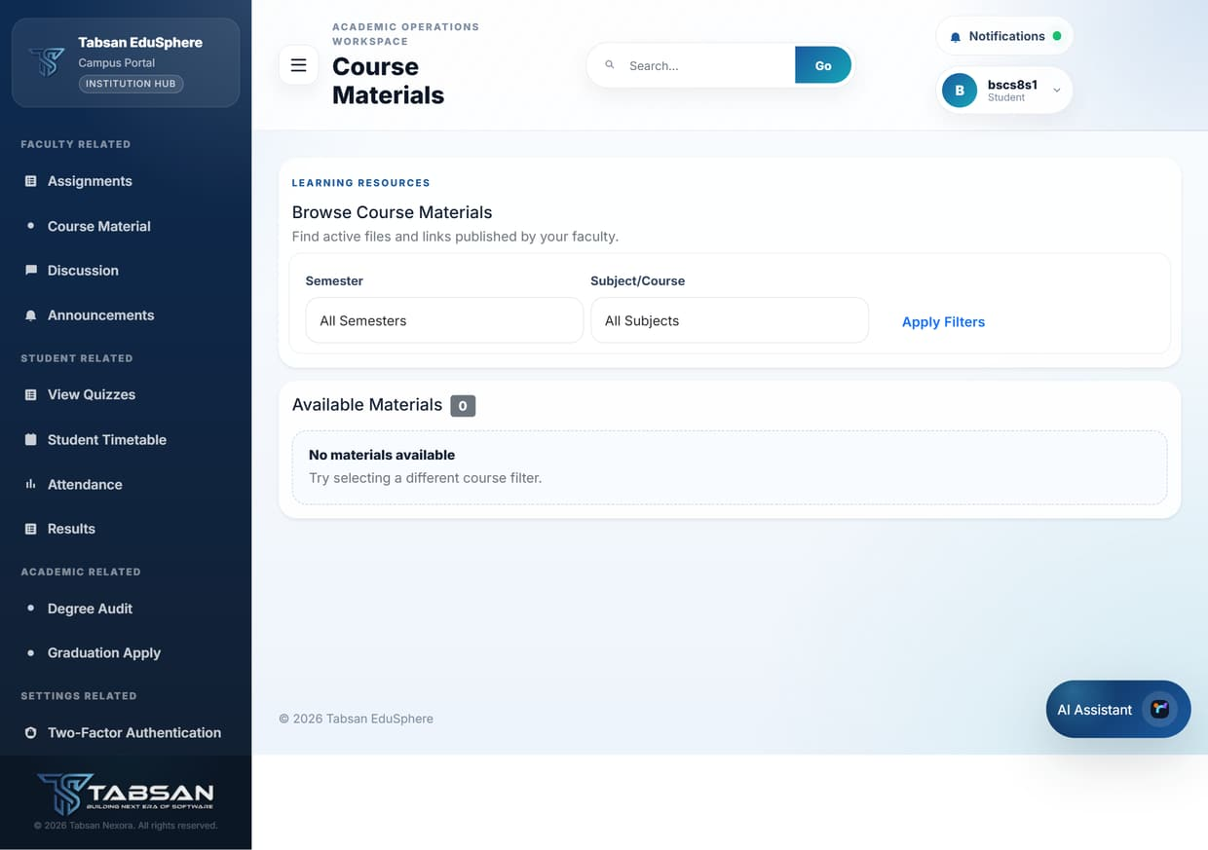
Figure 7.16 Browse Course Materials (Student)

Good to know
- Students see the material published for the subjects of their department; inactive material is hidden from them.

7.10 Discussion
Available to: SuperAdmin, Admin, Faculty, Student
Discussion is a question-and-answer board for each offering. Students can ask questions, classmates and teachers can reply, and a teacher can mark a thread as resolved once it has been answered, which helps others find the answer later.

Procedure
- Open Discussion and choose the offering.
- Under Start a New Thread, type your question and click Post.
- Open a thread to read the replies, add your own reply, or (teachers) mark it solved or unresolved.

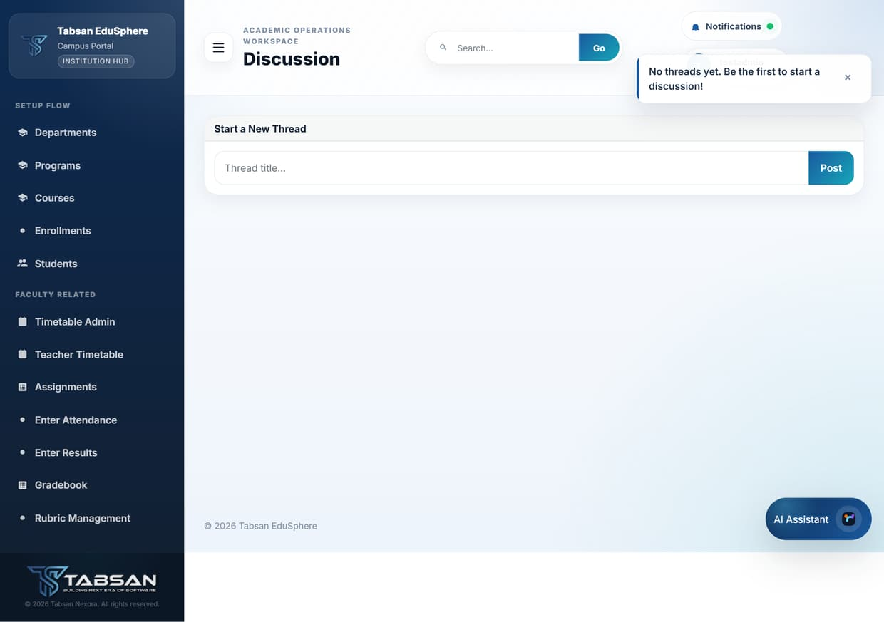
Figure 7.17 Discussion

7.11 Announcements
Available to: SuperAdmin, Admin, Faculty, Student
Announcements publish notices, such as a room change or an exam reminder, to a whole department or to a single course offering. Students see announcements for the courses they take.

Procedure
- Open Announcements.
- Choose a Department and, optionally, a Course Offering, then click Apply to see announcements in that scope.
- Staff: under Post Announcement, enter the title and message and click Post. With only a department chosen, the announcement goes to every offering in that department.
- Use Deactivate to hide an announcement without deleting it, or Delete to remove it permanently. Tick Show inactive to see hidden announcements.

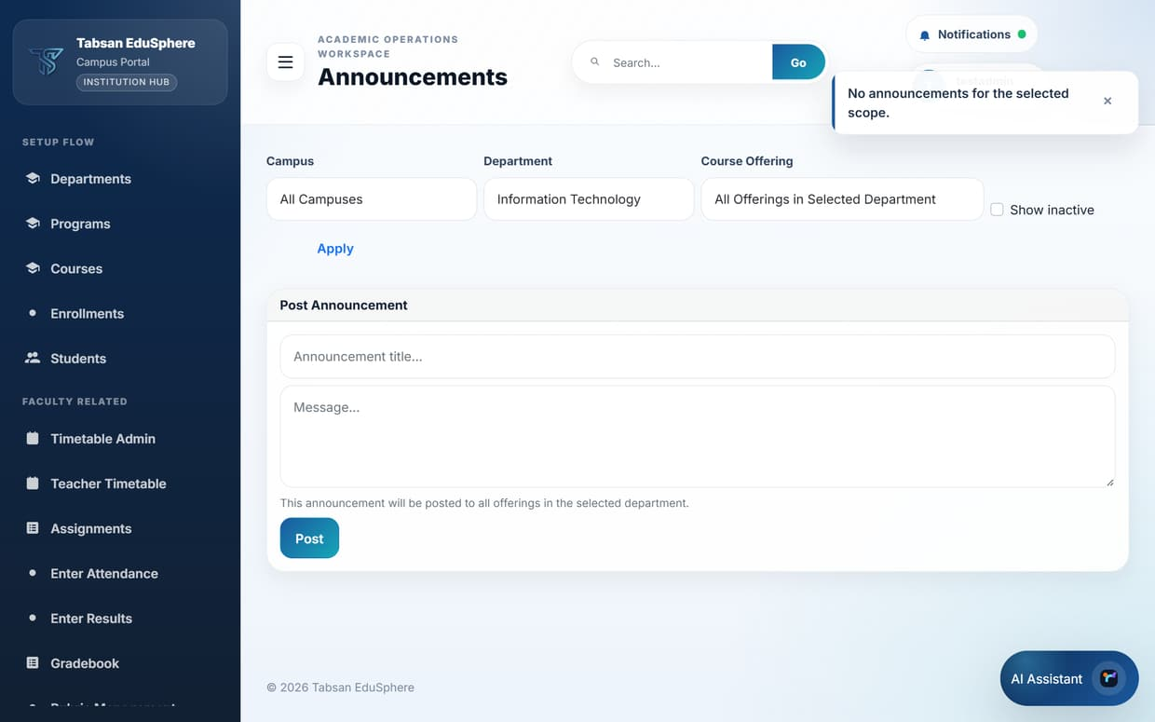
Figure 7.18 Announcements for a department
NOTE An announcement posted to a whole department reaches every course offering in it. It is listed once with an "N offerings" label, and Deactivate or Delete applies to all of those offerings together.

8 Results, Progression and Final Year Projects
This chapter covers how marks become grades, how students move from one level to the next, and how final year projects are run.

8.1 Results
Available to: SuperAdmin, Admin, Faculty, Student
The Results page shows published marks. Staff use the same filters as Enter Results to review a class. Students see only their own results, grouped by class or semester, with the mark, grade and publish date for each course.

Procedure
- Open Results. Students can choose a Class to narrow the list.
- Click Export CSV or Export PDF to download a copy of the results shown.
- Students: if you believe a mark is wrong, click Request Re-check on that result, give a Reason and submit.

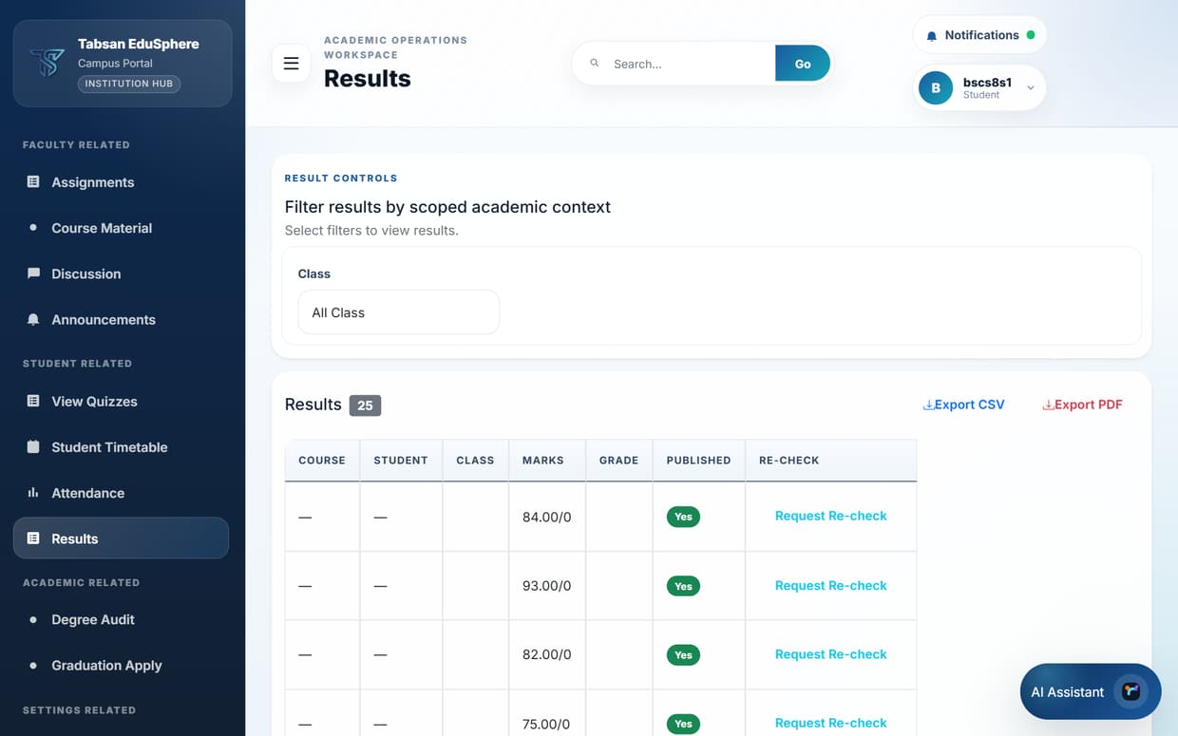
Figure 8.1 Results (Student view)

What happens next
The request is recorded as a change request for the administrators to review. If the mark is changed, the corrected result replaces the old one and the change is recorded in the audit log.

Good to know
- Results only appear after the teacher publishes them. An empty page usually means marks have not been published yet.

8.2 Result Calculation
Available to: SuperAdmin, Admin
Result Calculation tells the portal how to turn marks into grades and grade points. It has two sections: the score-to-GPA scale, and the weighting of each assessment within a subject.

Procedure
- In Section 1: GPA and Score, choose the Institute and add a row for each score band and its GPA value with Add Row (for example 85 and above = 4.0).
- In Section 2: Subject Score Calculation, choose the Course Type or a specific Course, and set the Weightage of each Component, for example Midterm 30%, Final 50%, Assignments 20%.
- Tick Active for the rows that should apply and click Save. Use X to remove a row.

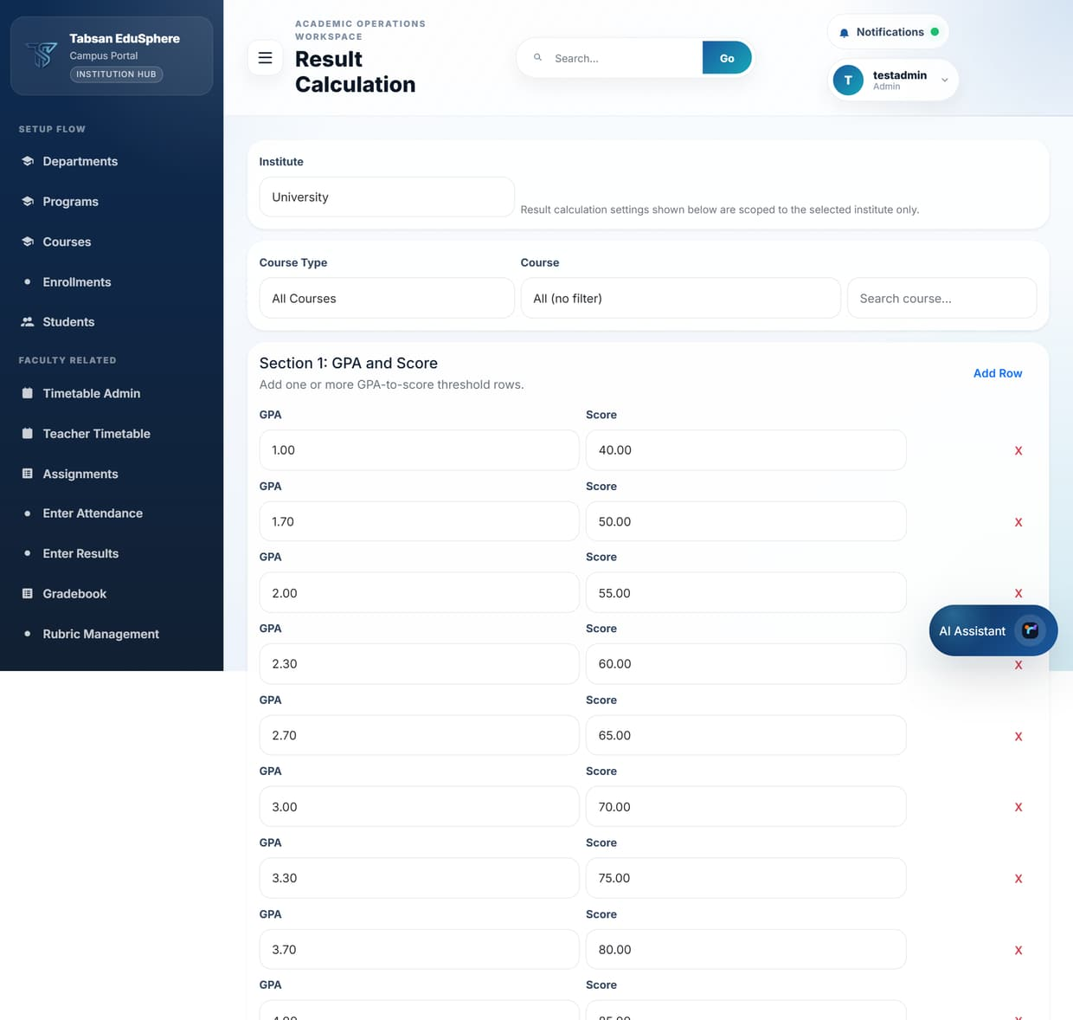
Figure 8.2 Result Calculation

Good to know
- Component weightings for a subject should add up to 100%.
- Change the rules before results are published for a term; changing them afterwards recalculates grades the next time results are processed.
NOTE University results use GPA scales. School and College results are percentage based and do not need GPA rows.

8.3 Grading Config
Available to: SuperAdmin (edit), Admin and Faculty (view)
Grading Config sets the pass threshold, and optionally the grade bands, separately for School, College and University. The pass threshold decides whether a student is eligible for promotion to the next level.

Procedure
- Choose the scope (institute, department, semester, course or subject) the setting applies to.
- Enter the Pass Threshold and, optionally, the Grade Ranges JSON that maps score ranges to letter grades.
- Tick Active and click the matching button: Save School Grading, Save College Grading or Save University Grading.

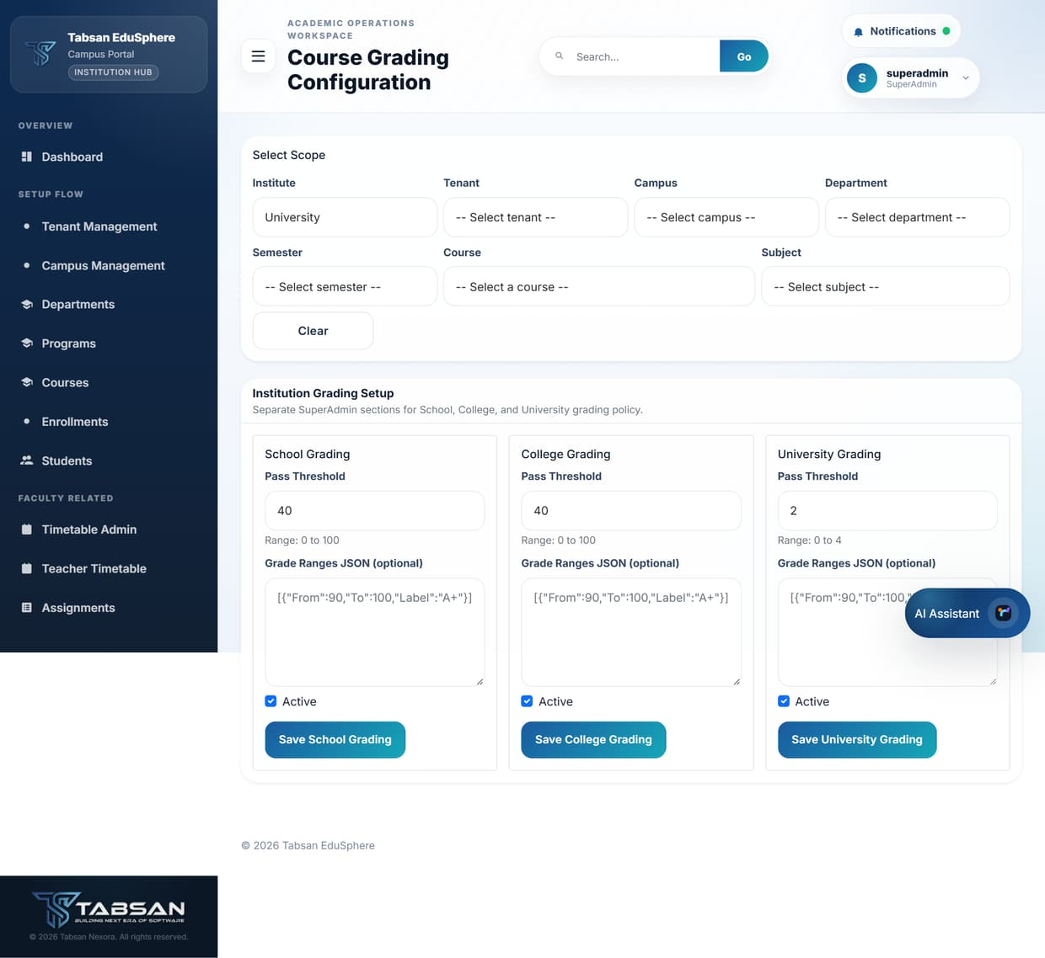
Figure 8.3 Grading Config (SuperAdmin)

8.4 Prerequisites
Available to: SuperAdmin, Admin
A prerequisite is a course a student must pass before they can enrol in another, for example CS101 before CS201. The page lists every course with the number of prerequisites it has.

Procedure
- Find the course in the list.
- Click Add Prerequisite and choose the course that must be passed first.
- To remove a requirement, click Remove next to it.

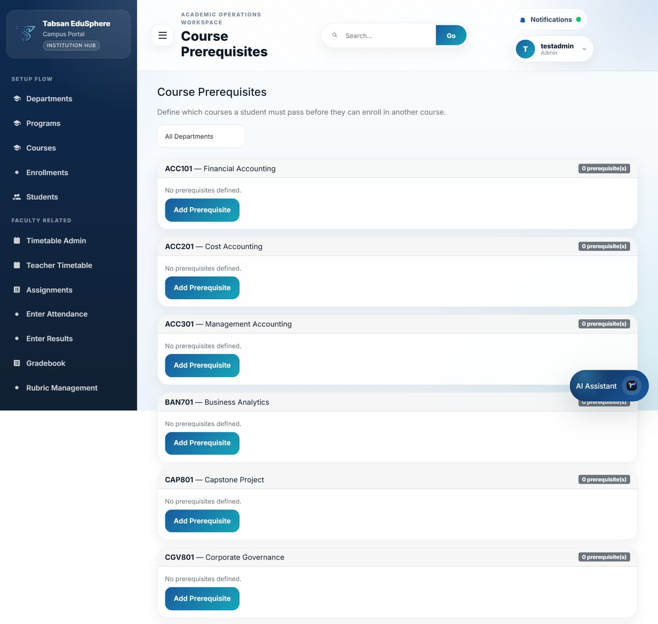
Figure 8.4 Course Prerequisites

What happens next
When a student, or an Admin on their behalf, tries to enrol in the course, the portal checks the student's published results and blocks the enrolment if a prerequisite has not been passed.

8.5 Student Lifecycle
Available to: SuperAdmin, Admin
Student Lifecycle moves students forward at the end of each term. Promote moves an eligible student to the next semester or class; Graduate completes the program for a student in the final level.
A student is eligible for promotion when their result for the level meets the pass threshold set in Grading Config.

Before you start
- Results for the level are published, so eligibility can be calculated.

Procedure
- Open Student Lifecycle and choose the Department.
- Choose the Semester (or Class). The students at that level are listed with their standing.
- Click Promote for each eligible student, or Graduate for a student in the final level.

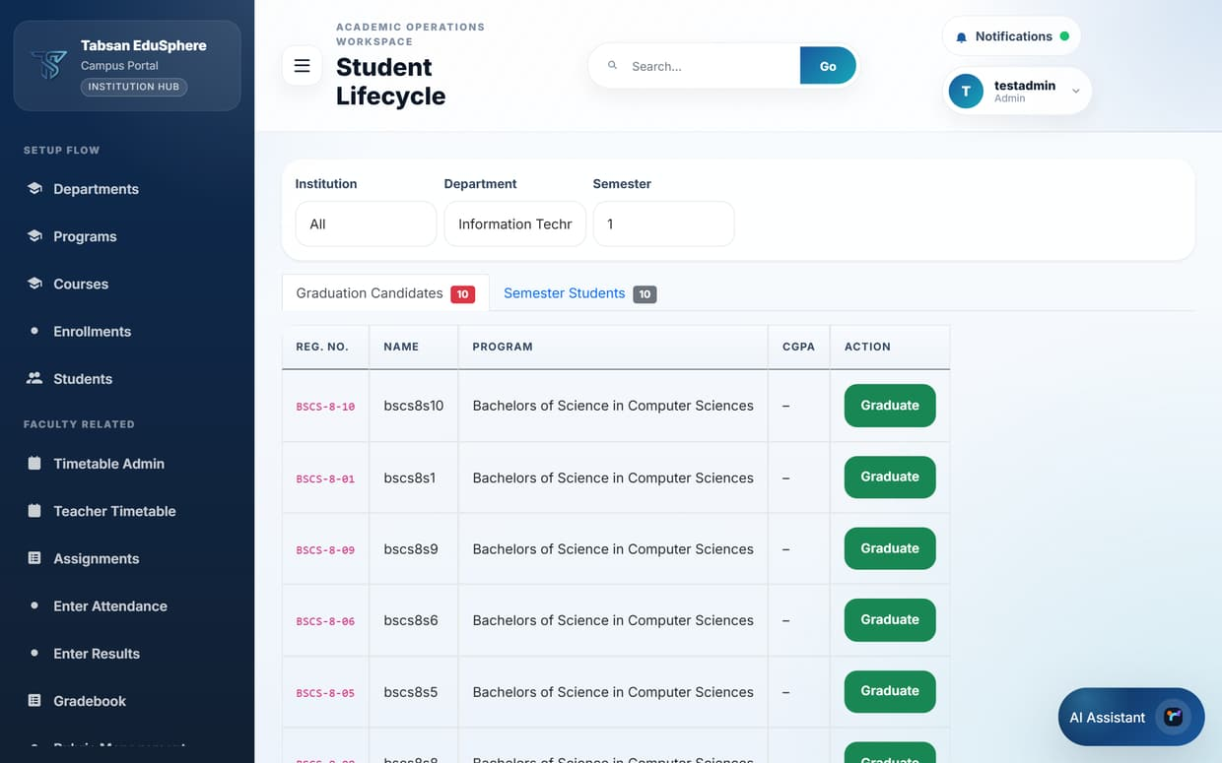
Figure 8.5 Department selected
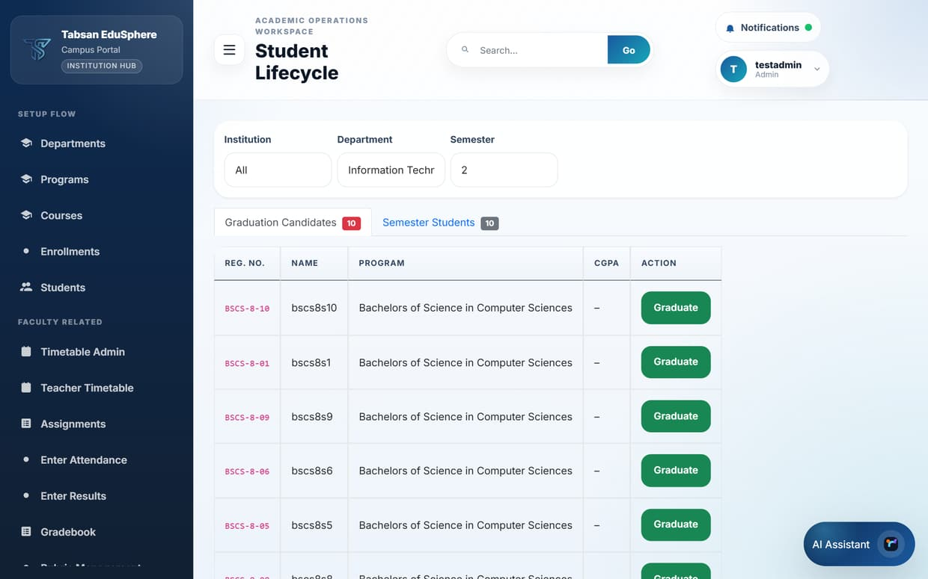
Figure 8.6 Students in the selected semester

What happens next
Promoted students move to the next level and appear in its lists. Graduated students change to the Graduated status and become eligible for certificates.
IMPORTANT University students must have their FYP created before the final promotion, because promoting past the last semester graduates the student automatically.

8.6 Study Plan
Available to: SuperAdmin, Admin, Faculty
A study plan records the courses a student intends to take in future semesters. Plans are reviewed by an academic advisor, which helps students avoid missing prerequisites or required courses.

Procedure
- Choose the Department and the Student, then click Create to start a plan.
- Open the plan and add the courses the student intends to take. The portal can also suggest courses through its recommendations.
- The advisor (Faculty) reviews the plan, adds advisor notes, and endorses or rejects it.

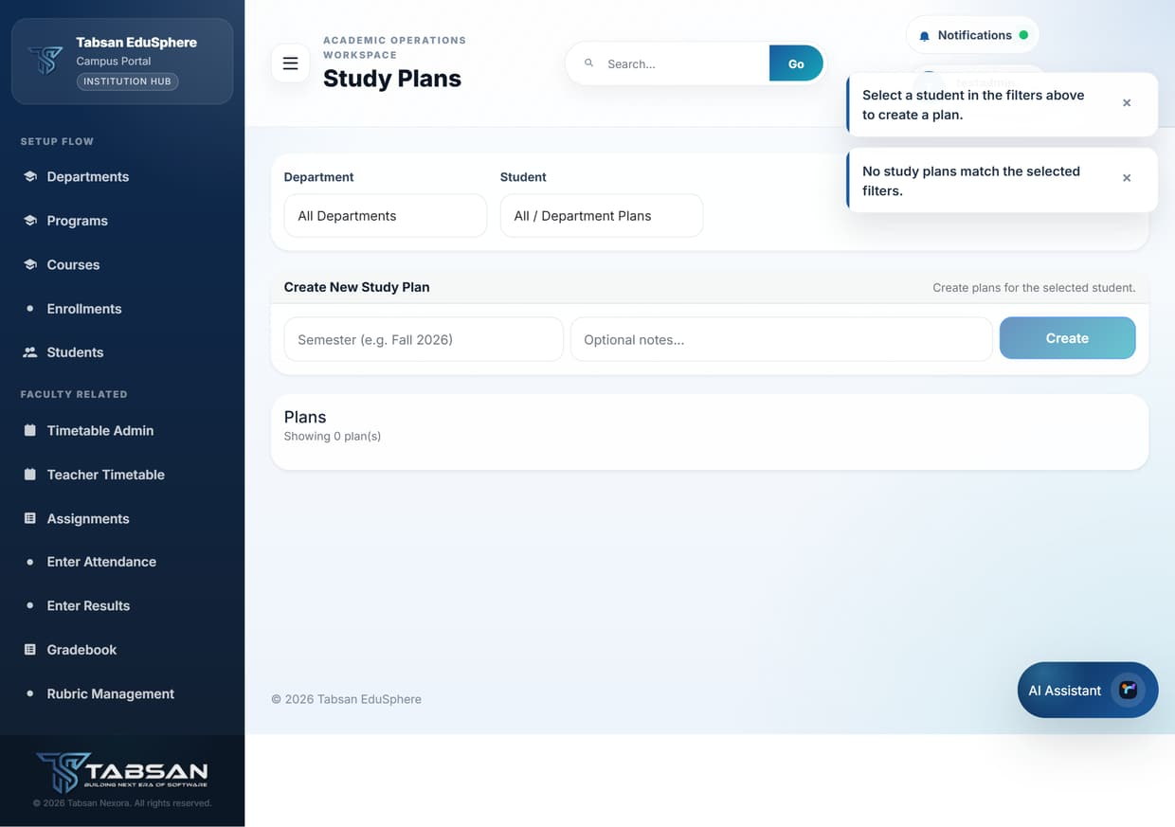
Figure 8.7 Study Plan

Study plan statuses
Status | Meaning
Pending | Waiting for advisor review.
Endorsed | Approved by the advisor.
Rejected | Returned with advisor notes; update and resubmit.

8.7 Final Year Projects (FYP)
Available to: SuperAdmin, Faculty
FYP tracks final year projects for University students in their last semester: the project title, the student, the supervisor, the department, the status and the final result. Supervisors also schedule meetings, which appear under Upcoming Meetings.

Procedure
- A project is registered with + Create Project (or proposed by the student), giving the Title, Description, Department and Student.
- The project is reviewed and approved or rejected. An Admin or SuperAdmin assigns the Supervisor.
- During the semester the supervisor holds meetings and tracks progress.
- When the work is finished, completion is requested and approved, then the supervisor clicks Enter Result to record the FYP result and marks the project Complete.

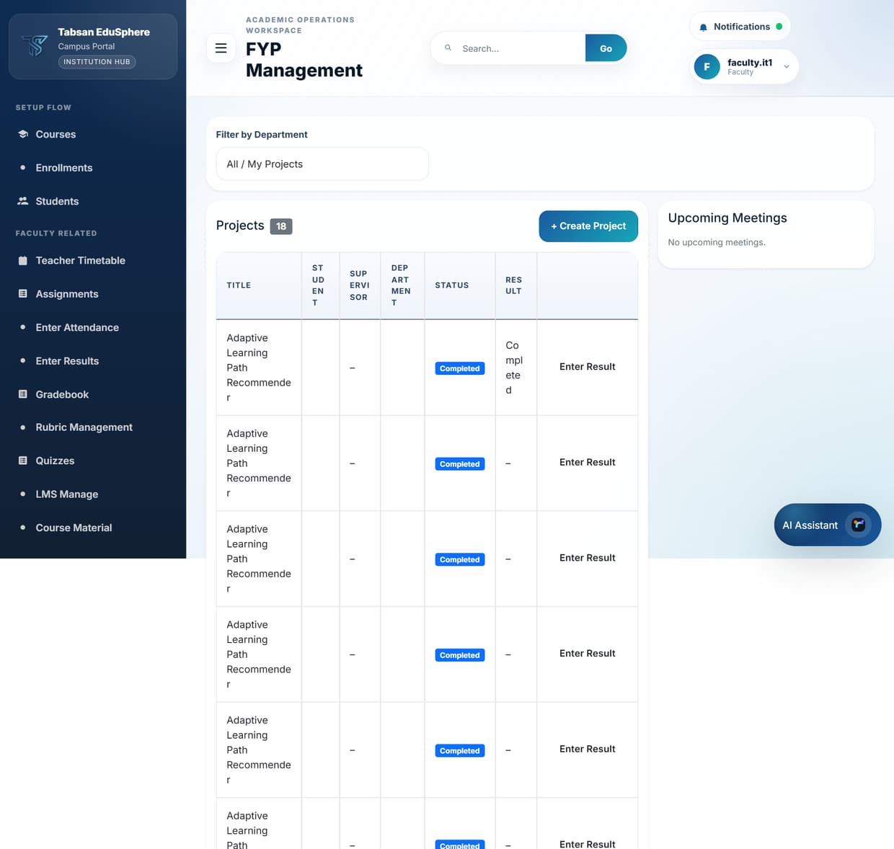
Figure 8.8 FYP (Faculty view)

FYP statuses
Status | Meaning
Proposed | Submitted for approval.
Under Review | Being reviewed by the department.
Approved | Accepted; work can start.
In Progress | Work is under way with a supervisor.
Completed | Finished and graded. Required before graduation.
Rejected | Not accepted; a new proposal is needed.

9 Graduation and Certificates
Graduation applies to University programs. The portal checks each student against the program's degree rule, takes the application through a three-stage approval, and then makes certificates available.

9.1 Degree Rules
Available to: SuperAdmin (edit), Admin and Faculty (view)
A degree rule sets what a University program requires before a student can graduate. Without a rule, the degree audit for that program reports "No degree rule has been configured".

Procedure
- Choose the Academic Program.
- Enter the minimum total, core and elective credits and the minimum GPA.
- Click Create Rule. Existing rules are listed below, with Delete to remove one.

Fields and options
Field | What to enter or choose
Min Total Credits | The total credit hours the student must complete.
Min Core Credits / Min Elective Credits | How many of those credits must come from core courses and from electives.
Min GPA | The lowest CGPA allowed for graduation, for example 2.00.

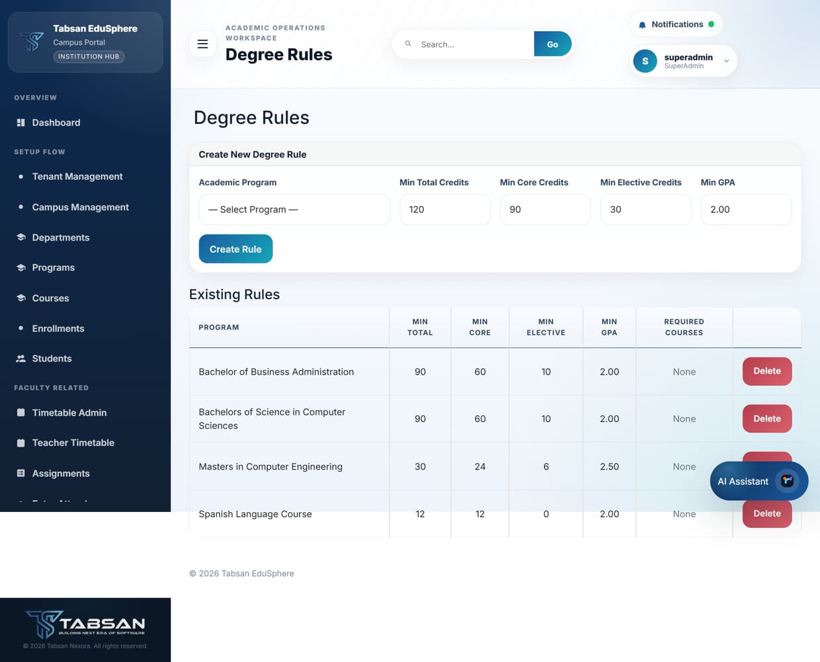
Figure 9.1 Degree Rules

9.2 Degree Audit
Available to: SuperAdmin, Admin, Faculty, Student
Degree Audit compares a student's completed courses with the program's degree rule and shows what is still missing. Staff choose a Student and click Load Audit. Students see their own audit straight away.
The audit lists completed courses with their credits, type (core or elective) and grade points, and an Unmet Requirements box such as "Total credits: 84/90 required".
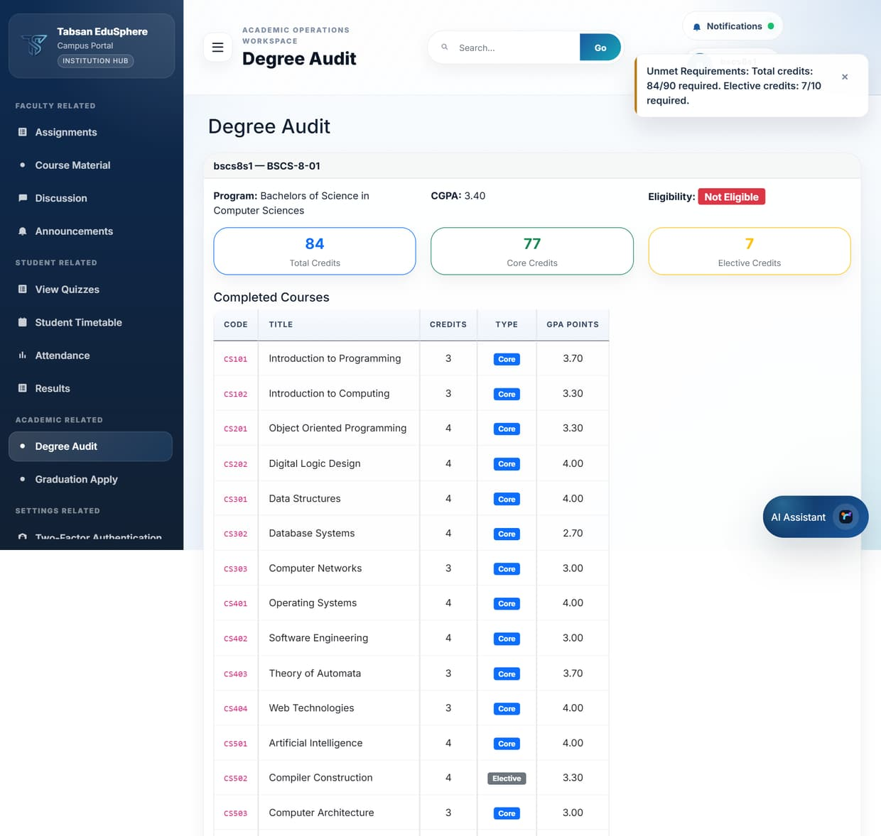
Figure 9.2 Degree Audit (Student view)

Good to know
- Students should check their degree audit at the start of the final year, so any missing courses can still be taken.

9.3 Graduation Eligibility
Available to: SuperAdmin, Admin, Faculty
Graduation Eligibility lists students with their credits earned, CGPA, unmet requirements and eligibility status, so staff can see who is ready to graduate. Click View Audit for the detail behind a student's status. Faculty see the students of their own departments.
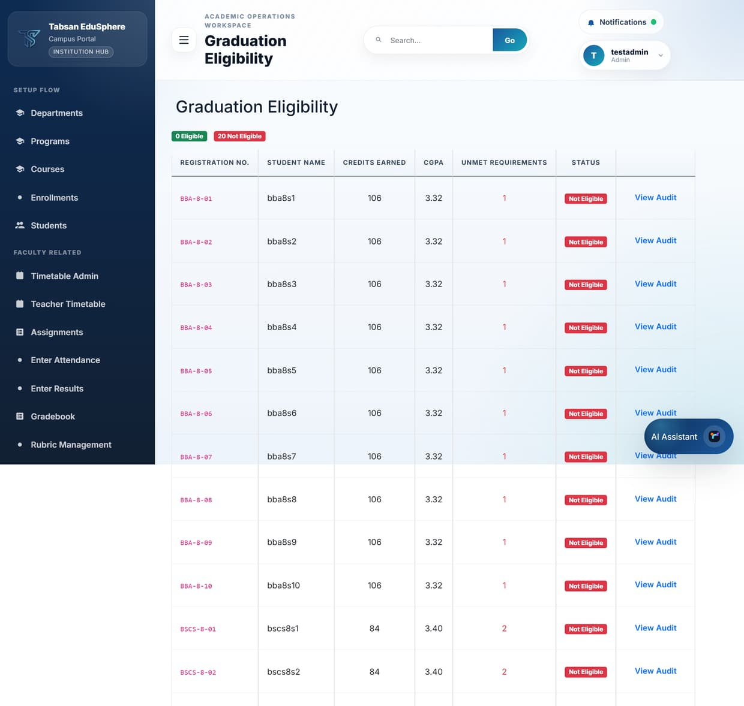
Figure 9.3 Graduation Eligibility

9.4 Applying for graduation (Students)
Available to: Student
An active University student in the final semester with a completed FYP can apply for graduation from the portal.

Before you start
- Your degree audit shows no unmet requirements, and your FYP status is Completed.

Procedure
- Open Graduation Apply.
- Optionally add a Personal Note for the reviewers.
- Click Submit Application. Your application and its current stage are shown on the same page.

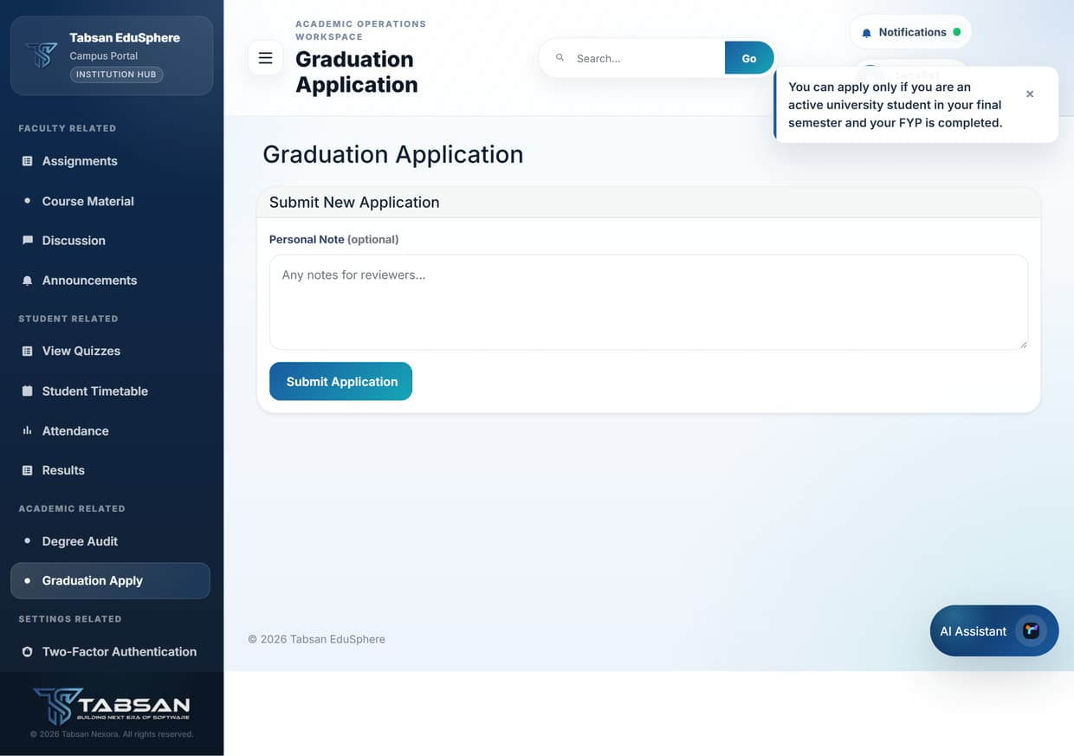
Figure 9.4 Graduation Application (Student)

9.5 Graduation Applications
Available to: SuperAdmin, Admin, Faculty
Applications are approved in three stages: first by Faculty, then by an Admin, and finally by a SuperAdmin. Any of these approvers can reject an application at their stage.

Procedure
- Open Graduation Applications.
- Filter by Status and Department and click Filter.
- Click View on an application, review the student's audit, and approve or reject it.

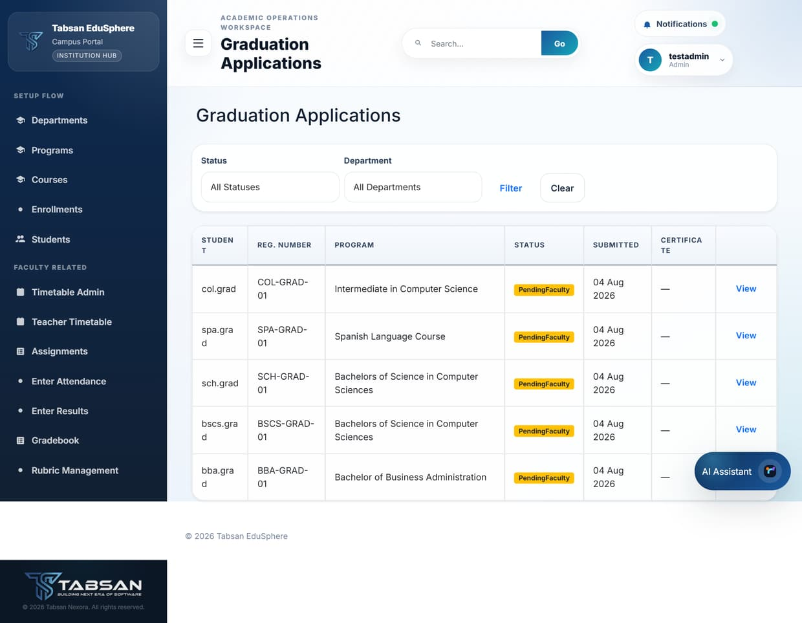
Figure 9.5 Graduation Applications

Application statuses
Status | Meaning
Pending Faculty | Waiting for a Faculty approver.
Pending Admin | Approved by Faculty; waiting for an Admin.
Pending Final Approval | Approved by an Admin; waiting for the SuperAdmin.
Approved | Graduation approved; the certificate becomes available.
Rejected | Not approved. The student can see the outcome on their application and should speak to their department.

9.6 Generate Certificates
Available to: SuperAdmin, Admin, Faculty
Generate Certificates produces official documents for students: degree certificates and transcripts for University graduates, and completion certificates and report cards for School and College students. Files are named with the registration number and document type.

Procedure
- Open Generate Certificates and filter by institution, department, course and class; use Search Students to find a student, then click Apply.
- In the student's row, choose the document type and click Generate. The generated files are listed under Certificates for download.
- Under Certificate Templates, use Download Default to get the standard layout, or Import Template to upload your institution's own design.

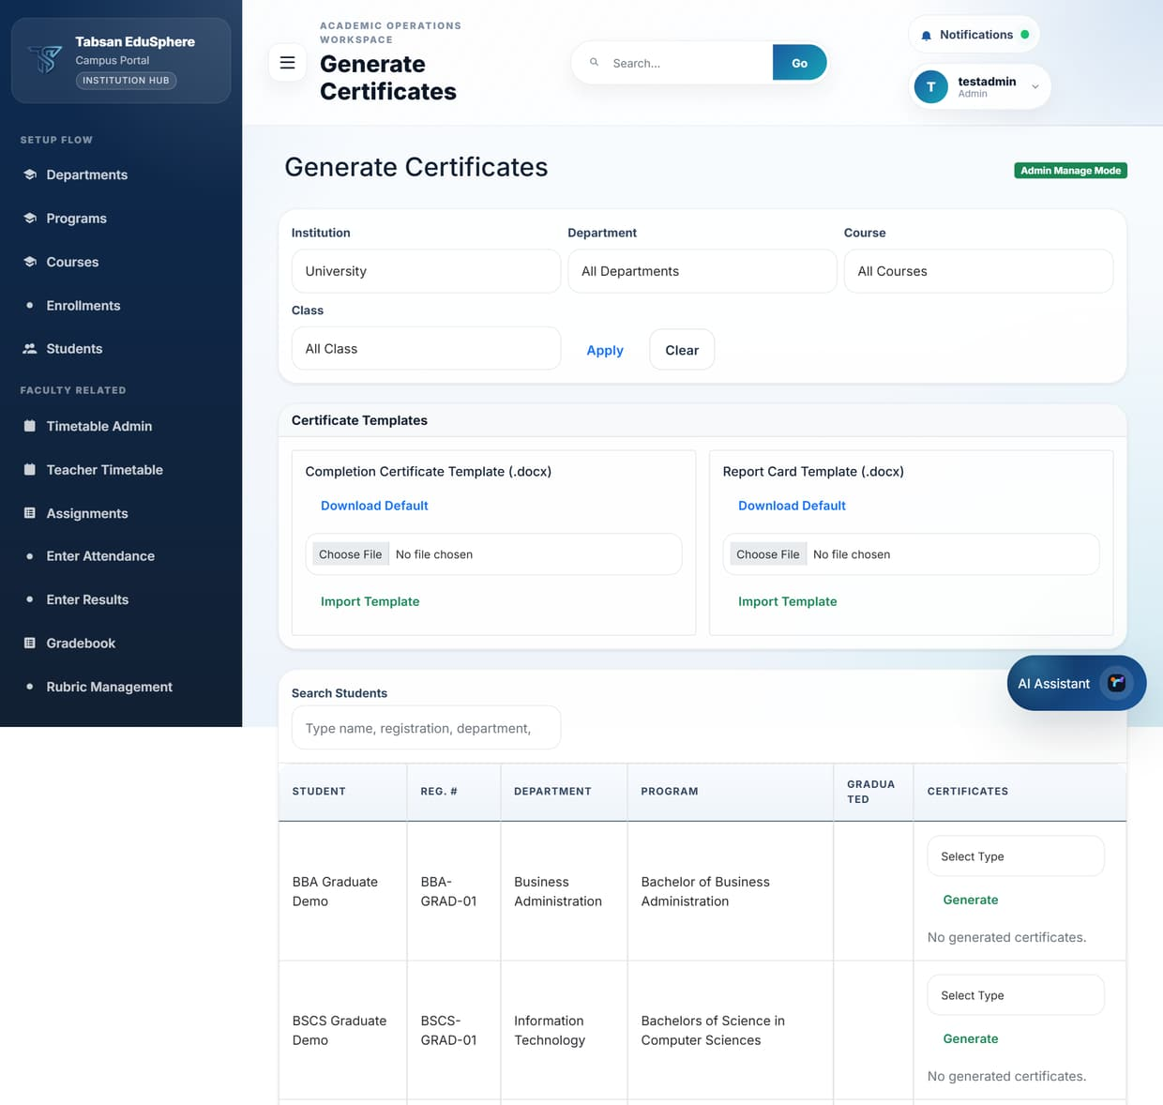
Figure 9.6 Generate Certificates

Good to know
- Degree certificates are available only for University graduates. School completion certificates require Class 10, and College ones require Class 11 and 12 results.

10 Reports and Analytics
Reports produce lists and summaries you can view on screen and download, while Analytics shows trends as charts.

10.1 Report Center
Available to: SuperAdmin, Admin, Faculty, Finance
Report Center lists the reports your role may run, as cards. Finance users see only the Payment Summary; students do not have reports.
Report | What it shows
Attendance Summary | Attendance totals and percentages by offering and student.
Enrollment Summary | Enrolment counts by department, program and semester.
FYP Status Report | Final year projects with supervisor, status and result.
GPA & CGPA Report | Semester GPA and CGPA per student (University only).
Low Attendance Warning | Students below the attendance threshold (default 75%).
Payment Summary | Fee receipts by status and amount.
Result Summary | Marks and grades by subject and exam type.
Semester Results | Results for a whole semester or class.
Student Transcript | A student's full academic record.

Procedure
- Open Report Center and click a report card.
- Choose the filters (for example Department and Program) and click Filter. Some reports need a particular filter: Semester Results needs a semester, and Student Transcript needs a student.
- Review the results on screen. A summary line shows the number of records and key totals.
- Click Excel, CSV or PDF to download the report in that format.

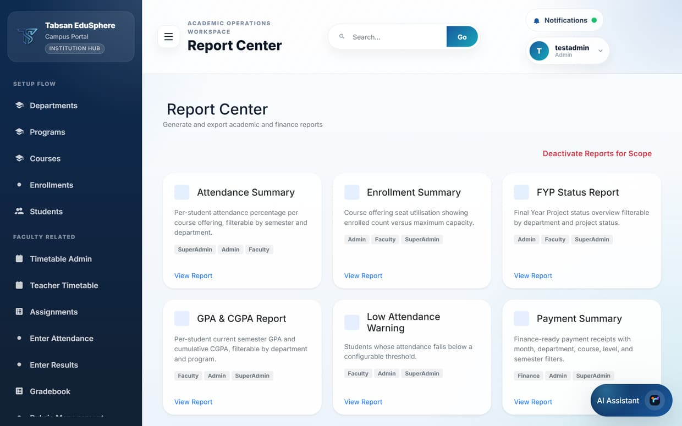
Figure 10.1 Report Center
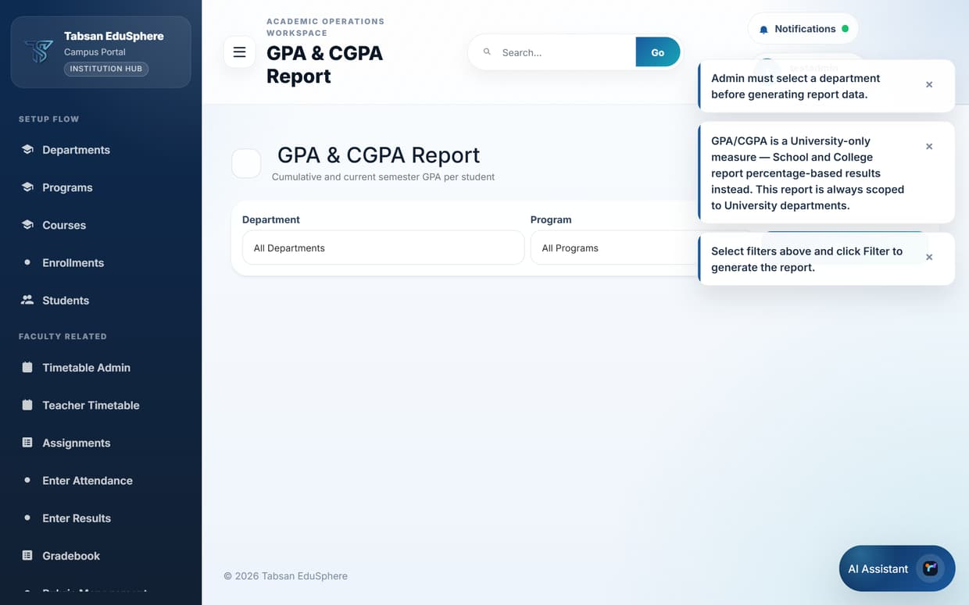
Figure 10.2 Report filters
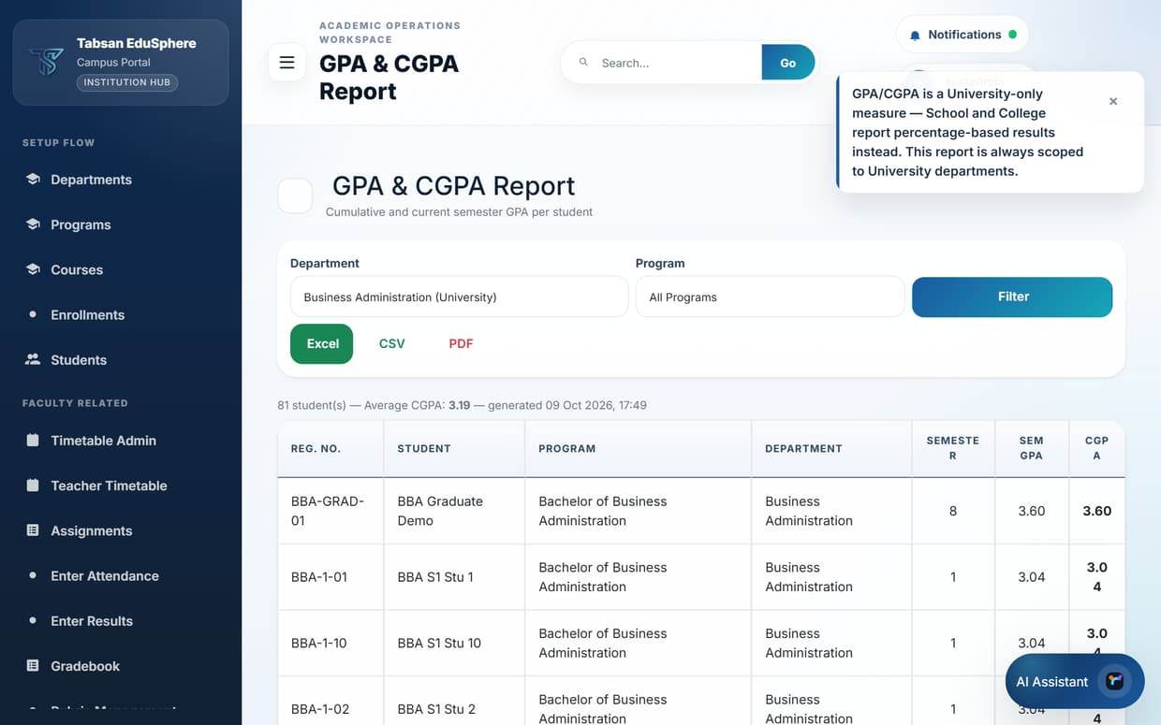
Figure 10.3 GPA & CGPA Report generated, with export buttons

Good to know
- Excel is best for further analysis, CSV for importing into other systems, and PDF for printing or sharing.
- Reports reflect published data only; unpublished marks are not included.
NOTE Admins must choose a department before a report generates. SuperAdmin can switch reports off for a tenant or campus with Deactivate Reports for Scope.

10.2 Analytics
Available to: SuperAdmin, Admin, Faculty, Finance
Analytics gives an overview of performance, attendance and assignments, with headline figures (for example average marks and overall attendance) and charts of trends over time, plus a student table you can sort and review.

Procedure
- Open Analytics.
- Choose the institute, campus, department, course and semester/class you are interested in, and click Apply Filters.
- Read the headline cards and charts. Click Reset to clear the filters.

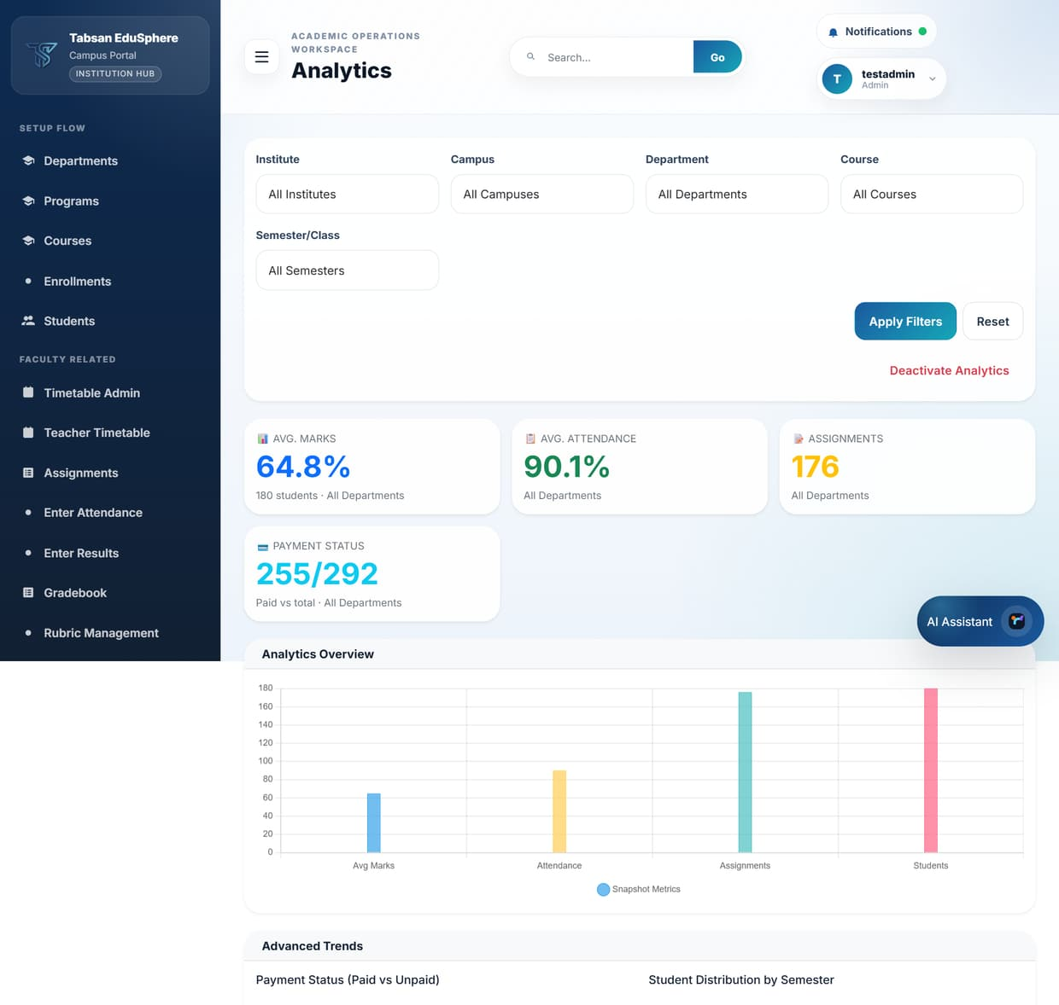
Figure 10.4 Analytics overview

11 Finance
Finance covers fee receipts: issuing them to students, recording payment and keeping the totals accurate.

11.1 Fee receipts (Payments)
Available to: SuperAdmin, Admin, Finance
Payments manages fee receipts from creation to confirmation. Each receipt belongs to one student and has an amount, a receipt number, a description and a due date. The list shows all receipts with their status, and can be filtered by student and paged with Previous and Next.

Procedure
- Open Payments.
- Under Create Fee Receipt, choose the Student, enter the Amount, Receipt No, Description and Due Date.
- Click Create. The receipt starts as Pending.
- When payment has been received, click Confirm on the receipt. It changes to Paid.
- If a receipt was issued in error, click Cancel.
- For many receipts at once, click Export Template, fill in the CSV and upload it with Import CSV.

Fields and options
Field | What to enter or choose
Student | The student the fee is for.
Amount | The amount due, in your institution's currency.
Receipt No | Your reference number, for example RCP-2026-0101. Use a unique number for each receipt.
Description | What the fee is for, for example "Semester 3 tuition fee".
Due Date | The date by which the student should pay.

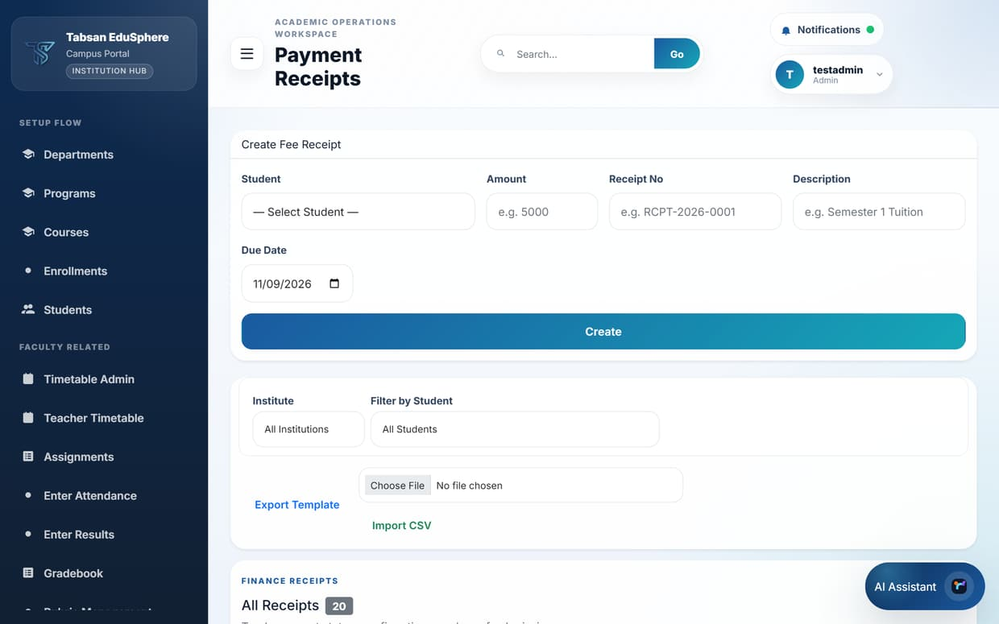
Figure 11.1 Payments – all receipts
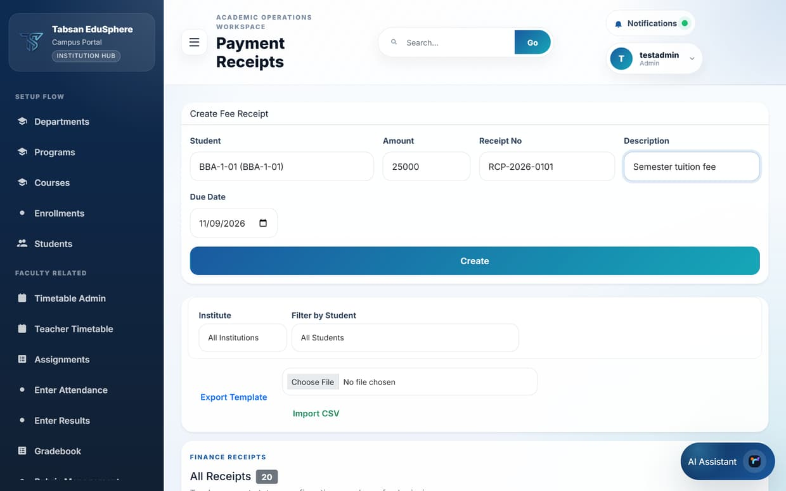
Figure 11.2 Create Fee Receipt form completed

Receipt statuses
Status | Meaning
Pending | Issued and waiting for payment.
Submitted | The student has reported payment and supplied proof; waiting for Finance to confirm.
Paid | Payment confirmed by Finance or an Admin. Cannot be cancelled.
Cancelled | Withdrawn. Hidden from the student's own list but kept for audit.

TIP Use Filter by Student to see one student's payment history, and Report Center > Payment Summary for totals.

12 Users, Communication and Personal Settings
This chapter covers creating accounts, keeping your own details and password up to date, notifications, the helpdesk and the look of the portal.

12.1 User Import and creating users
Available to: SuperAdmin, Admin
User Import creates accounts for students, faculty, admins and finance staff, either one at a time with a form or many at once from a CSV file. Every new account starts with the username as its temporary password and must choose a new password at first sign-in.
For students, the import also creates the student's academic profile (registration number, program and department), so they can use the student portal straight away.

Procedure
- Open User Import.
- Bulk: download faculty-admin-import-template.csv or students-import-template.csv, fill it in a spreadsheet (Username, Email and Role are required), save it as CSV, choose it in CSV File and click Upload and Import. Review the import report.
- Single user: in Create Single User, enter the Username, Email, Full Name and Role. For a Faculty member choose the Department; for a Student choose the Department and Program and, optionally, a Registration No. (it defaults to the username). Mobile number, address and profile photo are optional.
- Click Create User. A message confirms the account was created, or explains why it was not (for example, the username already exists).

Fields and options
Field | What to enter or choose
Username | The sign-in name. Must be unique. Also the temporary password.
Email | Used for notifications and password resets.
Role | Admin, Faculty, Student or Finance. SuperAdmin accounts cannot be created here.
Department (Faculty / Student) | The department the person belongs to.
Program (Student) | The program the student is admitted to. Choose a program of the selected department.
Registration No. (Student) | Optional. The student's registration number; if left blank, the username in capitals is used. Must be unique.
Campus Assignments | Optional. For staff who work on more than one campus: campus IDs separated by a | character.

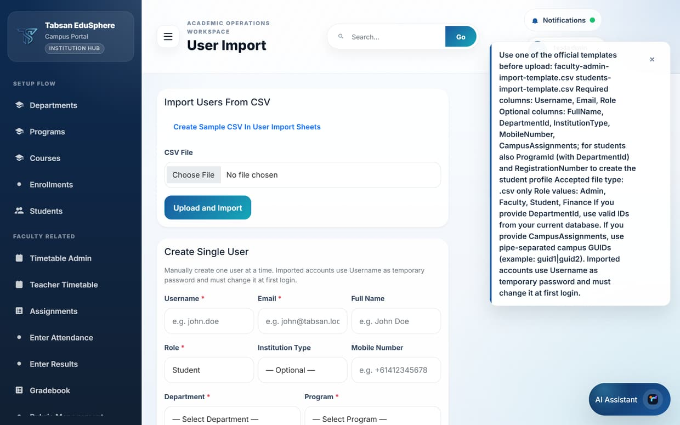
Figure 12.1 User Import
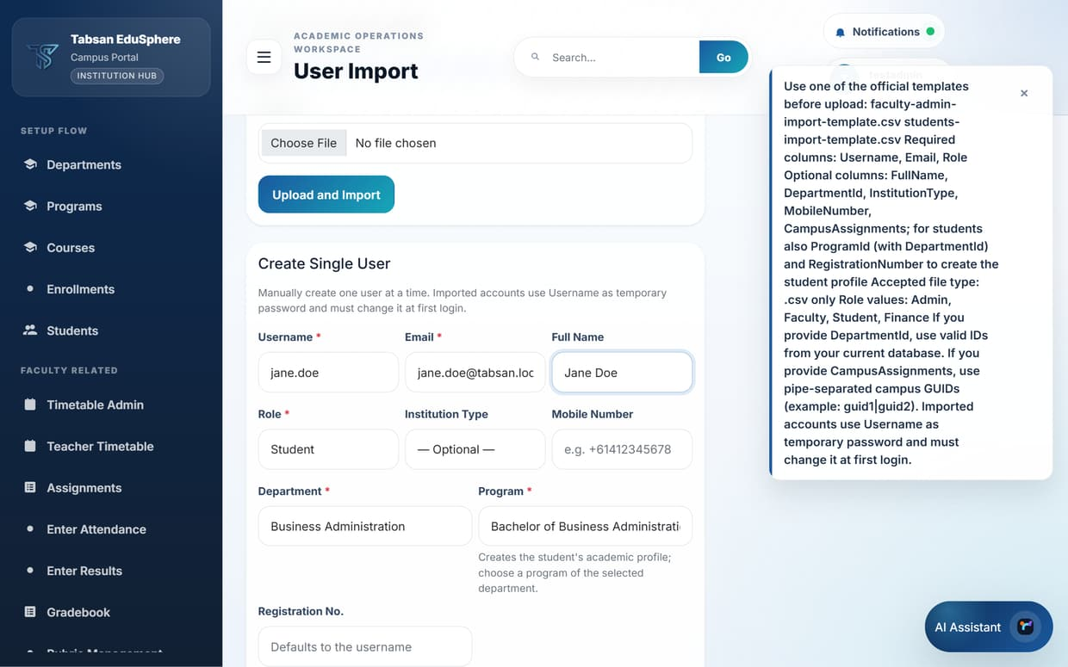
Figure 12.2 Create Single User form for a student, with Department and Program

What happens next
The import report shows how many rows were imported, how many were skipped as duplicates, and the reason for any errors, row by row. Fix the rows with errors and import just those rows again.
TIP In the students CSV template, fill DepartmentId and ProgramId (and optionally RegistrationNumber) to create each student profile during a bulk import.

12.2 User Settings
Available to: SuperAdmin, Admin, Faculty, Student, Finance
Every user can keep their own details up to date: email, mobile number, address and profile photo. This is also where you change your password.
Admins see an extra user directory on the left. They can search for a user in their scope, edit the user's name and contact details, and reset the user's password to the default when someone is locked out.

Procedure
- Open User Settings from the sidebar or the profile menu.
- Update your Email, Mobile or Address and click Save Details.
- To change your profile picture, choose an image and click Upload Photo (JPG or PNG, up to 2 MB).
- To change your password, enter your Current password, a New password and Confirm new password, then click Change Password.

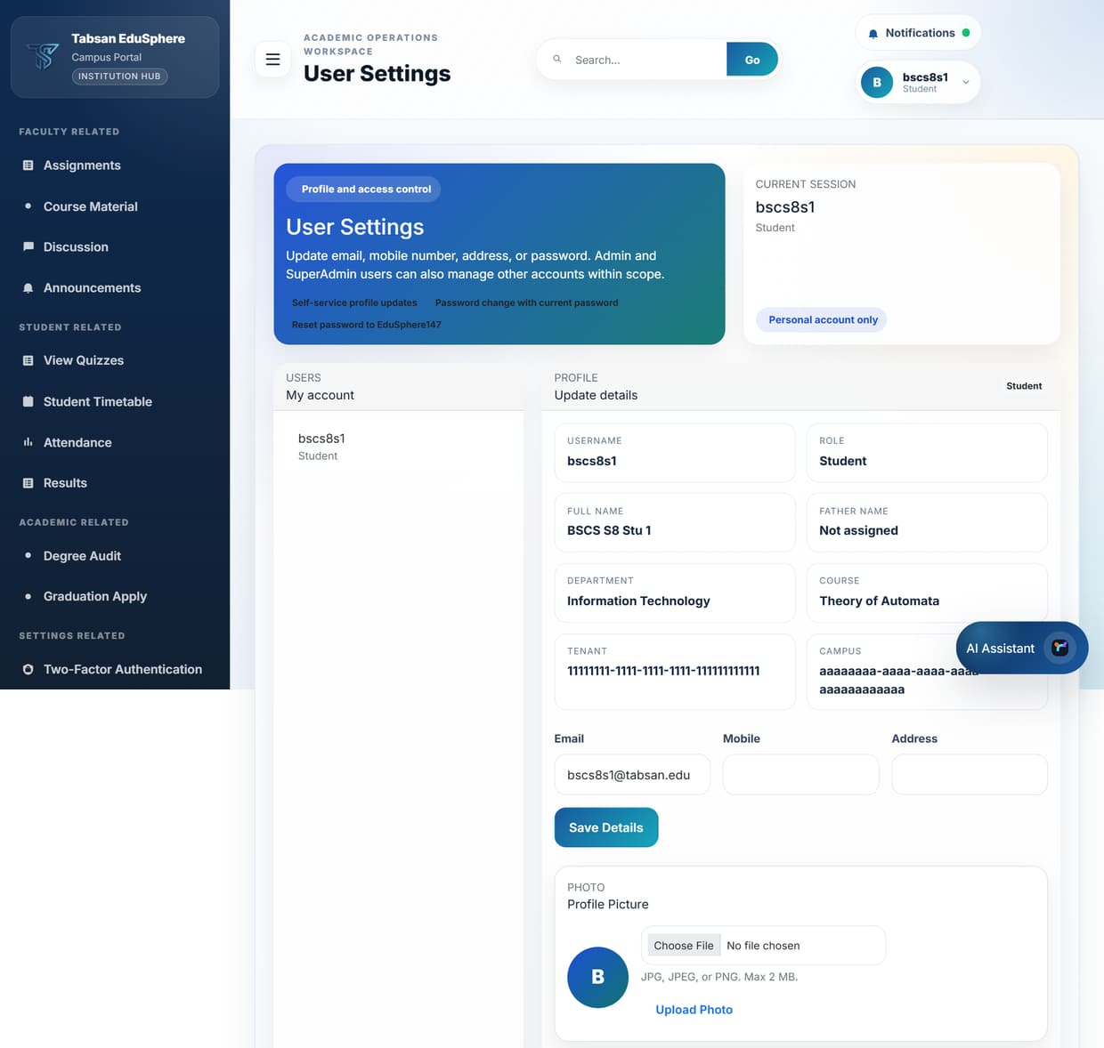
Figure 12.3 User Settings (Student view)
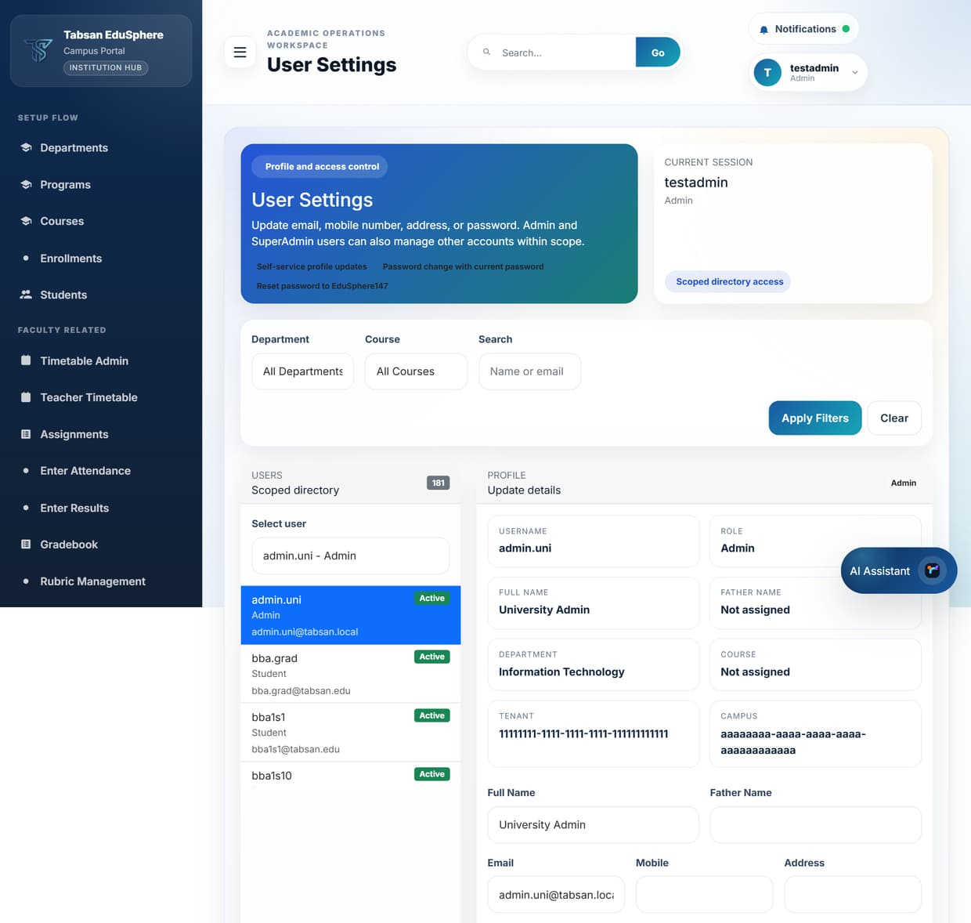
Figure 12.4 User Settings with the user directory (Admin view)

Good to know
- A new password must be at least 8 characters and different from your current one.
- Admins: after Reset Password, tell the user their temporary password; they must change it at their next sign-in.

12.3 Two-Factor Authentication
Available to: SuperAdmin, Admin, Faculty, Student, Finance
Two-factor authentication (2FA) protects your account even if someone learns your password. After you enable it, signing in needs both your password and a 6-digit code from an authenticator app on your phone, such as Microsoft Authenticator, Google Authenticator or Authy. The code changes every 30 seconds.

Before you start
- Install an authenticator app on your phone.

Procedure
- Open Two-Factor Authentication from the profile menu.
- Click Start 2FA Setup. A QR code and a manual key appear.
- In your authenticator app, add an account and scan the QR code (or type the manual key).
- Enter the 6-digit code shown in the app to verify and enable 2FA.
- Write down the recovery codes shown and keep them somewhere safe. Each can be used once instead of a code if you lose your phone.
- To turn 2FA off later, return to this page, enter a current code and disable it. The old secret is deleted, so setting it up again needs a new QR code.

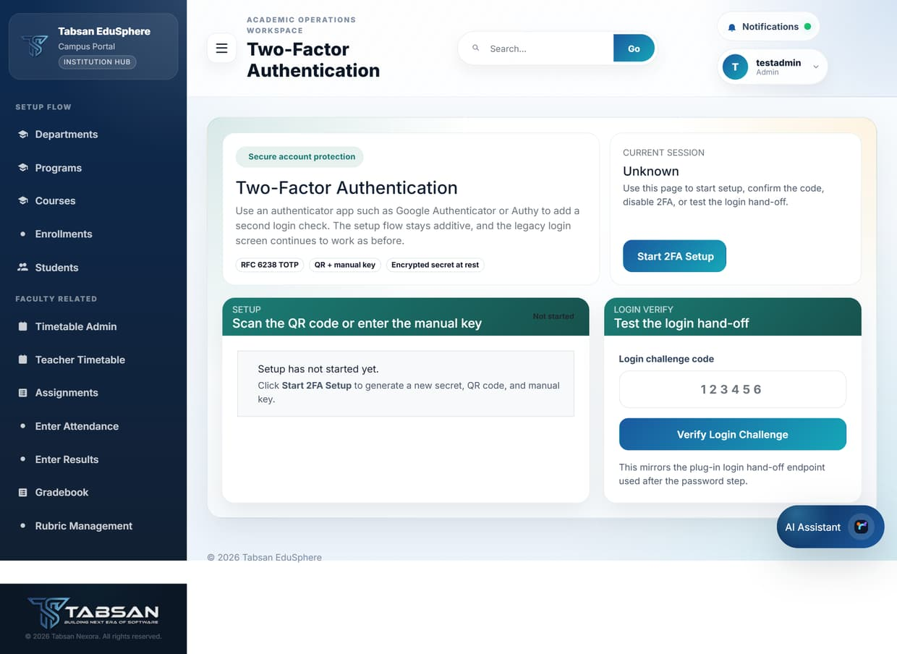
Figure 12.5 Two-Factor Authentication
IMPORTANT If you lose your phone and your recovery codes, an administrator must reset two-factor authentication for you.

12.4 Notifications
Available to: SuperAdmin, Admin, Faculty, Student, Finance
The notification inbox collects messages from the portal, such as new announcements, published results, graduation decisions and replies to your helpdesk tickets. A green dot on the Notifications button means you have unread items.
Click a notification to mark it as read, or click Mark All Read to clear the indicator.
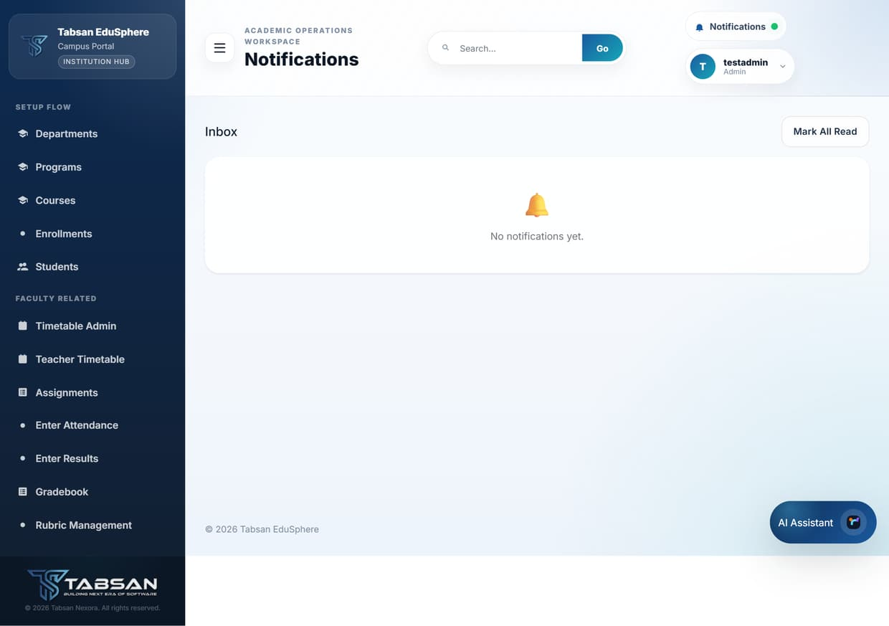
Figure 12.6 Notifications inbox

12.5 Helpdesk
Available to: SuperAdmin, Admin, Faculty, Student, Finance
Helpdesk is the place to ask the institution for help, for example about a timetable clash, a missing mark or a sign-in problem. Each request is a ticket that staff answer and track until it is resolved. All messages in a ticket are kept together.

Procedure
- Open Helpdesk. Use the status tabs (All, Open, InProgress, Resolved, Closed) to filter your tickets.
- Click New Ticket.
- Choose the Department (optional) and Category, enter a short Subject and the Details, and click Submit Ticket.
- Open a ticket with View to read replies and respond.

Fields and options
Field | What to enter or choose
Category | Academic (courses, marks, timetables), Technical (sign-in or portal problems) or Administrative (fees, documents, records).
Subject | A one-line summary, for example "CS201 midterm mark missing".
Details | Include what you were doing, what you expected and what happened. Screenshots help.

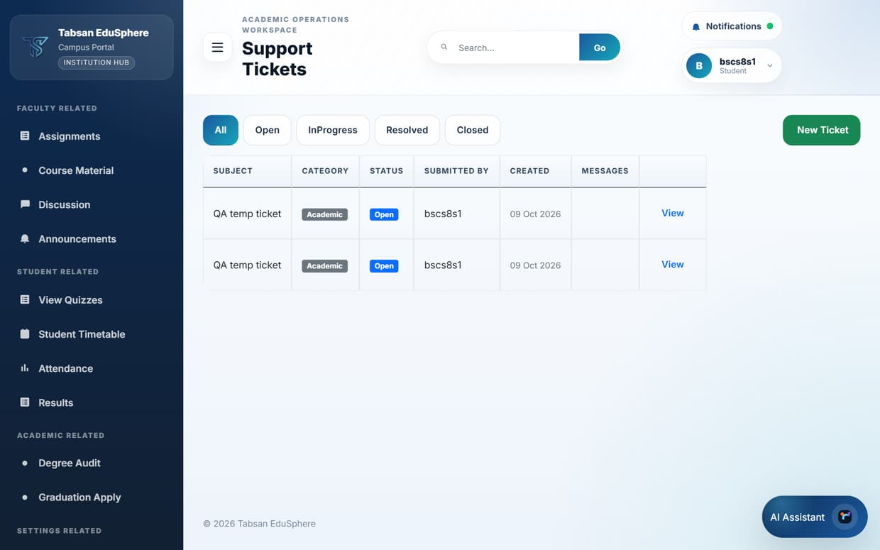
Figure 12.7 Helpdesk ticket queue
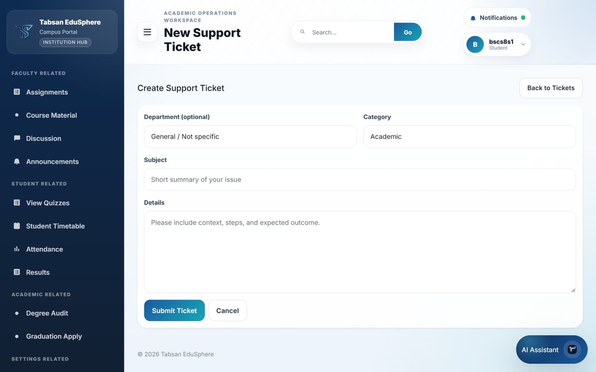
Figure 12.8 New Support Ticket form

Ticket statuses
Status | Meaning
Open | New; waiting for staff.
In Progress | A staff member is working on it.
Resolved | Staff believe the issue is fixed. Reply if it is not.
Closed | Finished. Open a new ticket for a new issue.

12.6 Theme Settings
Available to: SuperAdmin, Admin, Faculty, Student, Finance
Theme Settings changes the colours of the portal for your own account, for example a dark theme for evening use. Click a theme to preview it on the page, then save it. You can return to Default at any time.
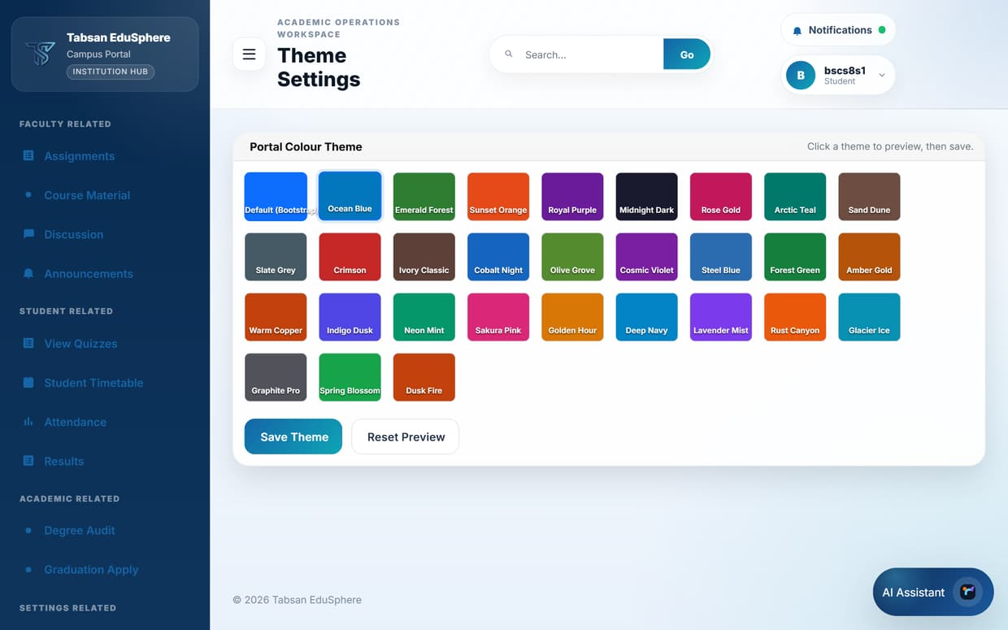
Figure 12.9 Theme Settings with a theme previewed

13 SuperAdmin Administration
The pages in this chapter are available only to SuperAdmin users. They control the whole installation, so changes here affect every user.

13.1 Dashboard
Available to: SuperAdmin
The SuperAdmin Dashboard explains the workspace modes and holds the API connection settings (API Base URL, access token and default department). These settings connect the portal to its back-end service. Change them only on instruction from your technical team.
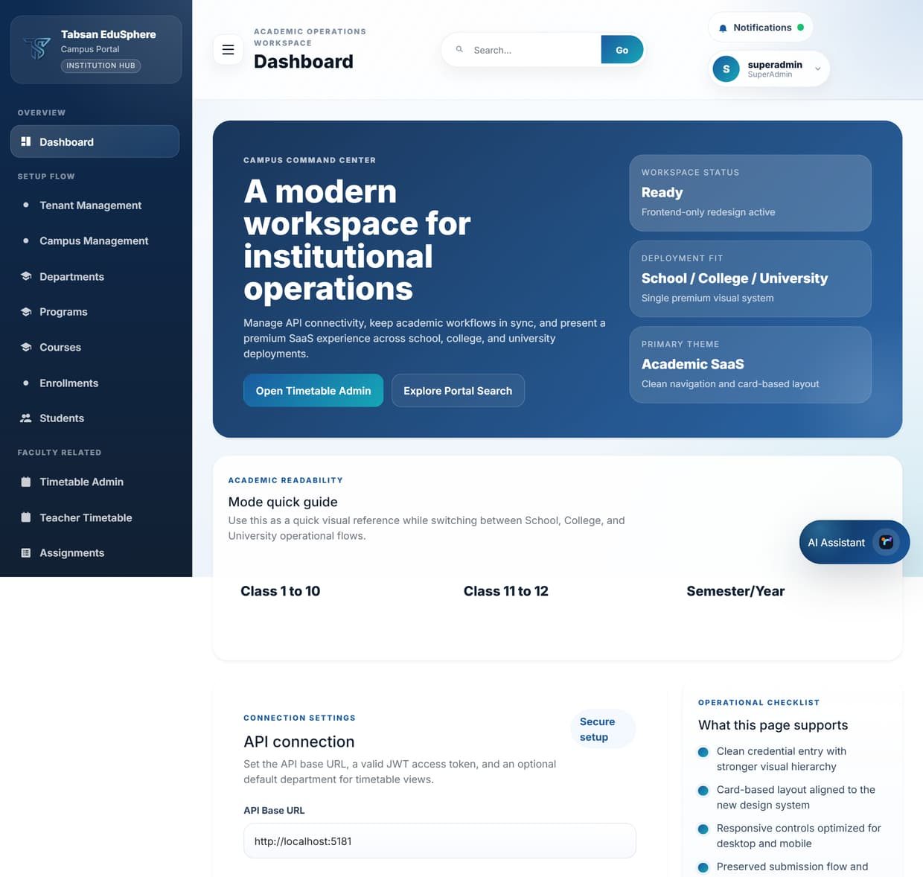
Figure 13.1 SuperAdmin Dashboard

13.2 Tenant and Campus Management
Available to: SuperAdmin
A tenant is a separate institution in the installation, for example the University, the College and the School, each with its own users and data. Each tenant has one or more campuses.

Procedure
- In Tenant Management, enter a Code and Name and click Create Tenant.
- Click Manage Campuses, choose the tenant, enter the campus Code and Name, and click Create.
- Use Save to rename, and Deactivate for tenants or campuses no longer in use. Deactivated items are hidden from all filters.

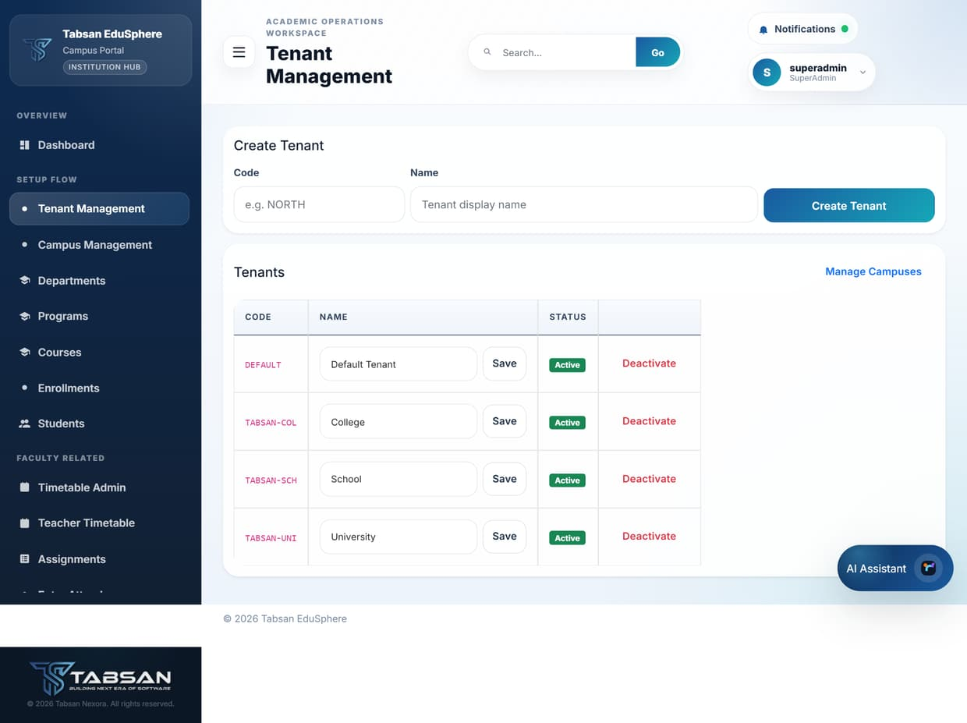
Figure 13.2 Tenant Management
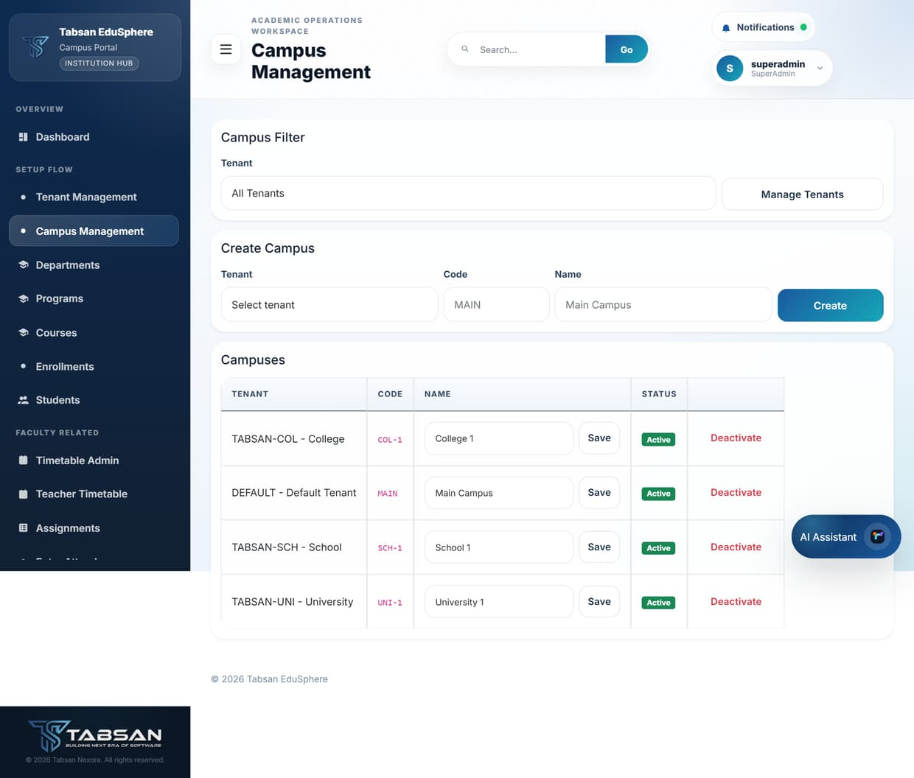
Figure 13.3 Campus Management

13.3 Admin Users
Available to: SuperAdmin
Admin Users creates Admin accounts and decides which departments each Admin manages. An Admin sees and manages only the departments assigned to them.

Procedure
- Enter the Username, Email and a Temporary Password, and optionally an Institution Type.
- Tick the Initial Department Assignments (use Select All or Clear to speed this up) and click Create Admin.
- To change an existing Admin, search for and select them, update their details and department assignments, and click Save Changes.

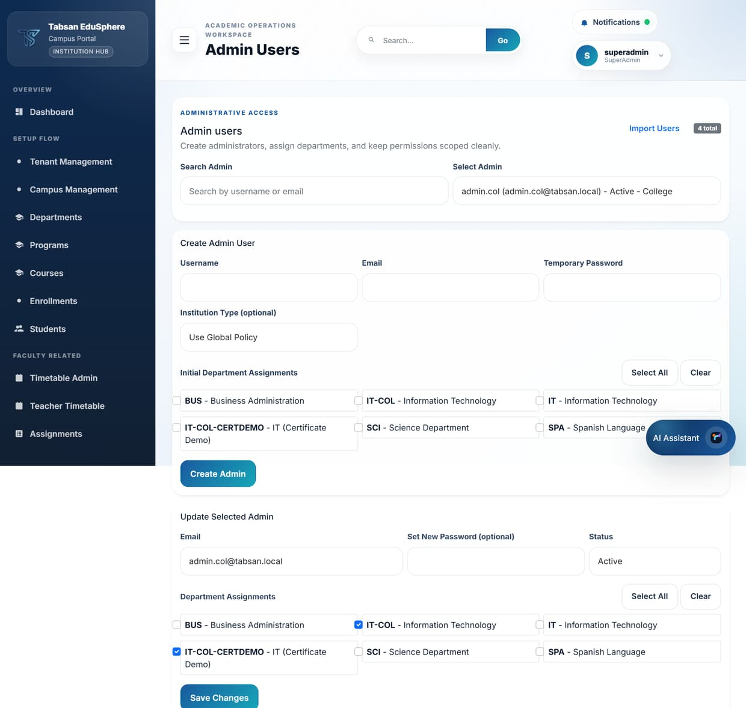
Figure 13.4 Admin Users

13.4 Module Composition
Available to: SuperAdmin
Module Composition shows the module registry (17 modules, such as Attendance, Results, Reports and FYP), whether each is active, whether your role can use it, and the dashboard widgets for your role. Deactivate a module to hide its features for everyone. Modules allowed by the license are activated automatically when the license is uploaded.
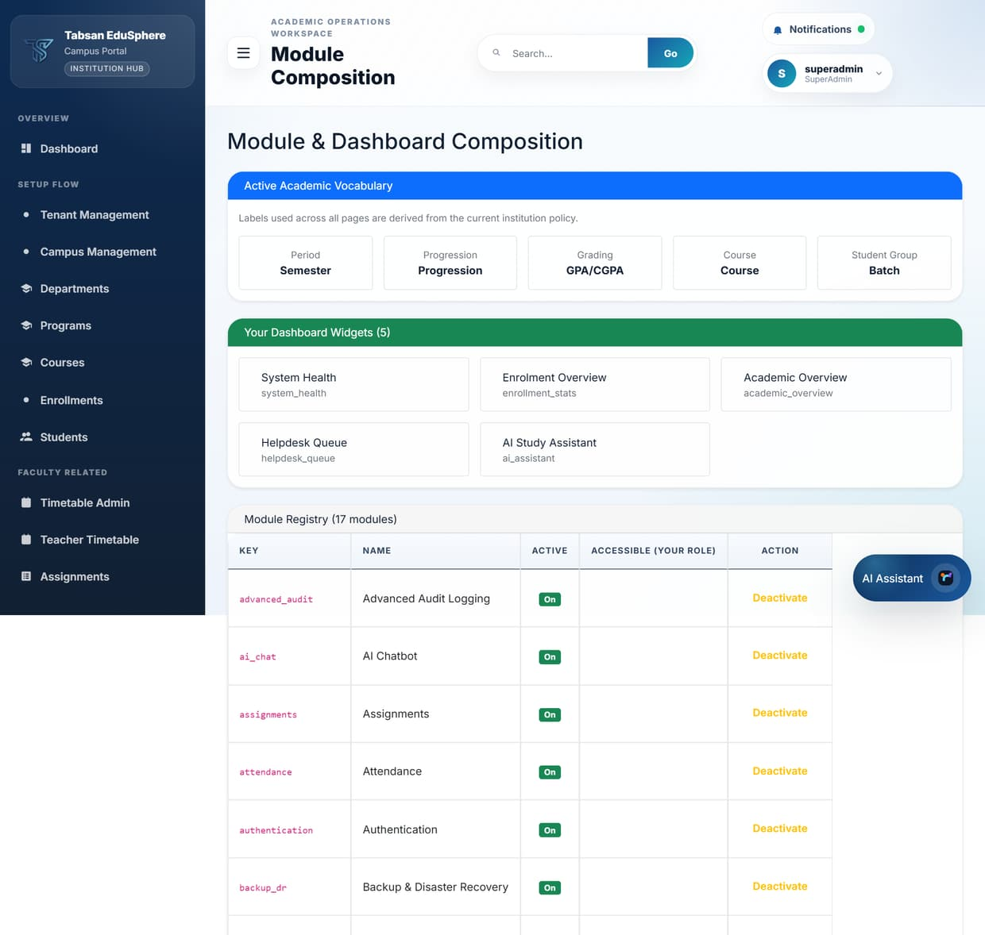
Figure 13.5 Module Composition

13.5 Sidebar Settings
Available to: SuperAdmin
Sidebar Settings controls which menu items Admin, Faculty and Student users see. Each row is a menu with its purpose and a switch for each role. SuperAdmin always keeps full access, and menus marked System cannot be switched off. Appendix A shows the default settings.
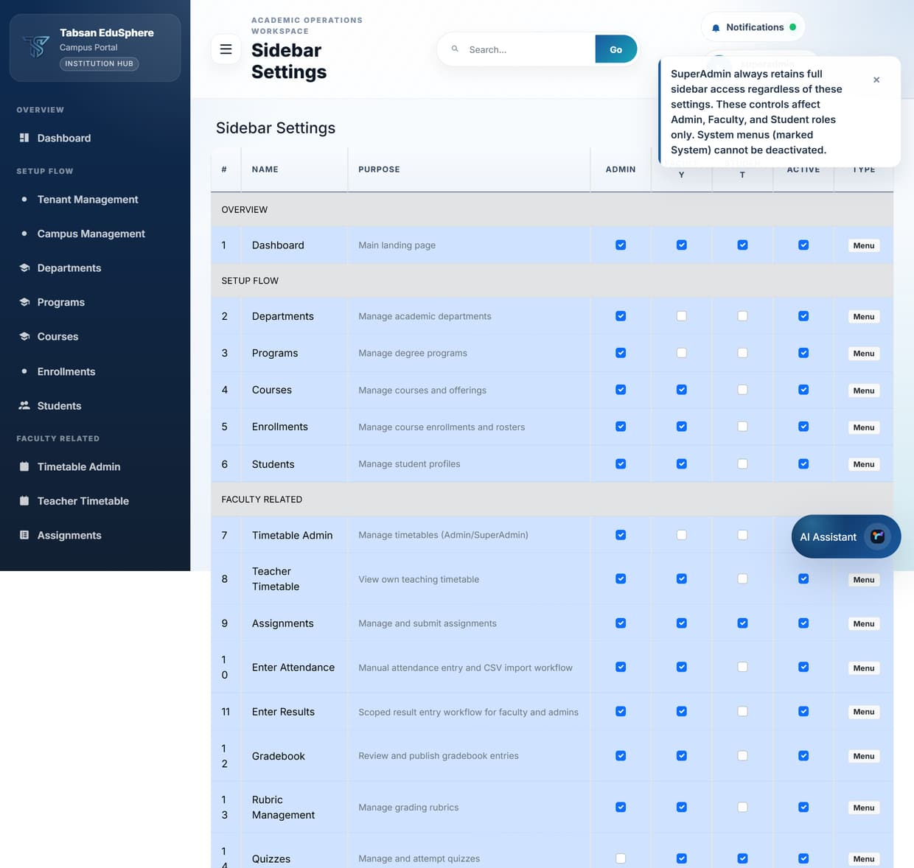
Figure 13.6 Sidebar Settings

13.6 Report Settings
Available to: SuperAdmin
Report Settings lists the report definitions (nine by default). Here you can create a new definition, switch a report on or off, and choose which roles may run it. Report Center then shows each user only the reports allowed for their role.
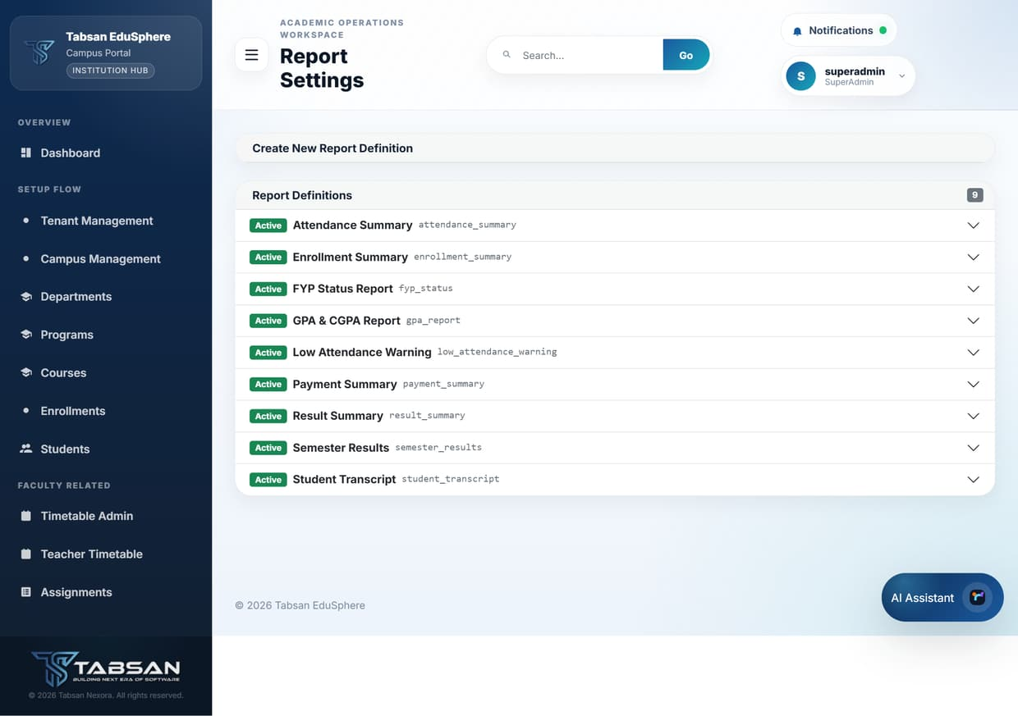
Figure 13.7 Report Settings

13.7 Dashboard Settings (Branding)
Available to: SuperAdmin
Dashboard Settings controls how the portal presents your institution.

Procedure
- Update the fields you want to change.
- Click Save Branding. The changes apply to all users at their next page load.

Fields and options
Field | What to enter or choose
University / Institution Name | Shown in the sidebar and on generated documents.
Portal Subtitle | The line under the name, for example "Campus Portal".
Footer Text | Text shown at the bottom of every page.
Portal Logo | Upload your institution's logo (shown in the sidebar). If none is uploaded, the Tabsan emblem is used.
Privacy Policy URL / Text | A link to, or the text of, your privacy policy.
Font Family / Font Size | The portal's main font and base text size.

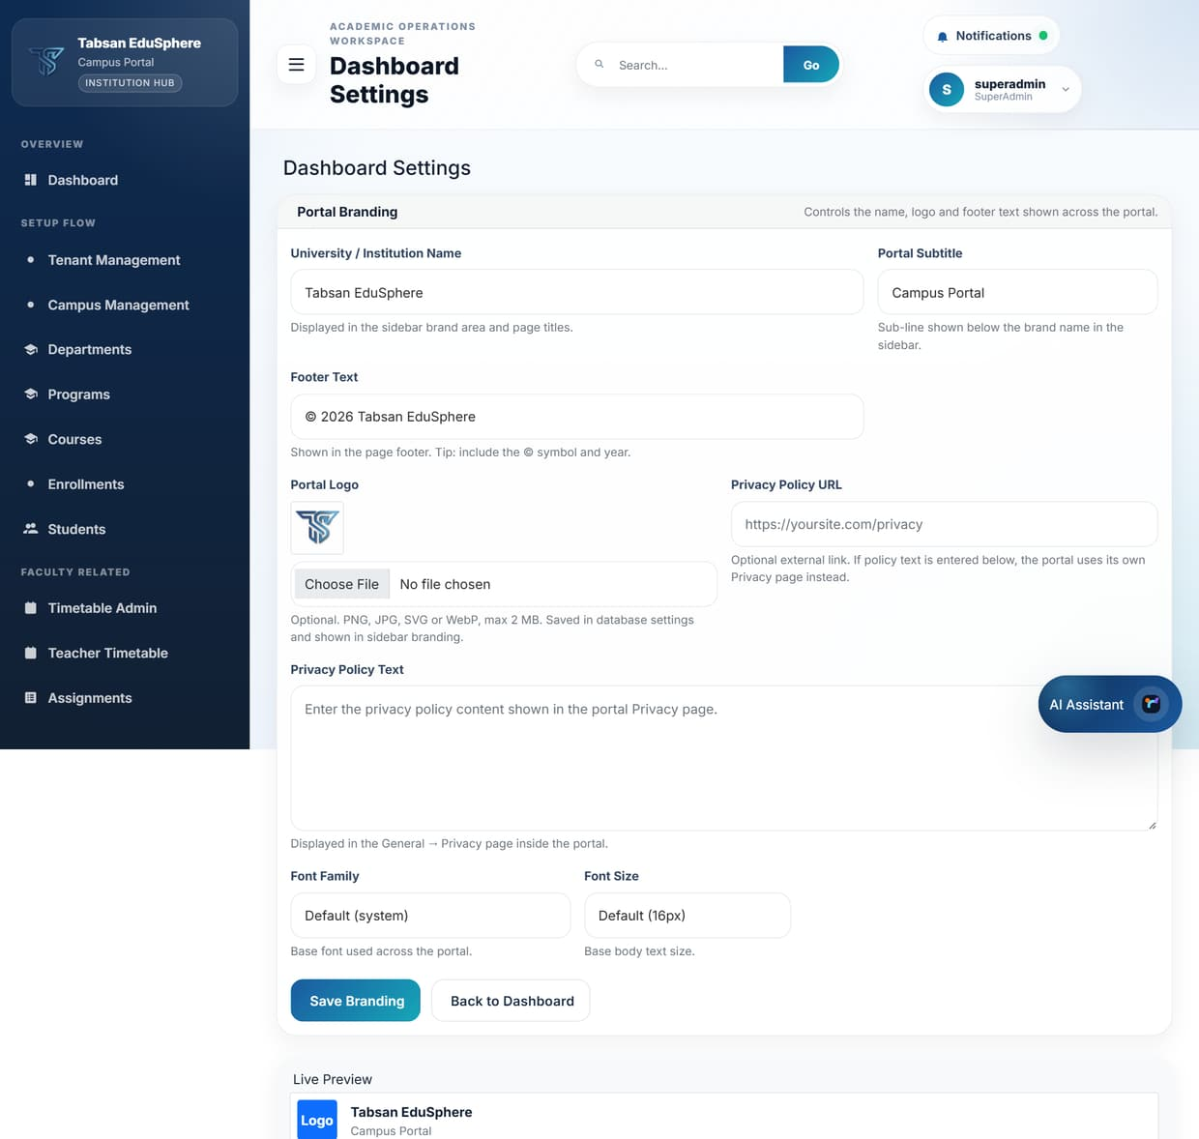
Figure 13.8 Dashboard Settings – portal branding

13.8 Institution Policy
Available to: SuperAdmin
Institution Policy switches the University, School and College institution types on or off for the installation, within what the license allows. Switching a type off hides its departments, menus and reports. Tick the types in use and click Save Policy.
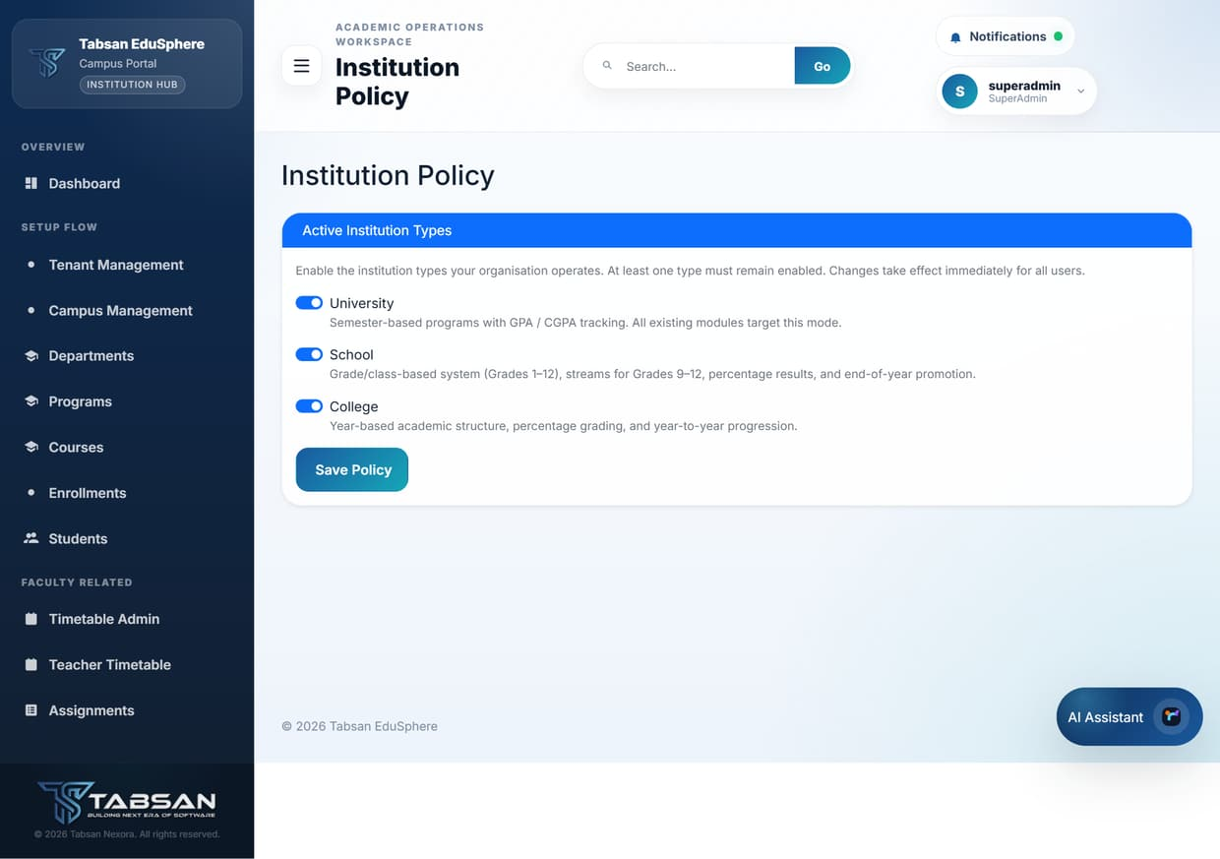
Figure 13.9 Institution Policy

13.9 License Update
Available to: SuperAdmin
License Update shows the current product license (status, type, activation date and expiry date) and lets you upload a new or renewed license file supplied by Tabsan.

Procedure
- Open License Update.
- Under Upload License File, choose the .tablic file supplied by Tabsan.
- Click Upload & Activate. The Current License table updates and the license status shows Active.

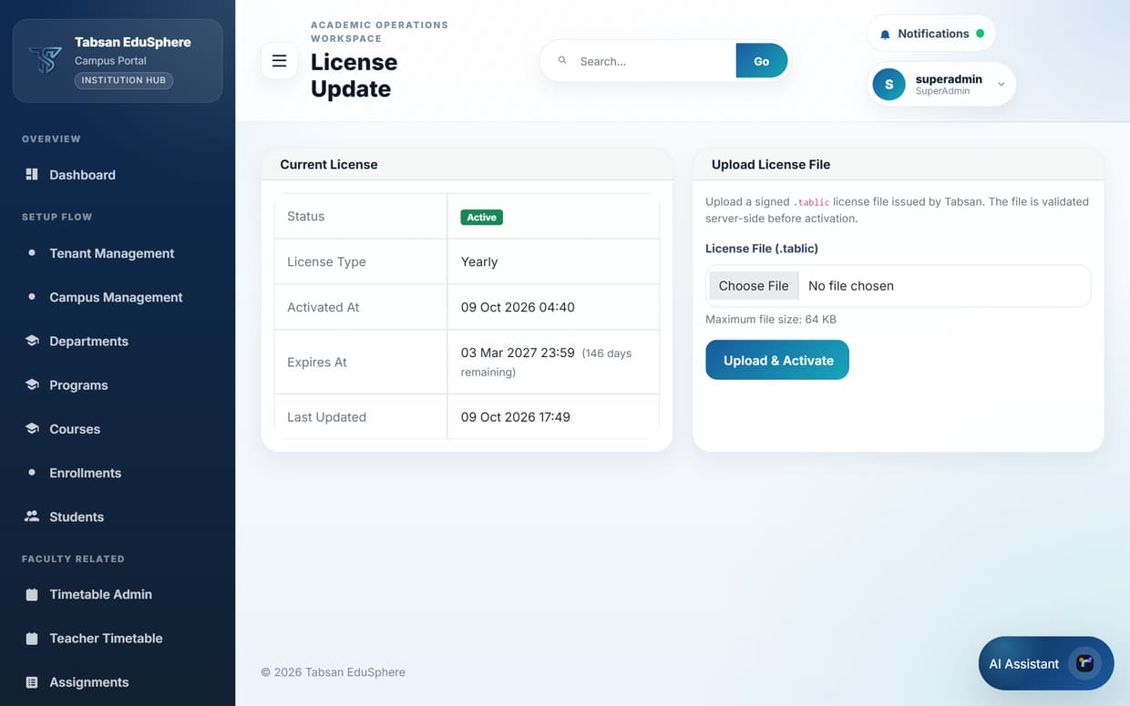
Figure 13.10 License Update

License statuses
Status | Meaning
Active | The license is valid; the portal works normally.
Expired | The expiry date has passed; the portal is read-only until a new license is uploaded.
Invalid | No license, or the stored license failed its security checks; the portal is read-only.

IMPORTANT License files are encrypted and digitally signed. A file that has been edited in any way is rejected. The expiry date is fixed inside the file and is the same on every server it is activated on. Each license file can be activated only once.

13.10 Library Config
Available to: SuperAdmin
Library Config connects the portal to an external library system so users can search the catalogue and see loans. Enter the Catalogue URL, Loan API URL and API Token supplied by the library system, then click Save Configuration.
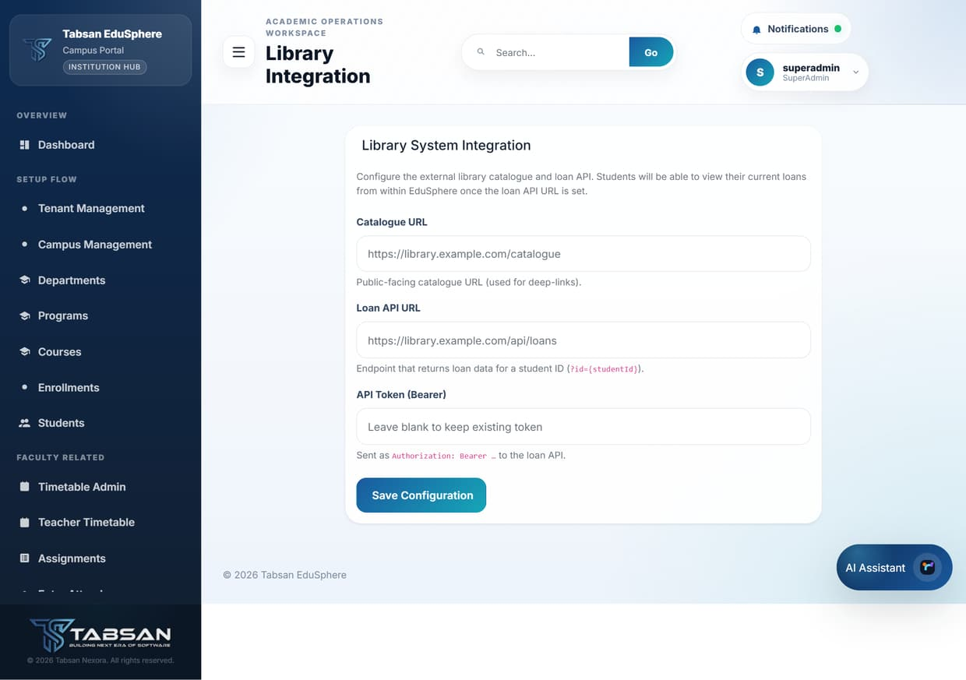
Figure 13.11 Library Config

13.11 Accreditation
Available to: SuperAdmin
Accreditation helps prepare documents for accreditation bodies. Download the simple template, complete it with your institution's information, and upload it back to keep it with your records.
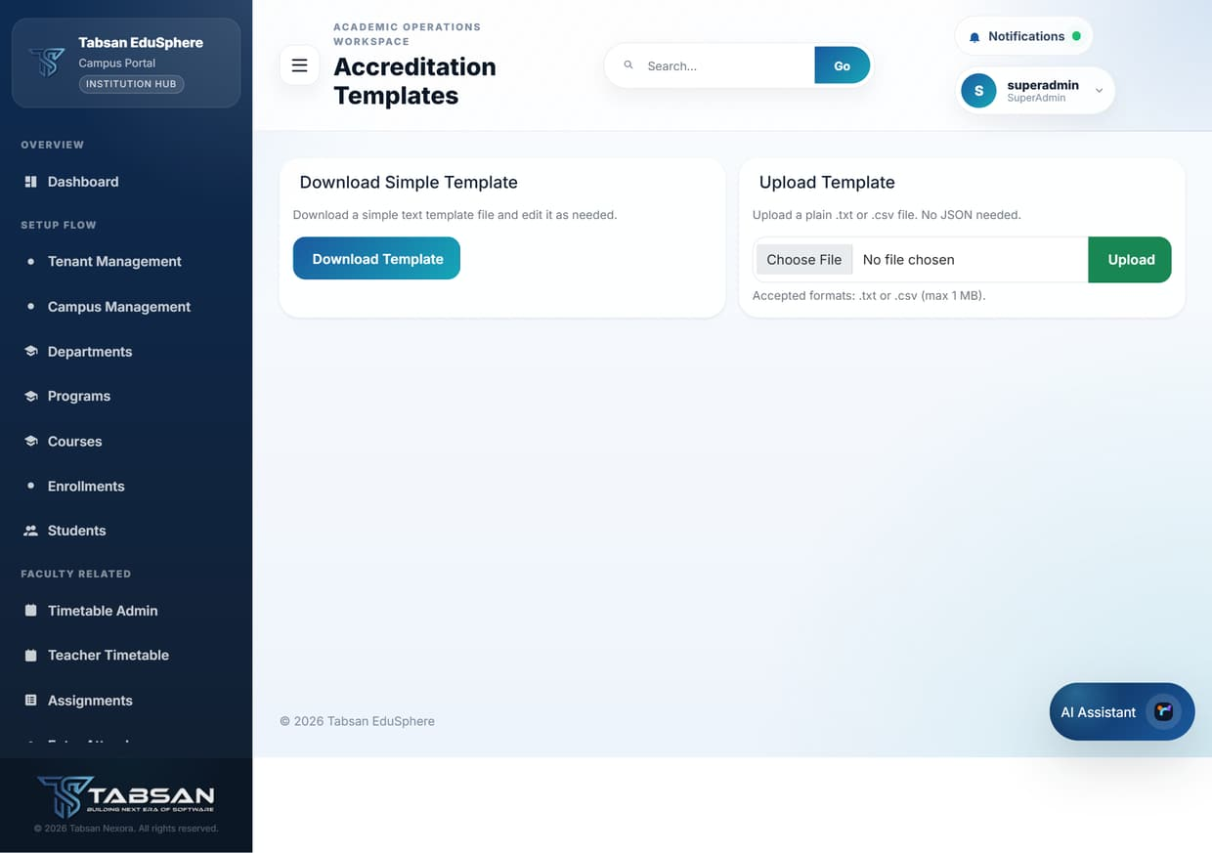
Figure 13.12 Accreditation templates

13.12 Advanced Audit
Available to: SuperAdmin
The audit log records who did what and when, including sign-ins, changes to records and settings, with the before and after values. Use it to investigate a problem or to answer compliance questions.

Procedure
- Filter by any combination of Search text, Actor User Id, Action, Module (Entity) and a From/To date range (UTC), choose how many Rows to show, and click Apply Filters.
- Use Previous and Next to page through the results. Your filters are kept.
- Click Export CSV, Export Excel or Export PDF to download the filtered log.

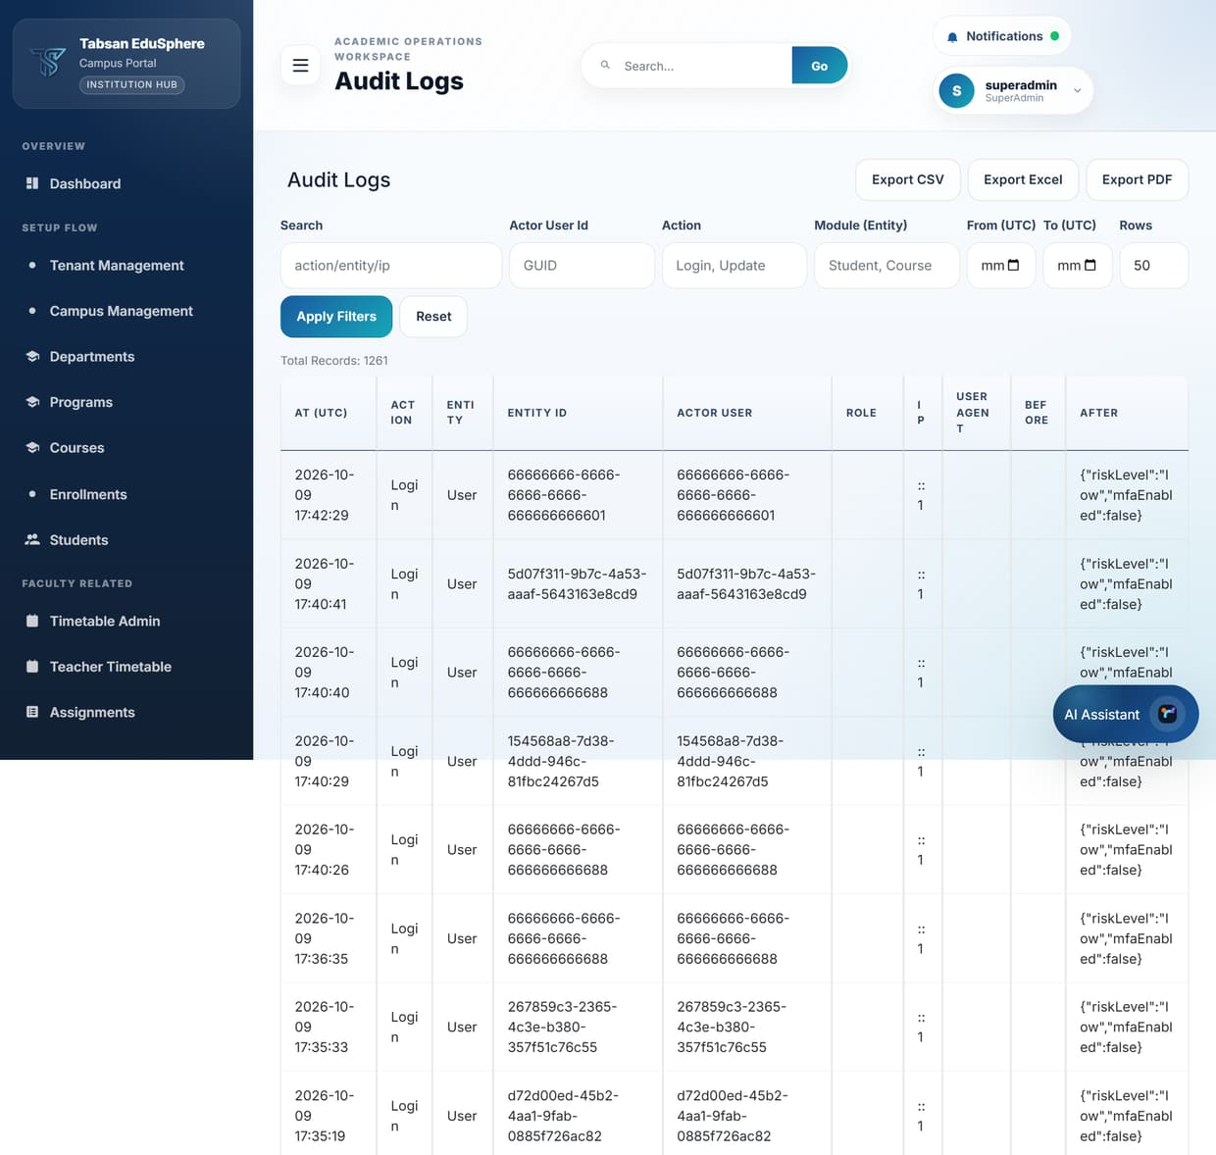
Figure 13.13 Audit Logs

14 Troubleshooting and FAQ

14.1 Signing in and accounts
Problem | What to do
I cannot sign in. | Check the username and that Caps Lock is off. If you have forgotten your password, ask an Admin to reset it from User Settings.
I am asked to change my password. | This happens at first sign-in and when your password expires (every 90 days by default). Choose a new password of at least 8 characters.
I was signed out unexpectedly. | Sessions end after a period of inactivity. Sign in again; save your work regularly on long forms.
I lost my authenticator device. | Use one of your recovery codes to sign in, or ask an administrator to reset two-factor authentication.
A new student cannot see their courses. | Check that the student was created with a Program (so a student profile exists) and has been enrolled in the term's offerings.

14.2 Pages and data
Problem | What to do
I was returned to the Helpdesk with a message. | The page is not available to your role. The message explains why. Ask your administrator if you need access.
A list is empty. | Check the filters at the top of the page. Most pages need a department, course or offering selected first.
Save buttons return "read-only mode". | The license is missing or expired. A SuperAdmin must upload a valid license in License Update.
A student cannot enrol in a course. | The course may have a prerequisite the student has not passed, the offering may be full (the student is waitlisted), or enrolment may be closed for the campus.
Results are not visible to students. | Results appear only after the teacher clicks Publish All in Enter Results.
A student cannot apply for graduation. | Only active University students in their final semester with a completed FYP can apply. Check Degree Audit for unmet requirements.
Degree Audit says no degree rule is configured. | A SuperAdmin must create a degree rule for the student's program in Degree Rules.
A report has no export buttons. | Choose all required filters and click Filter first; some reports need a semester or a student.
Exported files do not open. | Make sure the download finished. CSV files open in Excel; PDF files need a PDF reader.

14.3 Getting more help
If your question is not answered here, raise a ticket in Helpdesk with the Technical category, describing what you were doing and what you saw. Include the page name and, if possible, a screenshot. Your administrator can also check the audit log to see exactly what happened.

Appendix A Menu Access by Role
The table lists every sidebar menu and the roles that see it with the default settings. SuperAdmin can change Admin, Faculty and Student visibility in Sidebar Settings. Admin access was captured with the testadmin account.
Section | Menu | Super Admin | Admin | Faculty | Student | Finance
Overview | Dashboard | ✓ | – | – | – | –
Setup Flow | Tenant Management | ✓ | – | – | – | –
Setup Flow | Campus Management | ✓ | – | – | – | –
Setup Flow | Departments | ✓ | ✓ | – | – | –
Setup Flow | Programs | ✓ | ✓ | ✓ | – | –
Setup Flow | Courses | ✓ | ✓ | ✓ | – | –
Setup Flow | Enrollments | ✓ | ✓ | ✓ | – | –
Setup Flow | Students | ✓ | ✓ | ✓ | – | –
Faculty Related | Timetable Admin | ✓ | ✓ | – | – | –
Faculty Related | Teacher Timetable | ✓ | ✓ | ✓ | – | –
Faculty Related | Assignments | ✓ | ✓ | ✓ | ✓ | –
Faculty Related | Enter Attendance | ✓ | ✓ | ✓ | – | –
Faculty Related | Enter Results | ✓ | ✓ | ✓ | – | –
Faculty Related | Gradebook | ✓ | ✓ | ✓ | – | –
Faculty Related | Rubric Management | ✓ | ✓ | ✓ | – | –
Faculty Related | Quizzes | ✓ | – | ✓ | – | –
Faculty Related | LMS Manage | ✓ | ✓ | ✓ | – | –
Faculty Related | Course Material | ✓ | ✓ | ✓ | ✓ | –
Faculty Related | Discussion | ✓ | ✓ | ✓ | ✓ | –
Faculty Related | Announcements | ✓ | ✓ | ✓ | ✓ | –
Student Related | Student Timetable | ✓ | – | – | ✓ | –
Student Related | Attendance | ✓ | – | ✓ | ✓ | –
Student Related | Results | ✓ | ✓ | ✓ | ✓ | –
Student Related | FYP | ✓ | – | ✓ | – | –
Student Related | Student Lifecycle | ✓ | ✓ | – | – | –
Academic Related | Result Calculation | ✓ | ✓ | – | – | –
Academic Related | Prerequisites | ✓ | ✓ | – | – | –
Academic Related | Generate Certificates | ✓ | ✓ | ✓ | – | –
Academic Related | Degree Audit | ✓ | ✓ | ✓ | ✓ | –
Academic Related | Graduation Eligibility | ✓ | ✓ | ✓ | – | –
Academic Related | Degree Rules | ✓ | ✓ | ✓ | – | –
Academic Related | Graduation Apply | ✓ | – | – | ✓ | –
Academic Related | Graduation Applications | ✓ | ✓ | ✓ | – | –
Academic Related | Grading Config | ✓ | ✓ | ✓ | – | –
Academic Related | Study Plan | ✓ | ✓ | ✓ | – | –
Settings Related | Two-Factor Authentication | ✓ | ✓ | ✓ | ✓ | ✓
Settings Related | Buildings | ✓ | ✓ | – | – | –
Settings Related | Rooms | ✓ | ✓ | – | – | –
Settings Related | Report Settings | ✓ | – | – | – | –
Settings Related | Module Composition | ✓ | – | – | – | –
Settings Related | Sidebar Settings | ✓ | – | – | – | –
Settings Related | Theme Settings | ✓ | ✓ | ✓ | ✓ | ✓
Settings Related | License Update | ✓ | – | – | – | –
Settings Related | Dashboard Settings | ✓ | – | – | – | –
Settings Related | Institution Policy | ✓ | – | – | – | –
Settings Related | Library Config | ✓ | – | – | – | –
Settings Related | Accreditation | ✓ | – | – | – | –
Settings Related | Advanced Audit | ✓ | – | – | – | –
Settings Related | Notifications | ✓ | ✓ | ✓ | ✓ | ✓
Settings Related | User Import | ✓ | ✓ | – | – | –
Settings Related | User Settings | ✓ | ✓ | ✓ | ✓ | ✓
Settings Related | Analytics | ✓ | ✓ | ✓ | – | ✓
Settings Related | Helpdesk | ✓ | ✓ | ✓ | ✓ | ✓
Settings Related | Report Center | ✓ | ✓ | ✓ | – | ✓
Settings Related | Admin Users | ✓ | – | – | – | –
Financial Related | Payments | ✓ | ✓ | – | – | ✓
Student Related | View Quizzes | – | – | – | ✓ | –

Appendix B Glossary
Term | Meaning
CGPA | Cumulative Grade Point Average across all completed semesters.
Course offering | A course taught in a specific semester or class, usually by one faculty member. Students enrol in offerings.
Degree rule | The credit and GPA requirements a University program must meet before a student can graduate.
FYP | Final Year Project – the capstone project of a University program.
Institution type | University, College or School. Departments, grading and progression follow the institution type.
Level | A semester (University) or class (School and College) within a program.
License (.tablic) | The encrypted, signed file that activates the portal and sets its expiry date.
Module | A feature area (for example Attendance or Reports) that SuperAdmin can activate or deactivate.
Prerequisite | A course a student must pass before enrolling in another course.
Read-only mode | The state in which the portal allows viewing but blocks changes, used when the license is not valid.
Tenant | A separate institution in the installation with its own campuses, departments, users and data.
Two-factor authentication (2FA) | A second sign-in step using a 6-digit code from an authenticator app.

Index

A
Academic structure 8
Access matrix 96
Accreditation 91
Admin Users 83
AI Assistant 12
Analytics 66
Announcements 46
Approvals 61
Assignments 31
Attendance 33, 36
Audit logs 92
B
Branding 87
Buildings 25
C
Campuses 81
Certificates 62
Course Material 44
Course offerings 20
Courses 20
D
Dashboard 81
Degree Audit 58
Degree Rules 57
Departments 17
Discussion 46
E
Enrollments 22
Enter Attendance 33
Enter Results 37
F
Fee receipts 68
Filters 13
Final Year Project 55
FYP 55
G
GPA 49
Gradebook 39
Grading Config 50
Graduation 52
Graduation Applications 61
Graduation Apply 60
Graduation Eligibility 59
H
Helpdesk 77
I
Institution Policy 88
Institution types 8
L
Library 90
License 14, 89
LMS 43
Login 10
M
MFA 75
Modules 84
N
Notifications 12, 76
P
Pass mark 50
Password 9, 73
Payments 68
Prerequisites 51
Profile menu 13
Programs 19
Promotion 52
Q
Quizzes 41
R
Read-only mode 14
Re-check 48
Report Center 64
Report Settings 86
Reports 64
Result Calculation 49
Results 37, 48
Roles 6
Rooms 25
Rubrics 40
S
Search 12
Session timeout 9
Sidebar 12
Sidebar Settings 85
Sign in 10
Sign out 13
Student Lifecycle 52
Student Timetable 29
Students 24
Study Plan 54
Support tickets 77
T
Teacher Timetable 28
Tenants 81
Test accounts 6
testadmin 6
Theme 79
Timetable 27
Two-factor authentication 75
U
User Import 71
User Settings 73
Users 71

